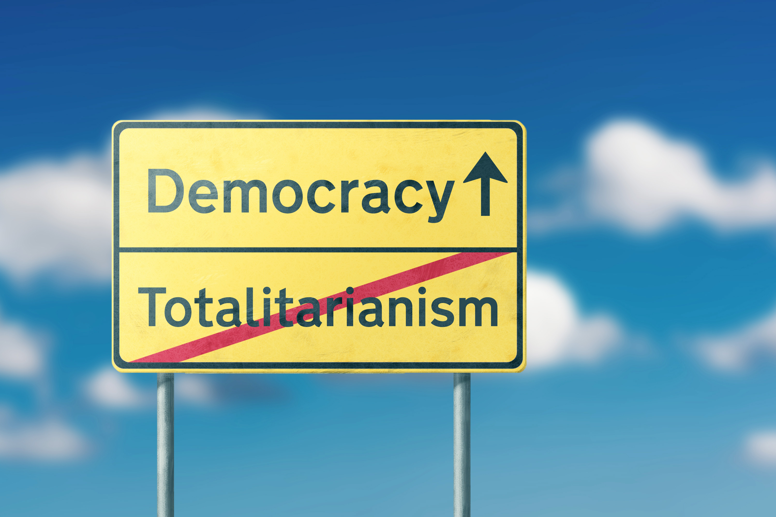
Warning
George Orwell was inspired to write 1984
as he watched the rise of totalitarian governments across Europe. A totalitarian government provides no individual freedoms and subjects all citizens to the state’s authority. It is run by a dictator, who has complete control and who usually came to power by force rather than by the will of the people. Fascism is a type of totalitarianism and is characterized by excessive nationalism, which is a devotion to one’s own country even if that devotion is at the expense of other countries.

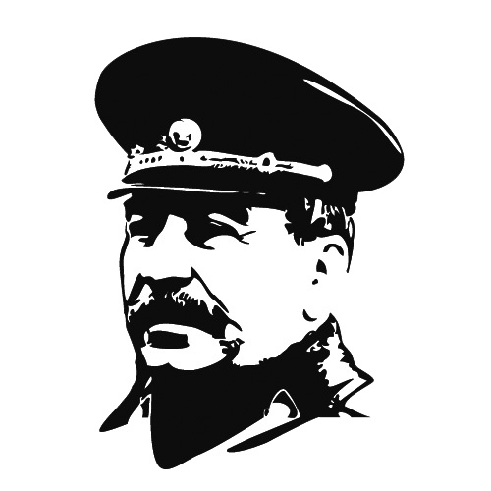
Totalitarianism in the Soviet Union
The Soviet Union was the first country to be controlled by a totalitarian government after World War I under dictator Joseph Stalin. The Soviet Union was established in 1922 by Vladimir Lenin, who founded the Russian Communist Party. Lenin’s goal was for the government to be controlled by the working class. However, after Lenin’s death in 1924, Stalin seized control of the Soviet Union and became its dictator. Stalin’s government controlled people by using terror, making it known that anyone who opposed him could be murdered at any time. He had a secret police force and encouraged citizens to spy on one another. Before the outbreak of World War II, Stalin and Hitler signed a nonaggression pact, which Germany broke in 1941 by invading the Soviet Union. Stalin’s army eventually drove the Germans out of the Soviet Union. Even after World War II, Stalin continued to eliminate any potential opponents by killing them or removing them to forced labor camps. Despite the government’s claim that life was better for its citizens under Stalin, most people lived in harsh conditions with food shortages and limited housing. Stalin died in 1953, but the Soviet Union and its totalitarian government were not dissolved until 1991.

Nazi Germany
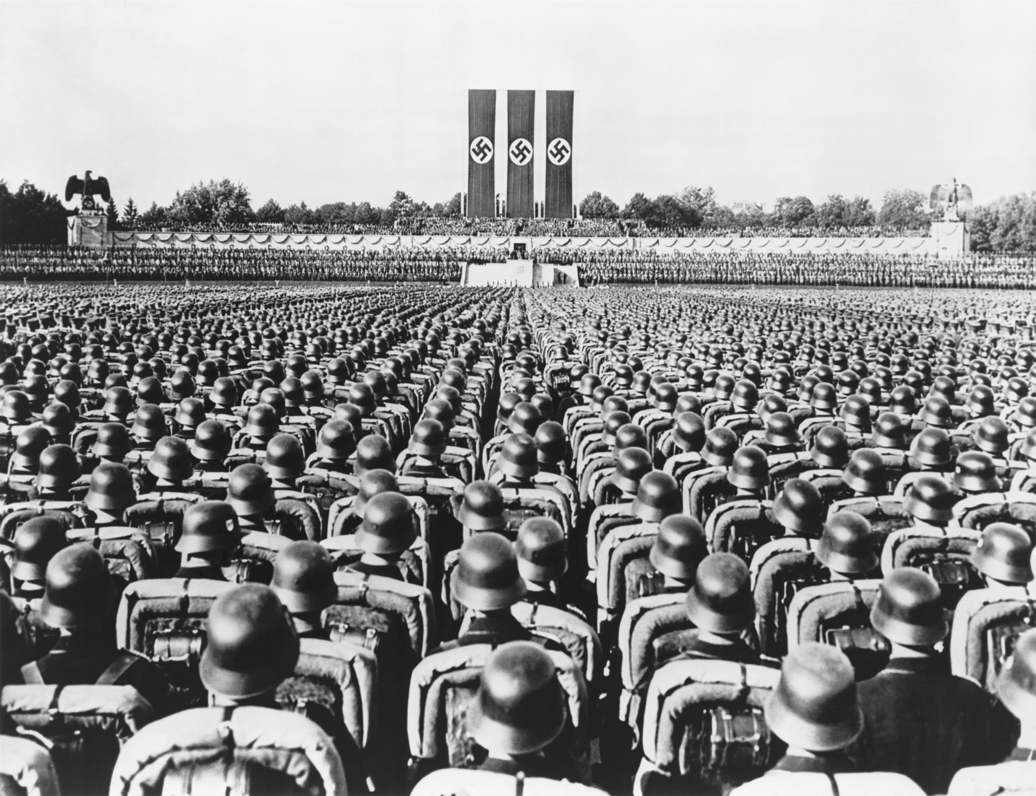
The Nazi Party, or National Socialist German Workers’ Party, was founded in 1919 on the beliefs of nationalism and anti-Semitism. Adolf Hitler became its leader in 1921. Early members of the party were angry about Germany’s defeat in World War I and the fact that their economy was suffering as a result. Hitler used Jewish people, along with other groups such as gypsies, Communists, and the disabled, as scapegoats for the problems Germany was facing. He was a charismatic speaker, so his speeches claiming that Germany’s problems would be solved by removing anyone who was not part of the “master” race from the country were effective. In 1933, Hitler was appointed chancellor of Germany’s government, and Nazi rule began. He banned all political parties except for Nazism and opened what would be the first concentration camp in Dachau. Over the years, Jewish people were banned from most public places. As the government began to arrest people and send them to concentration camps, people began fleeing the country or going into hiding. Hitler called the eventual planned murder of all Jewish people “the final solution.” In 1939, Germany began its attempt to dominate all of Europe by invading Poland, which prompted Great Britain and France to declare war on Germany. By the end of World War II in 1945, six million Jewish people had been murdered. The new German government outlawed Nazism and brought remaining Nazi officials to trial for the murders they’d committed.

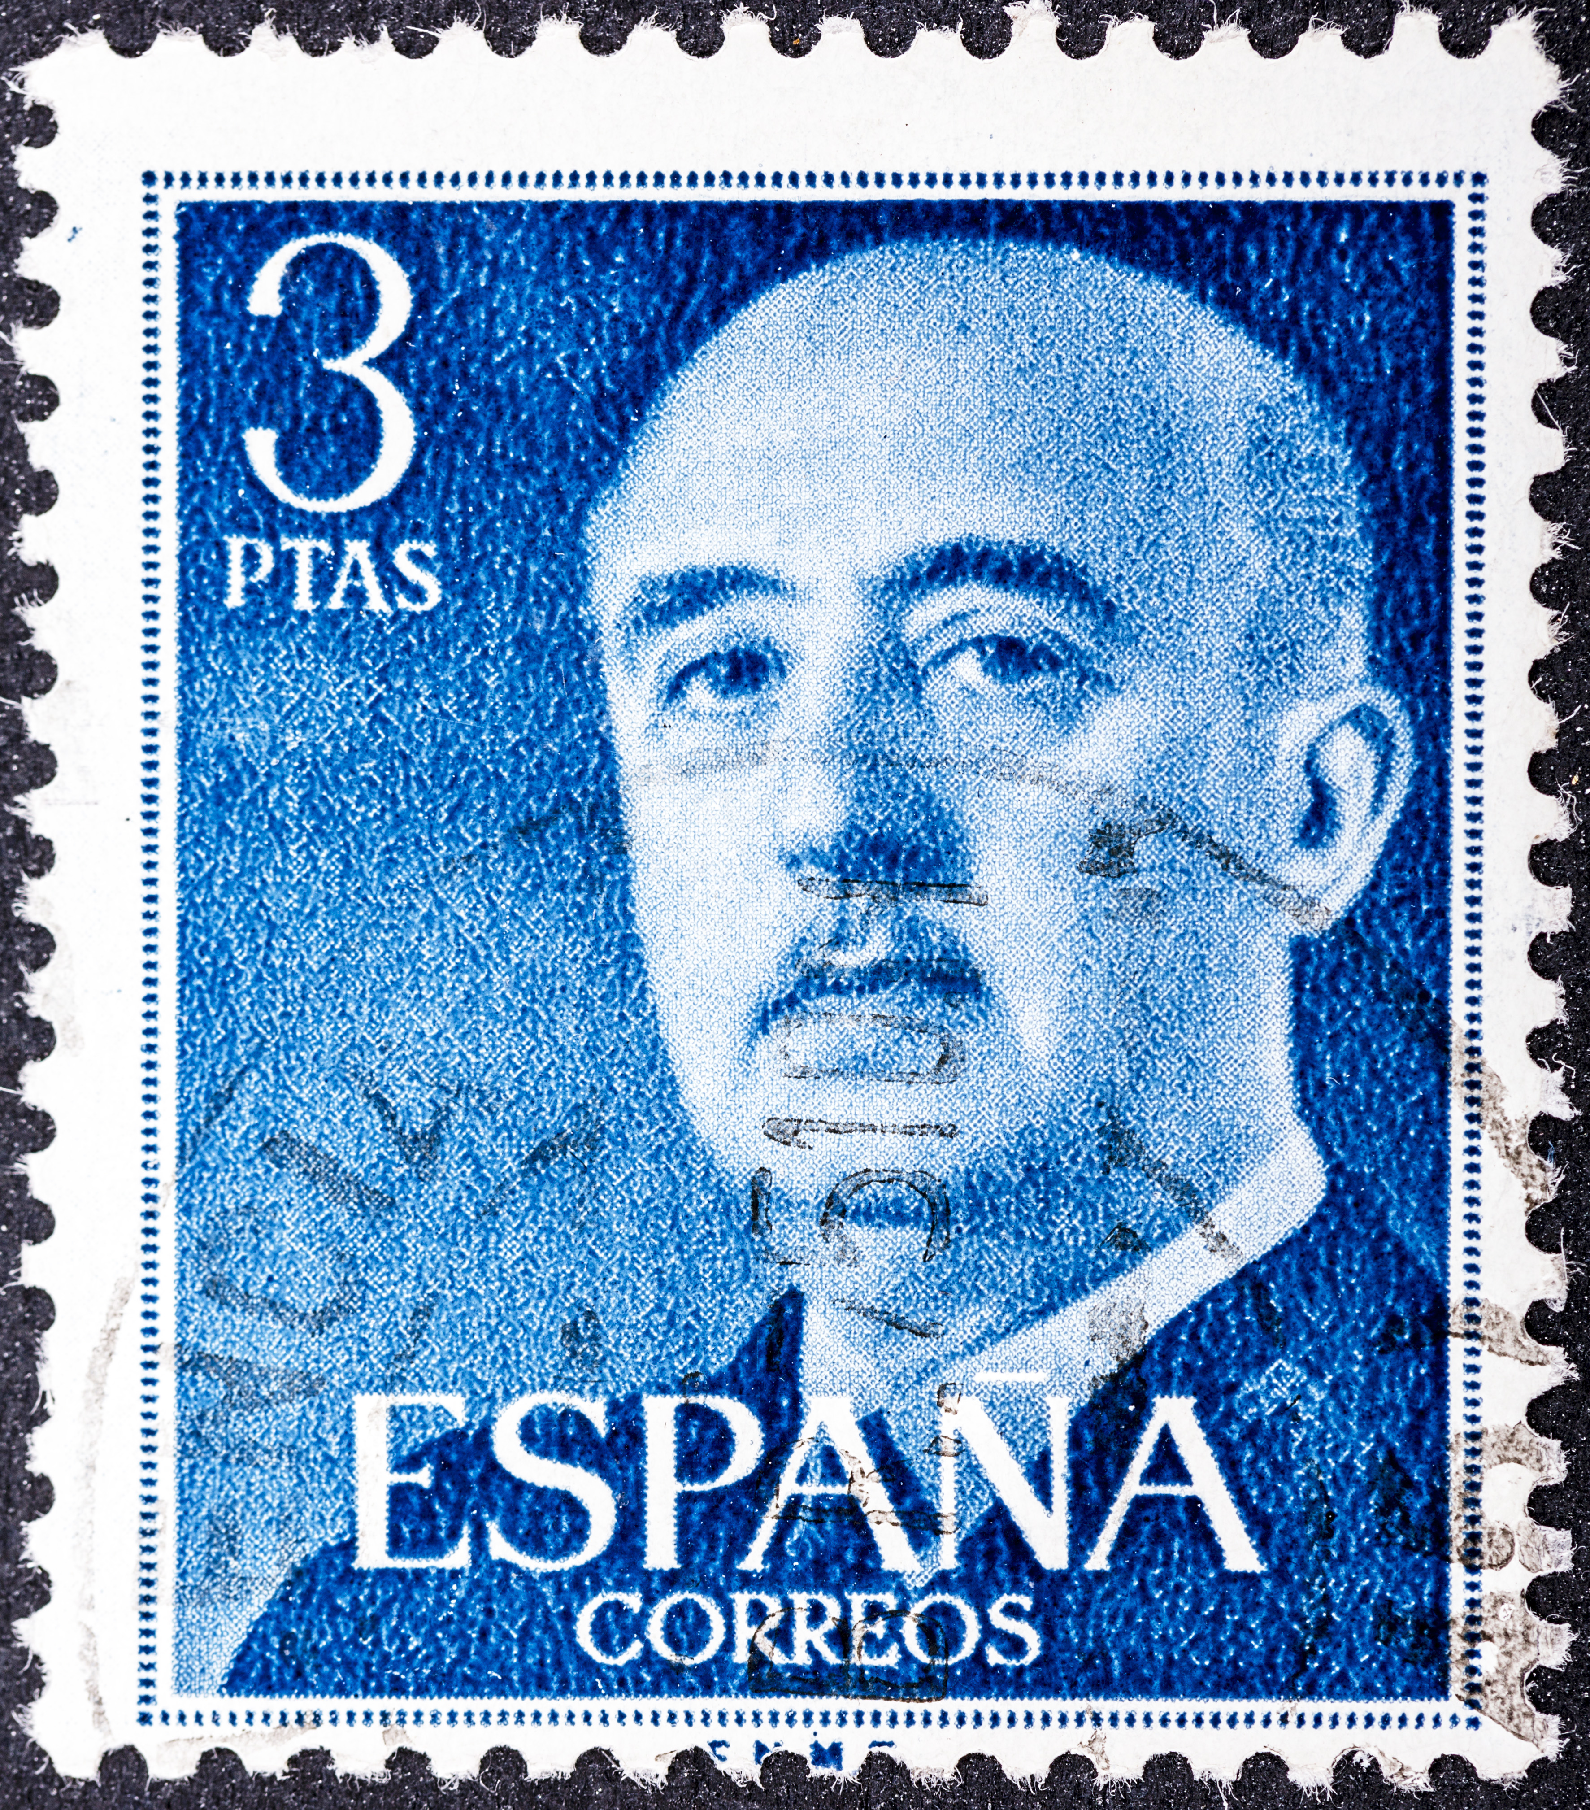
Spain Under Francisco Franco
The Spanish Civil War broke out in 1936, when nationalist rebels revolted against the democratically elected government. The rebels eventually seized control in 1939, with General Francisco Franco as their leader. Franco did not have any ideology that guided him but believed that military control was the only way to keep the country in order. Once in power, Franco put many officials of the previous Republican government to death. He banned all religions aside from Catholicism as well as the Catalan and Basque languages. Like Stalin, he created a secret police network that worked to arrest anyone who might oppose him. Franco also imposed strong censorship, hiring people to erase anything that was critical of him or Spain. Franco ruled until his death in 1975, after which Spain held democratic elections. George Orwell fought for the Republicans in the Spanish Civil War, and it was in Spain that he first became concerned about the rise of totalitarianism.

