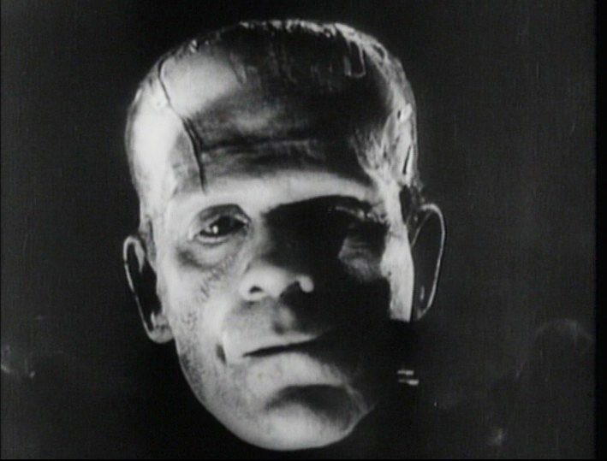Today the term *Frankenstein* has become synonymous with frightening monsters, “mad” scientists, and science gone too far. Terms like *Frankenfood* and *Frankenscience* have become part of the modern lexicon, underscoring the potentially overreaching powers of scientists and scientific creations gone amok. But what did *Frankenstein*, and science, mean to Mary Shelley and her contemporaries?

## Playing with Fire

One clue lies in the subtitle to Shelley’s novel: *Prometheus Unbound.* Shelley’s subtitle refers to the myth of Prometheus, a Titan in Greek mythology who was punished by Zeus for bringing fire to humans. Fire gave humans the ability to care for themselves without the gods’ help. Zeus became outraged: Humans could be free, but they must still be subservient to the gods. For his offense, Zeus had Prometheus bound to a rock and tortured by an eagle that tore out and ate his liver daily. In the eighteenth and nineteenth centuries, with the rise of the Scientific Revolution, the myth of Prometheus began to speak to humankind’s gloriously increasing powers over the natural world and the dangers of “playing God.” *Frankenstein,* then, became a cautionary tale of what Prometheus looks like “unbound” and unloosed on the world again.

## Evolving Ideas of Science and Faith

The Scientific Revolution (1550–1700) marked a period of enormous advancements in science and set the stage for the developments in science of the eighteenth and nineteenth centuries. Sparked by Nicolaus Copernicus’s “blasphemous” theory that the sun, not the earth, was the center of the solar system, the Scientific Revolution marked a seismic shift in thinking in which people began to question the previously accepted “truths” delivered by the Church and scientific observers took a more active role in their inquiries. Advancements in mathematics, physics, and biology soon blossomed, culminating with Sir Isaac Newton’s *Principia*, which laid out laws of planetary motion and gravitation still used today. The powers of the individual human mind seemed limitless and the secrets of the universe tantalizingly within human grasp. A new truth was considered: The answers to life’s mysteries lay not inside the walls of a church but inside the human mind.

## The Mind on Fire

Alongside these dramatic shifts came the forces of political, social, and intellectual change. The tide of democratic idealism of the American and French Revolutions of the late eighteenth century swept through Shelley’s age, promoting freedom of the individual mind and democratic rule. Shelley’s own father, William Godwin, a former minister turned atheist, was at the forefront of these changes. A leader of the “free-thinking” movement, Godwin argued that logic, not established belief, should be used to form opinion.

## Boundaries of Science and Magic

Yet a clear line in the sand between science and religion was still yet to be drawn. Where today the lines between science and faith become ever sharper, the science of Shelley’s time was still a murky blend of rationalism and mysticism. Alchemicalscience still held sway, and strange feats of science like the galvanism of Luigi Galvani, who made the muscles in the detached legs of frogs “come alive” with electricity in the 1790s, blurred the boundaries of science and magic. Giovanni Aldini, Galvani’s nephew, electrocuted the cadavers of murderers for capacity crowds. And Erasmus Darwin, who Shelley mentions in the preface to *Frankenstein*, went so far as to claim the source of life itself was knowable.

## Challenges to Science and Rationalism

Shelley herself is considered a writer of Romanticism, a period during which writers, intellectuals, and artists questioned rationalism and deterministic belief. One could have a faith in the rational mind, but at what cost? The Romantics’ growing suspicion of scientific progress began to place the subjective, emotional mind over the rational and objective mind as a way to retain spiritual and moral balance. Writers like William Wordsworth and Samuel Taylor Coleridge, pioneers of Romanticism, promoted nature and humankind’s connection to nature as a way to spiritualize the connection to one’s self and society.

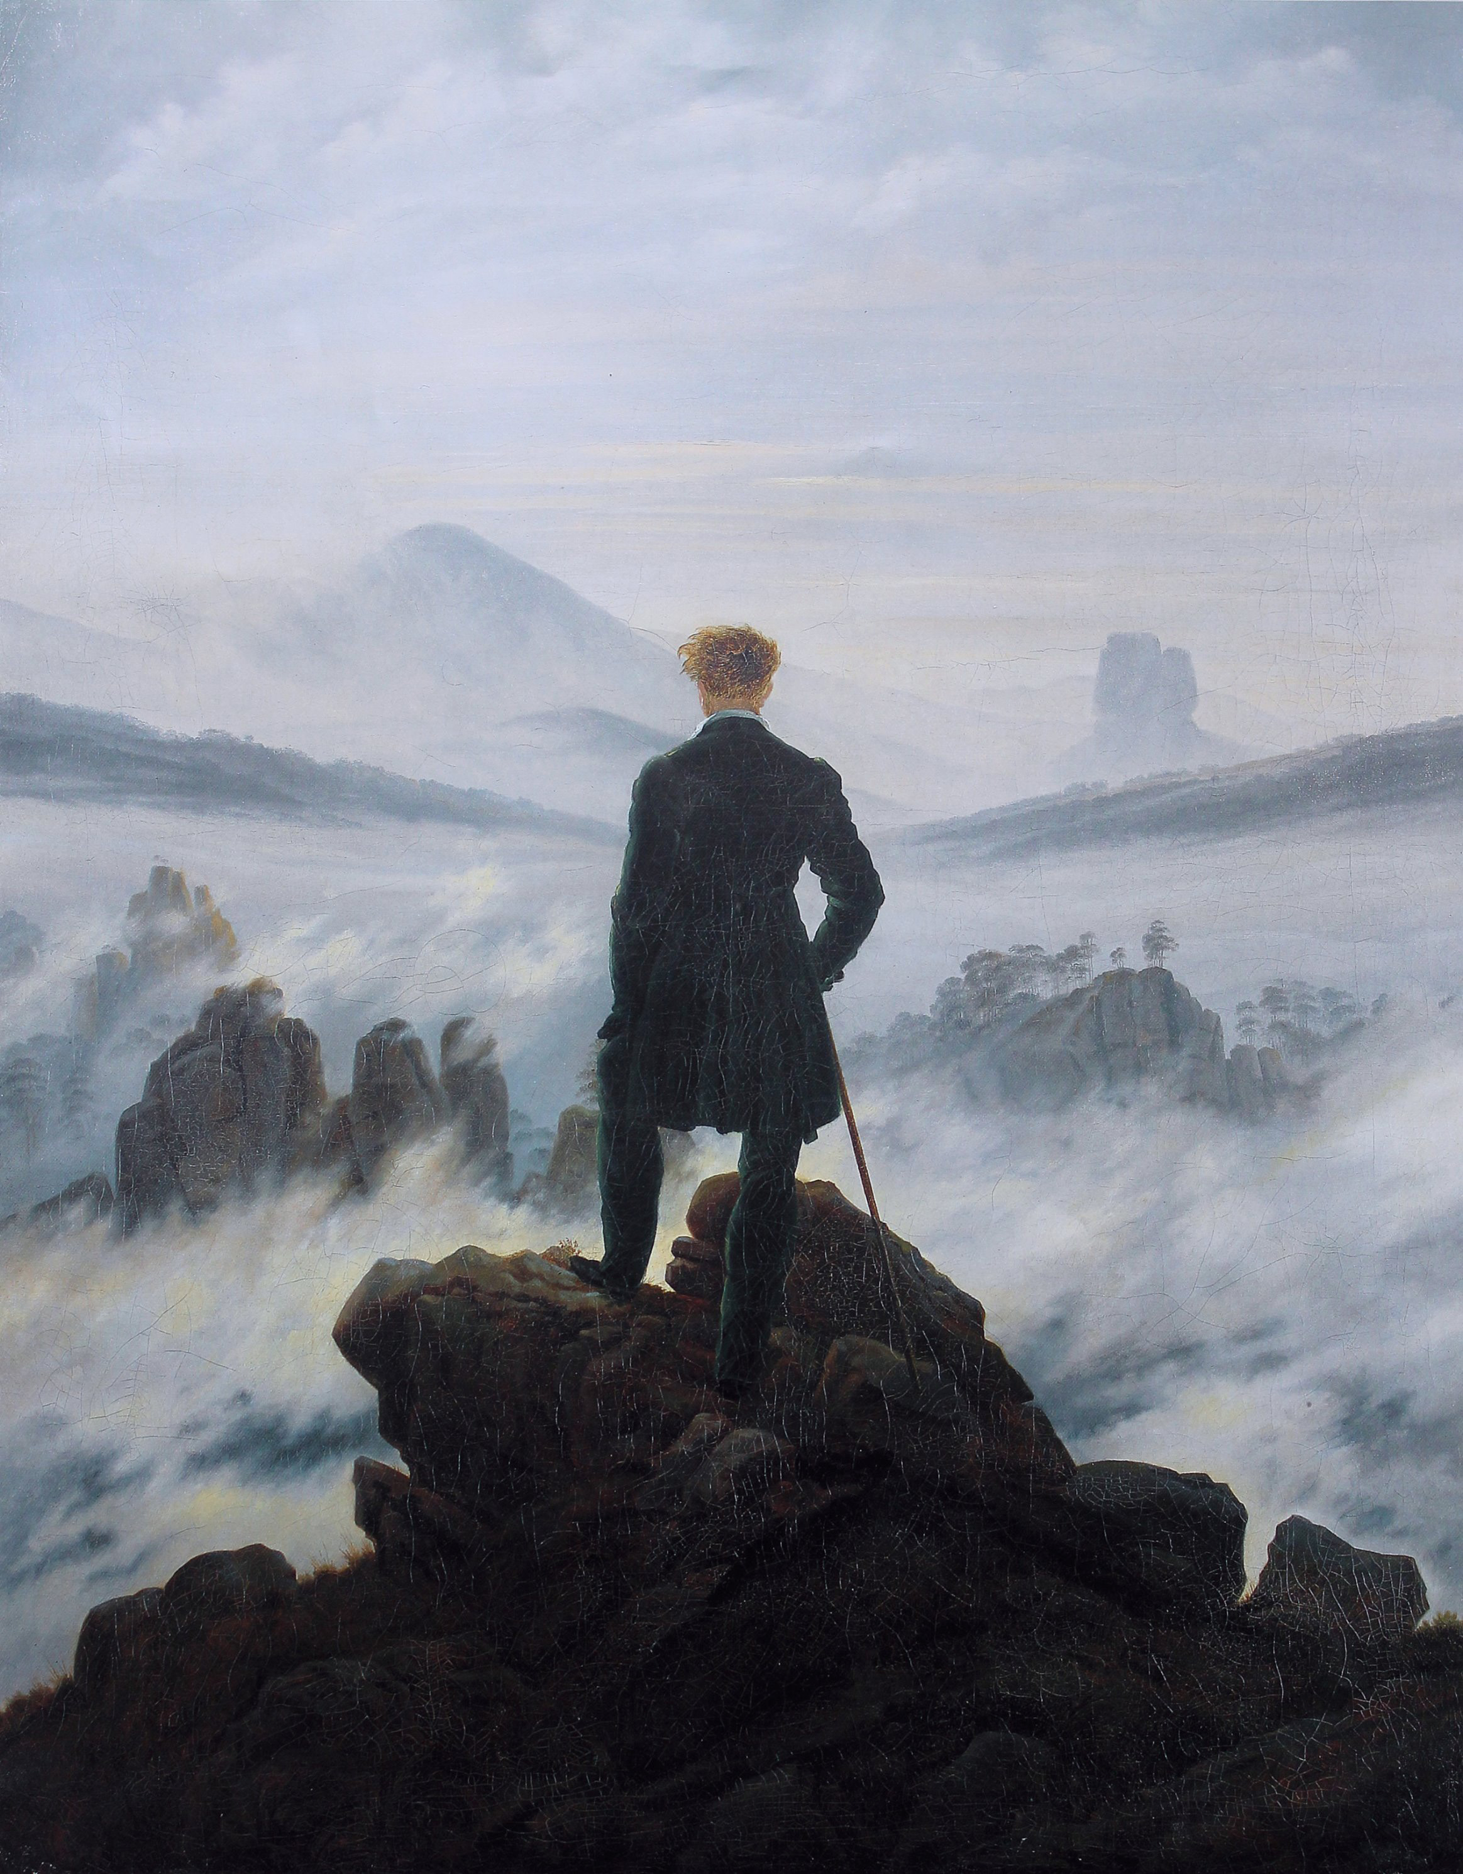So just what are the moral implications of scientific experiments? Are scientists, in their quest to unlock the secrets of the universe, violating natural law? These were the questions Shelley and her peers grappled with as the world rapidly changed around them. “Frightful must it be,” Shelley postures in *Frankenstein*’s Author’s Introduction, “the effect of any human endeavour to mock the stupendous mechanism of the Creator of the world.”