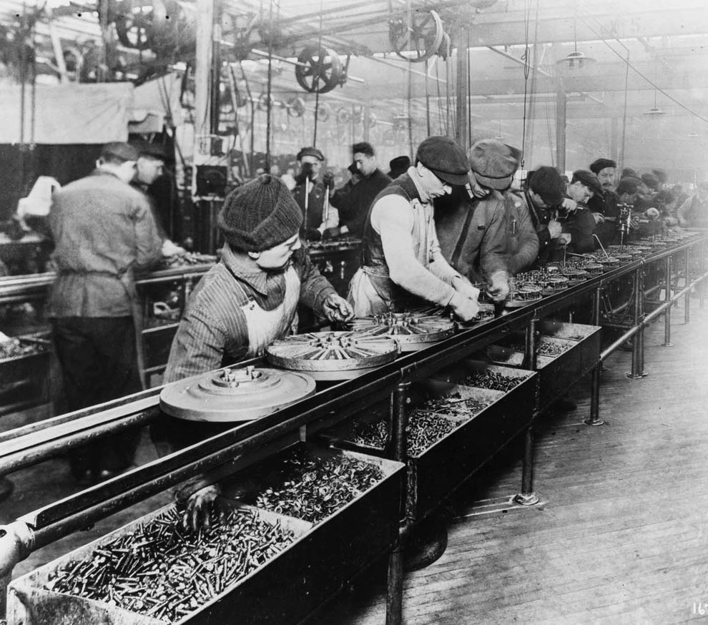
How World War I Affected the Economy
World War I broke out on June 28, 1914, when
Austria-Hungary declared war on Serbia following the assassination of Austria-Hungary’s Archduke Franz Ferdinand. While several European countries joined the war, the United States remained neutral until 1917. At the beginning of the war, the United States was in a recession, or period of economic decline. As the United States was not participating in the war, other countries relied on the United States to manufacture materials needed for the war. This fact not only contributed to the U.S. economy but also caused factories to increase efficiency by using assembly lines, which would continue to be used for mass production throughout the 1920s.

Prohibition
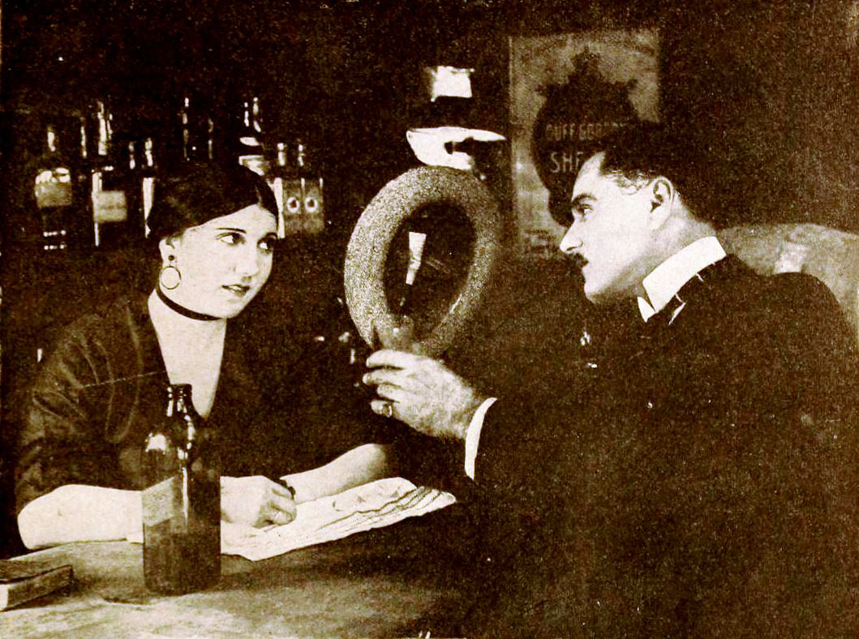
In January 1919, the U.S. Congress ratified the Eighteenth Amendment, which prohibited the manufacture and sale of alcoholic beverages. The amendment took effect in January 1920 and remained in place until it was repealed in 1933. The amendment was supported and brought about by members of the temperance movement, who promoted abstaining from liquor entirely. However, many other people used this opportunity to make money by bootlegging (making liquor illegally) and running speakeasies (establishments where people could drink liquor in secret). This way of doing business led to a great deal of criminal activity and turf wars between gangs. As evidenced in The Great Gatsby, the ban on alcohol did little to prevent people from acquiring and drinking alcohol in great quantities if they wanted to.

Consumerism
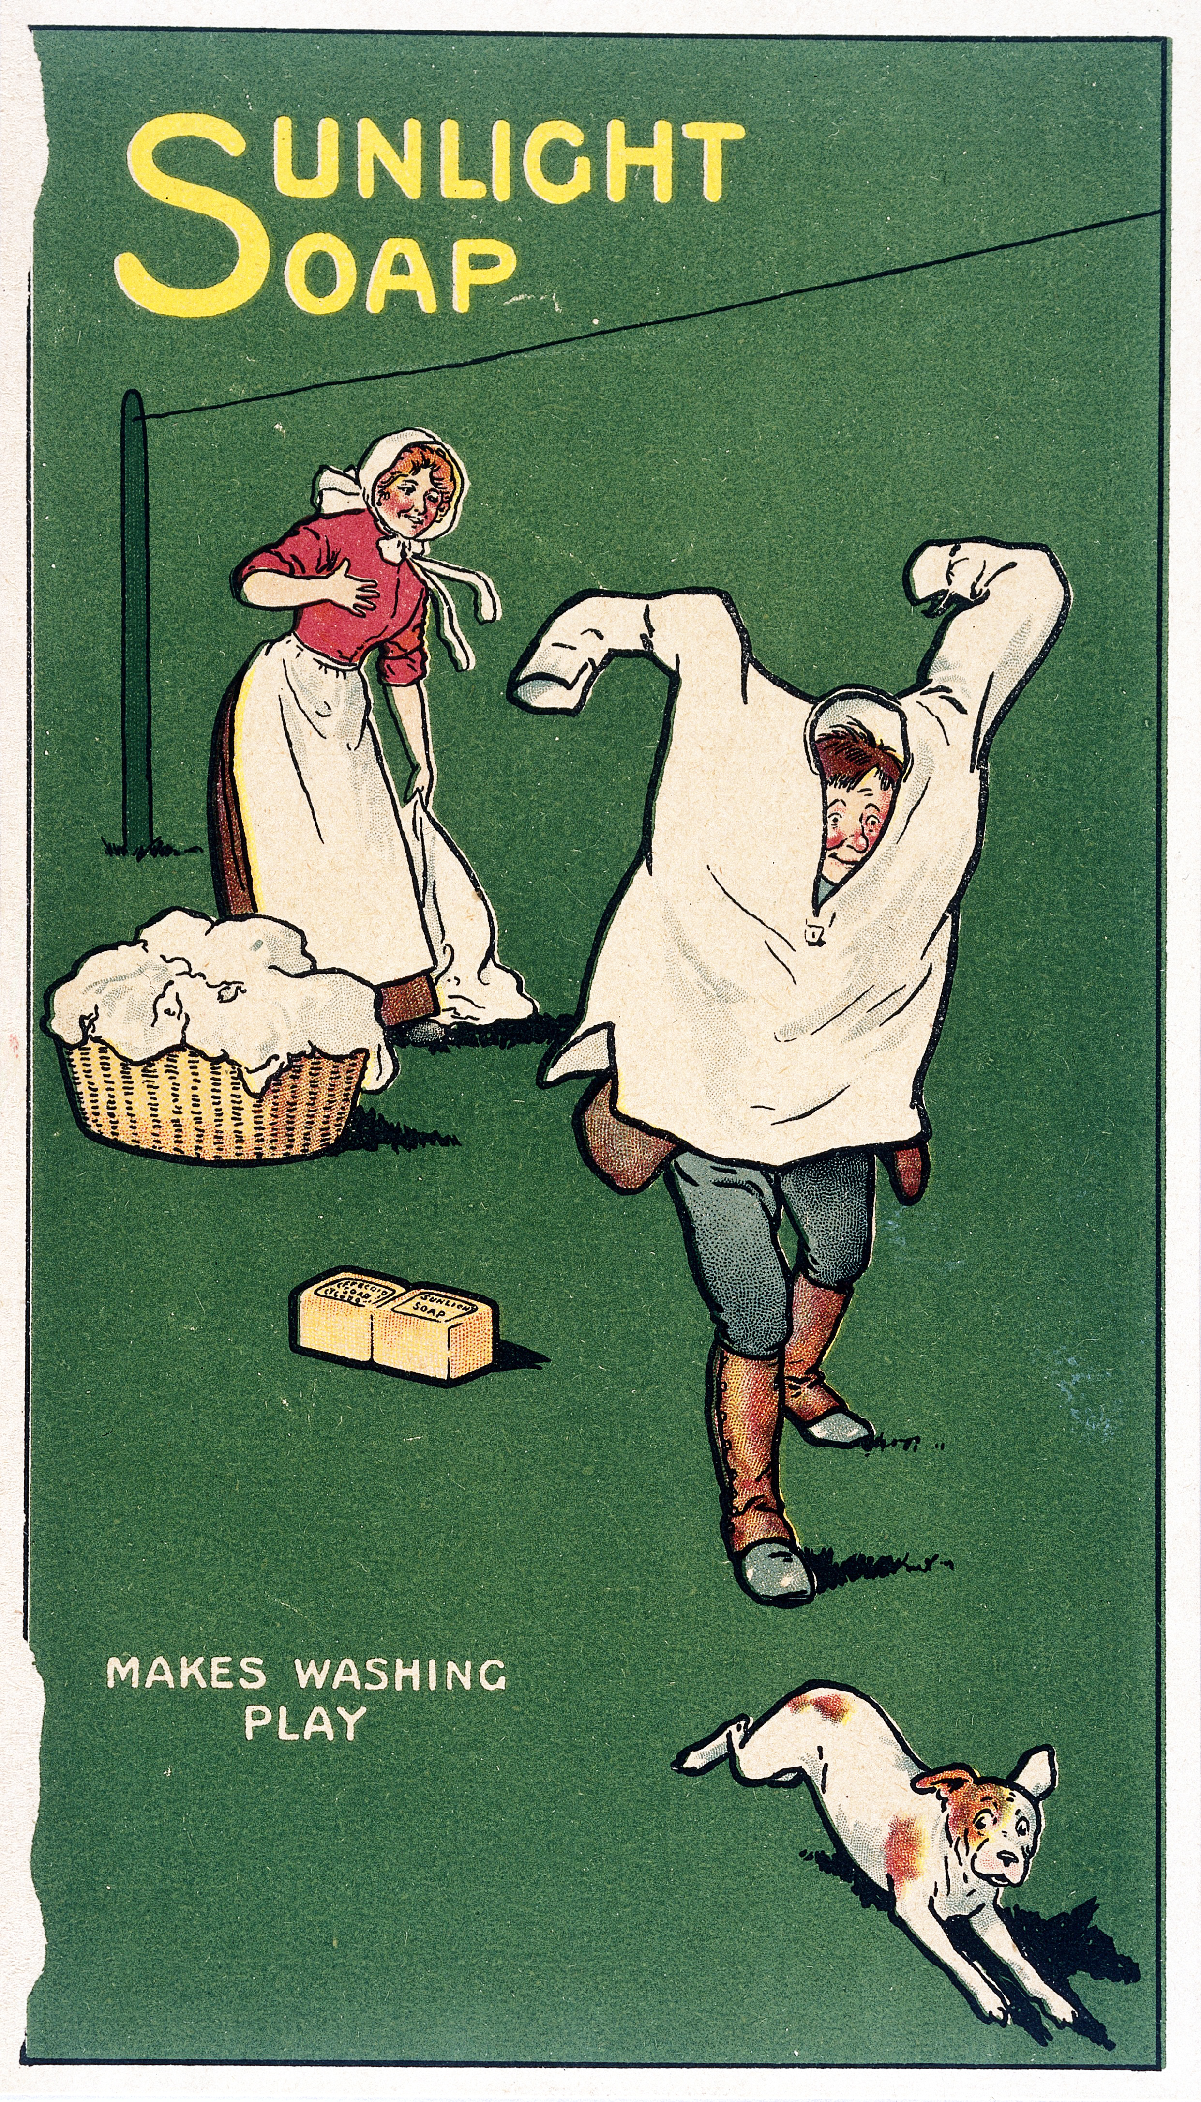
With a booming economy and plethora of emerging technology, the 1920s was the first era of consumerism. New inventions that were affordable for many families, such as vacuum cleaners and irons, made household work easier, which in turn allowed more leisure time for families. The advertising industry also took advantage of this new consumerist mindset, pushing products in newspapers and magazines as well as on the radio. People were more willing to buy on credit as opposed to being wary of going into debt. And with Henry Ford’s cars being mass-produced, automobiles were suddenly no longer a luxury. These circumstances made people like Gatsby and the Buchanans eager to show off their wealth rather than hide it.

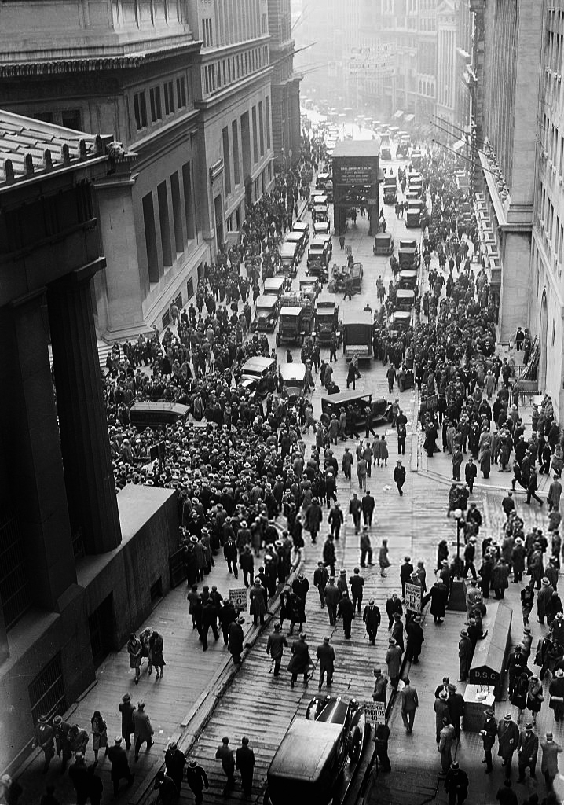
The Events That Led to the Great Depression
While many people, similar to those in The Great Gatsby, enjoyed unprecedented wealth throughout the 1920s, they did not do so without eventual consequence. People of every social class invested their savings in the stock market throughout the twenties, causing the stock market to expand very quickly. However, as wages began to stagnate and people felt the burden of debt they had taken on, consumer spending slowed down while stock prices rose. Finally, in October 1929, investors began selling and trading overpriced shares that ended up being completely worthless. The stock market crashed, plummeting the U.S. economy into a depression that would last nearly ten years.
RL.11-12.9 Demonstrate knowledge of eighteenth-, nineteenth- and early-twentieth-century foundational works of American literature, including how two or more texts from the same period treat similar themes or topics.

