
Hierarchy and Power Dynamics
Hierarchies are present in all social structures. During Shakespeare’s time and the time periods he wrote about, most civilized areas were governed by some form of hierarchical system. A king or queen sat atop the structure, usually proclaiming divine providence to justify his or her grip on power. This upper tier also included the rest of the nobles. Different noble classes held a wide degree of power and prominence, which usually depended on the noble’s family prestige and wealth. Nobility, in fact, was considered a birthright and was associated with wealth and power. Most military leaders, prominent businesspeople, and royal advisors were noble men and women. Nobles ruled and governed the lands. They made the laws and reaped the benefits of their wealth and power.
The Church, the next tier down in the hierarchy, also held a tremendous amount of power during Shakespeare’s time. Unlike the rule of law in the United States that creates a separation between church and state, the Church in the Elizabethan era held enormous political and social power. Divine authority and Christian values pervaded the morality of the day. Most people ascribed to some Christian faith, and these beliefs gave the church a distinct and palpable power over the people and even the decisions made by the ruling class.
The merchants and middle class existed on the next tier of power. Those who had acquired new wealth and had distinguished themselves and their families through the acquisition of wealth through industry grew in power, as is possible today. However, the opportunities for advancement were few, and even the wealthiest of merchants was not equal to the lowest nobleman.
At the bottom of the power structure was the working class. This class consisted of workers from the most skilled artisans to farmers. The lowest group in this class was made up of peasants and laborers, who had very little power over their own lives and often struggled even to survive.

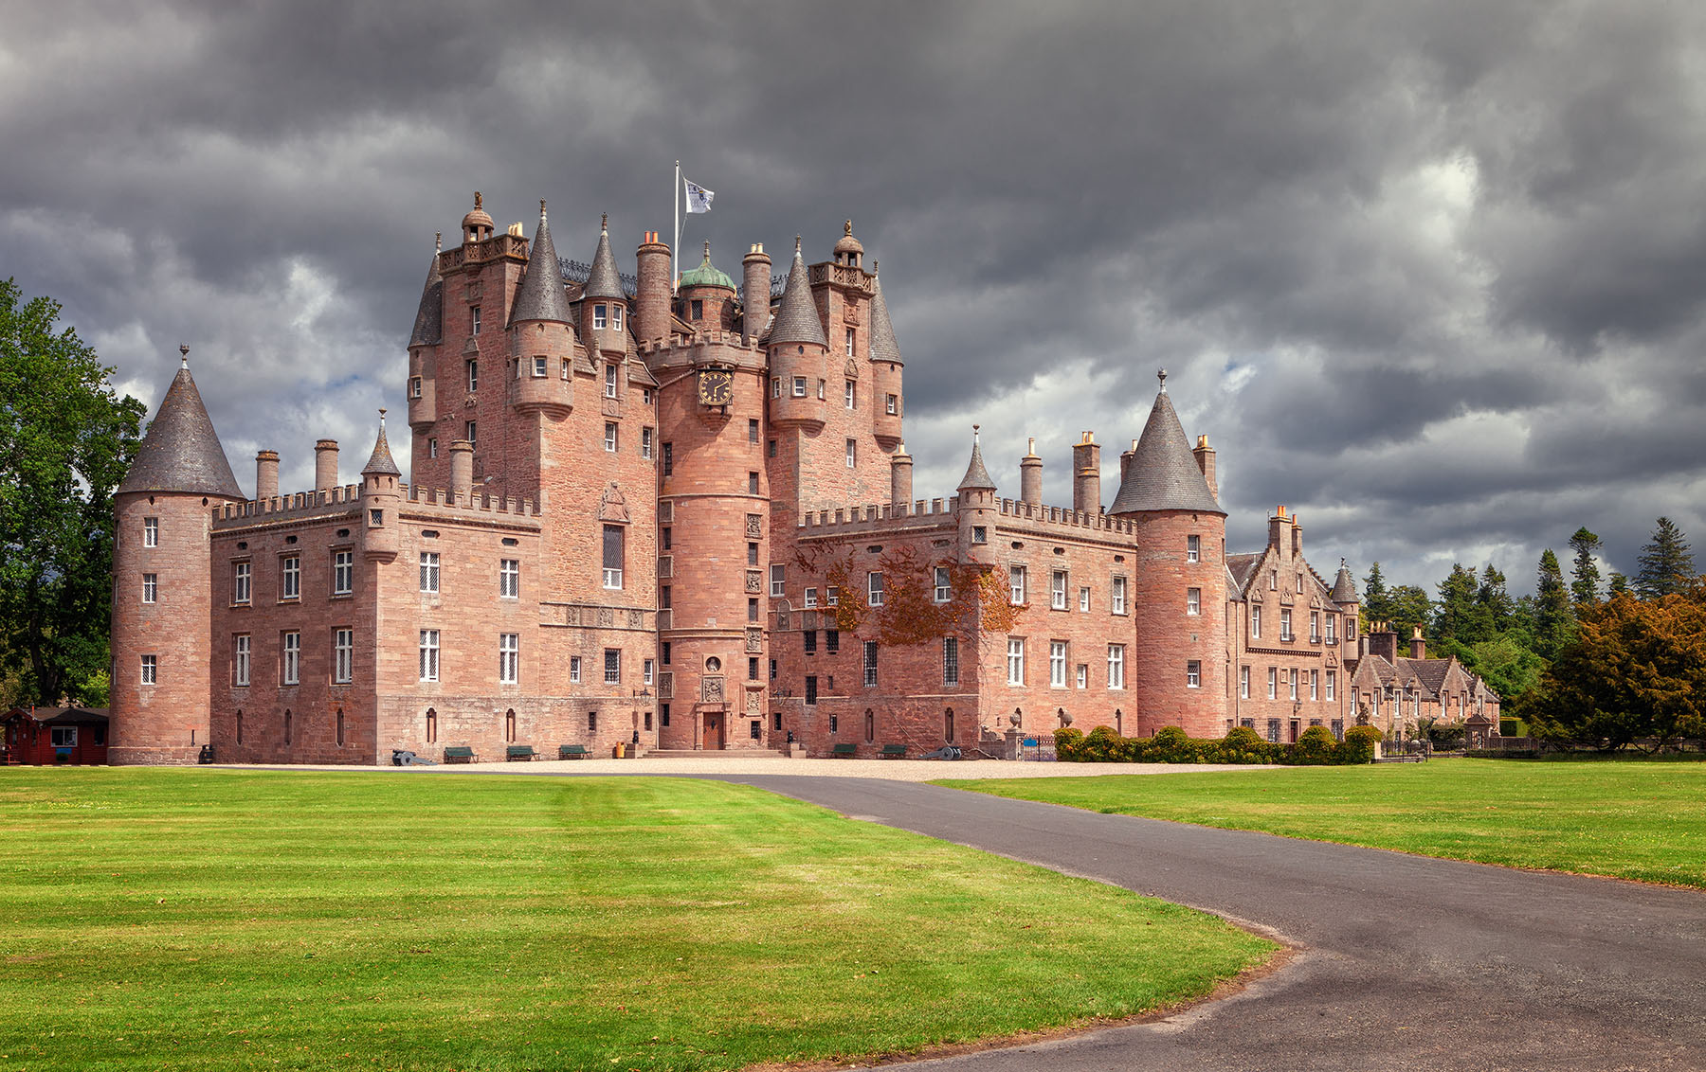
Scotland’s Feudal System: Kings,
Princes, and Thanes
Feudalism was a social system that depended on a hierarchical structure with a powerful lord at the top. The most powerful lord in a feudal region, often referred to as the king, would claim all the lands in the region as his own. Often in this system, kingship was hereditary and passed to the eldest male heir. In Macbeth, when Duncan names Malcolm the Prince of Cumberland, he declares that his son will rule Scotland after him. In exchange for military alliances and fealty, the king would give land out to the nobility to govern. The commoners had to pay homage and give their allegiances to their regional lords and, in exchange, were allowed to live on and work the land. In Shakespeare’s Macbeth, the men who held land and were loyal to the king are referred to by the title of thane. The modern equivalent of this title might be duke, baron, or governor. When the title thane was used, it also included the name of the region the lord held sway over. The traitorous Thane of Cawdor, who is executed by King Duncan at the beginning of Macbeth, would have ruled over the region of Scotland referred to as Cawdor. Macbeth is the Thane of Glamis, with Glamis referring to the area of Scotland he controls.

The Supernatural, the Devil, and Temptation
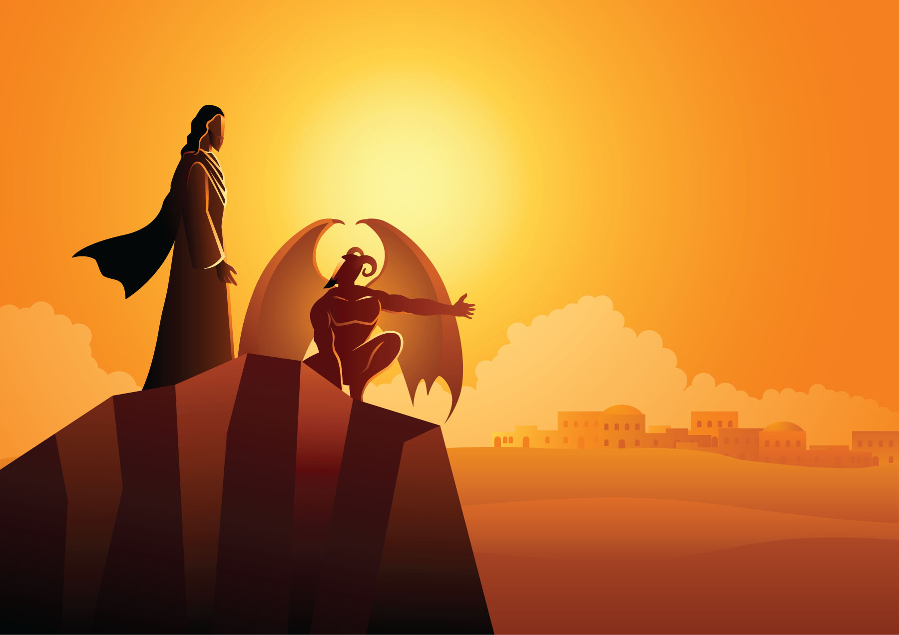
Today, science has explained, to varying degrees, many of the common wonders of and forces in the world, such as weather patterns, earthquakes, meteor strikes, droughts, diseases, and other natural phenomena. In Shakespeare’s day, many people blamed the wrath of God for disaster and disease and used superstition and a belief in the supernatural to explain what otherwise could not be understood. While beliefs in the supernatural will always be ingrained in human culture, in earlier periods, when religion rather than science was the central tool for understanding the world, the supernatural forces believed to exist were a far more tangible and real element in daily life than they are now. Today, when modern audiences see a witch appear on the stage, most will perceive the character as fictional or a caricature of evil. Yet most theatergoers in Shakespeare’s day would have equated the presence of the witches and their leader, Hecate, in Macbeth with the devil: a representation of the greatest evil and temptations of man. The predominant religious idea was that the devil was a very real creature who took on many forms in order to corrupt the human soul. Shakespeare’s audiences would therefore have directly related the presence of the witches and their temptation of Macbeth to the devil’s influence.

