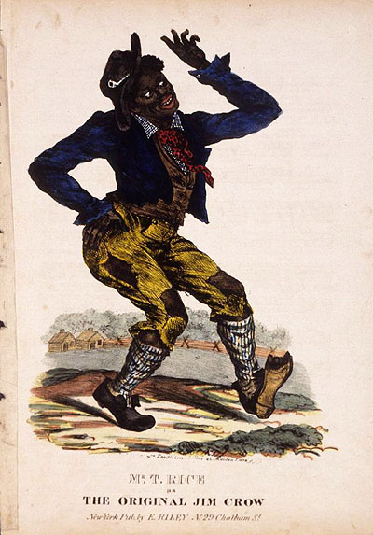
What Does the Term “Jim Crow” Mean?
After the Civil War ended in 1865 and the Emancipation Proclamation freed the slaves, the United States entered an era of optimism for African Americans. However, by the end of the 19th century, African Americans were, by law, subjugated again. The landmark 1896 decision Plessy v. Ferguson established “separate but equal” as the law of the land. African Americans were segregated, that is, separated into places apart from white citizens that, despite the letter of the law, were less equal: schools, libraries, transportation systems, restaurants, jobs, water fountains, toilets, housing, and more. Jim Crow laws got their name from a cartoon of a song-and-dance done in blackface called “Jump Jim Crow,” a mockery of African American people. Historically, this system of law was a step backward. To Kill a Mockingbird takes place smack in the middle of the Jim Crow era in Alabama, one of the nation’s southernmost states.

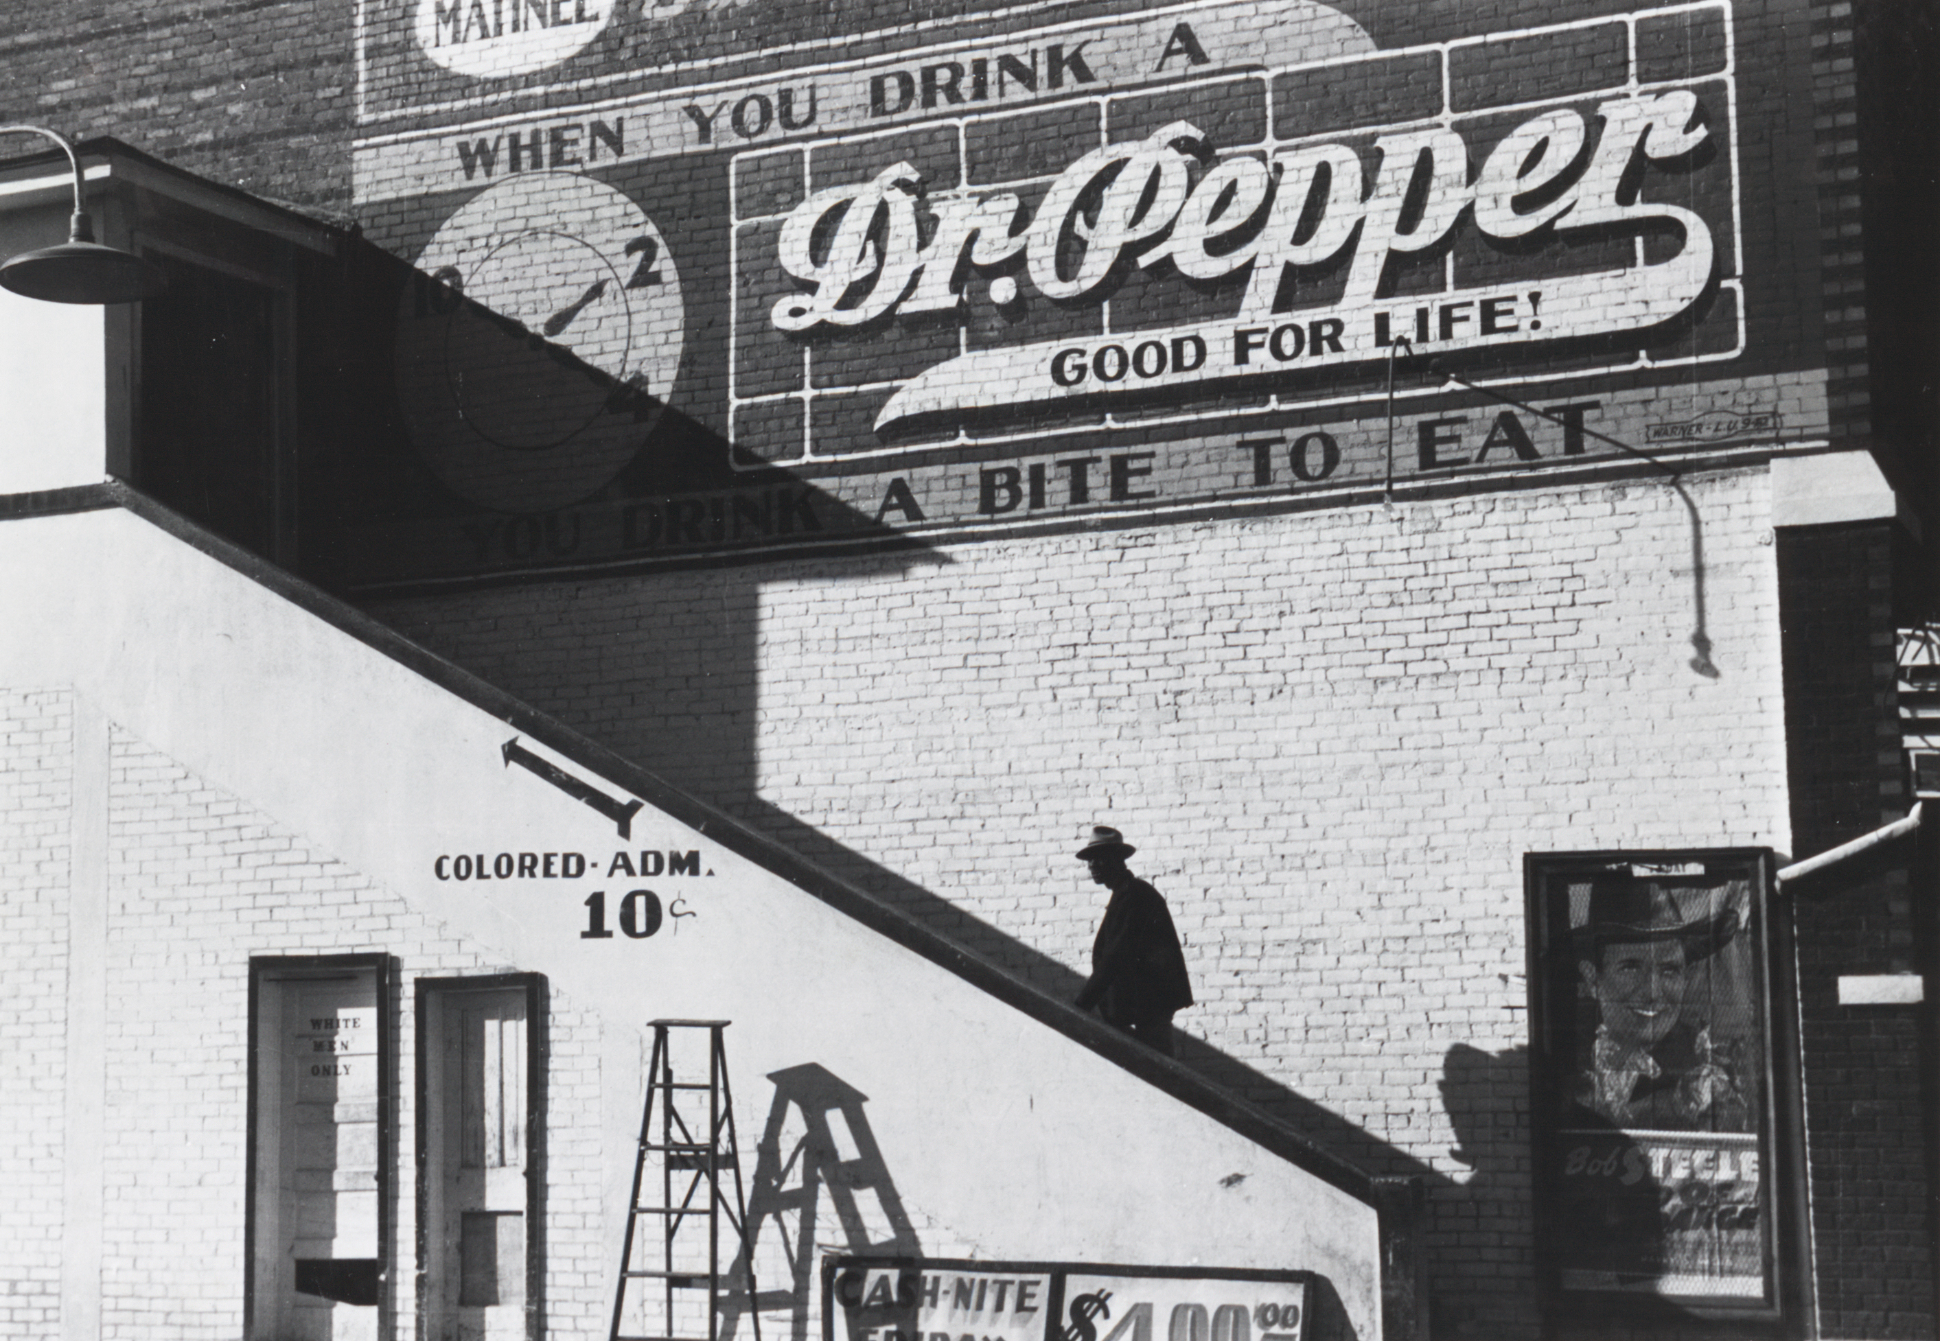
What Were the Effects of Jim Crow Laws?
From 1900 to the mid-twentieth century, African Americans, especially in the South, were restricted in many ways. Many were prohibited from voting by laws that were unfair. President Wilson segregated federal workplaces. Public schools were separated into “colored” and “white.” Everywhere there were segregated water fountains, restrooms, telephone booths, and hospitals. Railroads had cars for “blacks” and “whites.” Many African Americans were lynched and executed because local laws did not protect them. Although Jim Crow laws were unfair and unjust, they persisted for decades and took a huge social, political, and personal toll on African Americans and others who lived during these times.

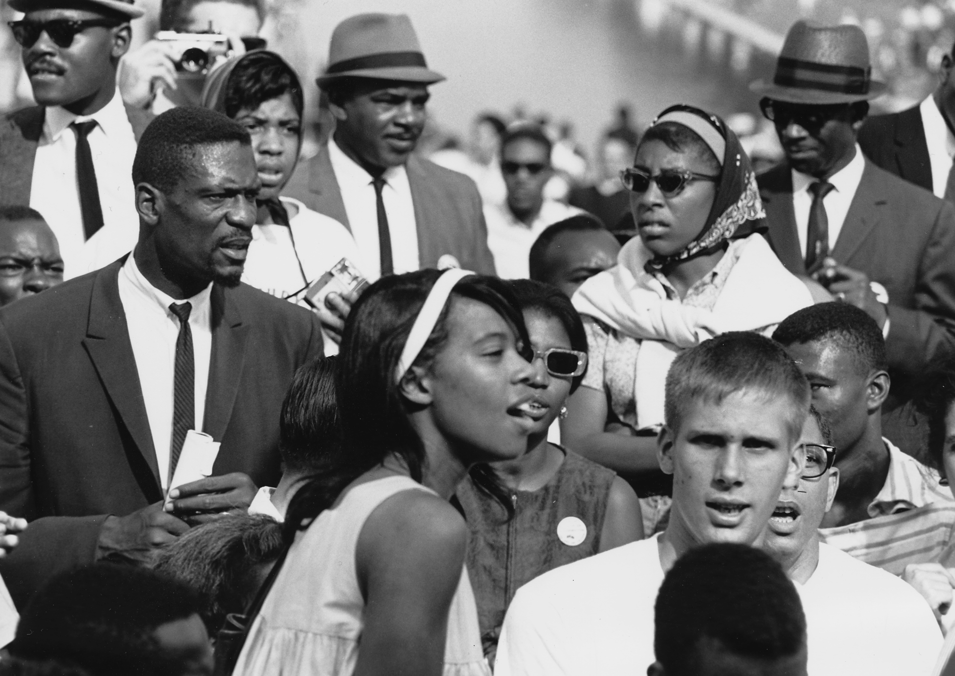
How Did Communities React to
Jim Crow Laws?
People fought back against these unjust laws. A social wave called the Civil Rights Movement gained momentum as people, both black and white, gave speeches, marched, registered voters, protested, held sit-ins, and wrote letters. In 1954, led by the NAACP and Justice Thurgood Marshall, the U.S. Supreme Court overturned the Jim Crow laws in Brown v. Board of Education of Topeka, which ruled that the laws establishing racial segregation in public schools were unconstitutional. In 1955, activist Rosa Parks refused to give up her seat on a Montgomery, Alabama, bus, which led to another wave of laws about transportation that continued overturning the Jim Crow system.

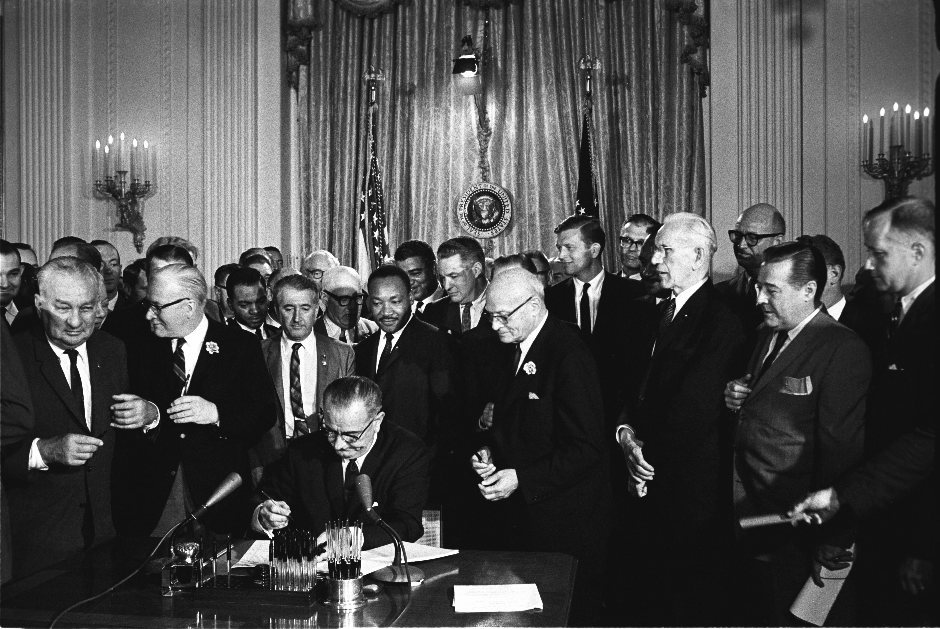
What Laws Were Passed to Protect
African Americans?
Federal law reflected the social and political wave. On July 2, 1964, President Johnson signed the historic Civil Rights Act of 1964 to outlaw discrimination in public accommodations. In 1965, the Voting Rights Act prevented states from discriminating against voters of color. In 1967, the Supreme Court ruled in Loving v. Virginia that people of different races could legally marry. Today, the United States continues to grapple with issues of prejudice and discrimination, but as Dr. Martin Luther King, Jr. reminded us, “The arc of the moral universe is long, but it bends toward justice.”

