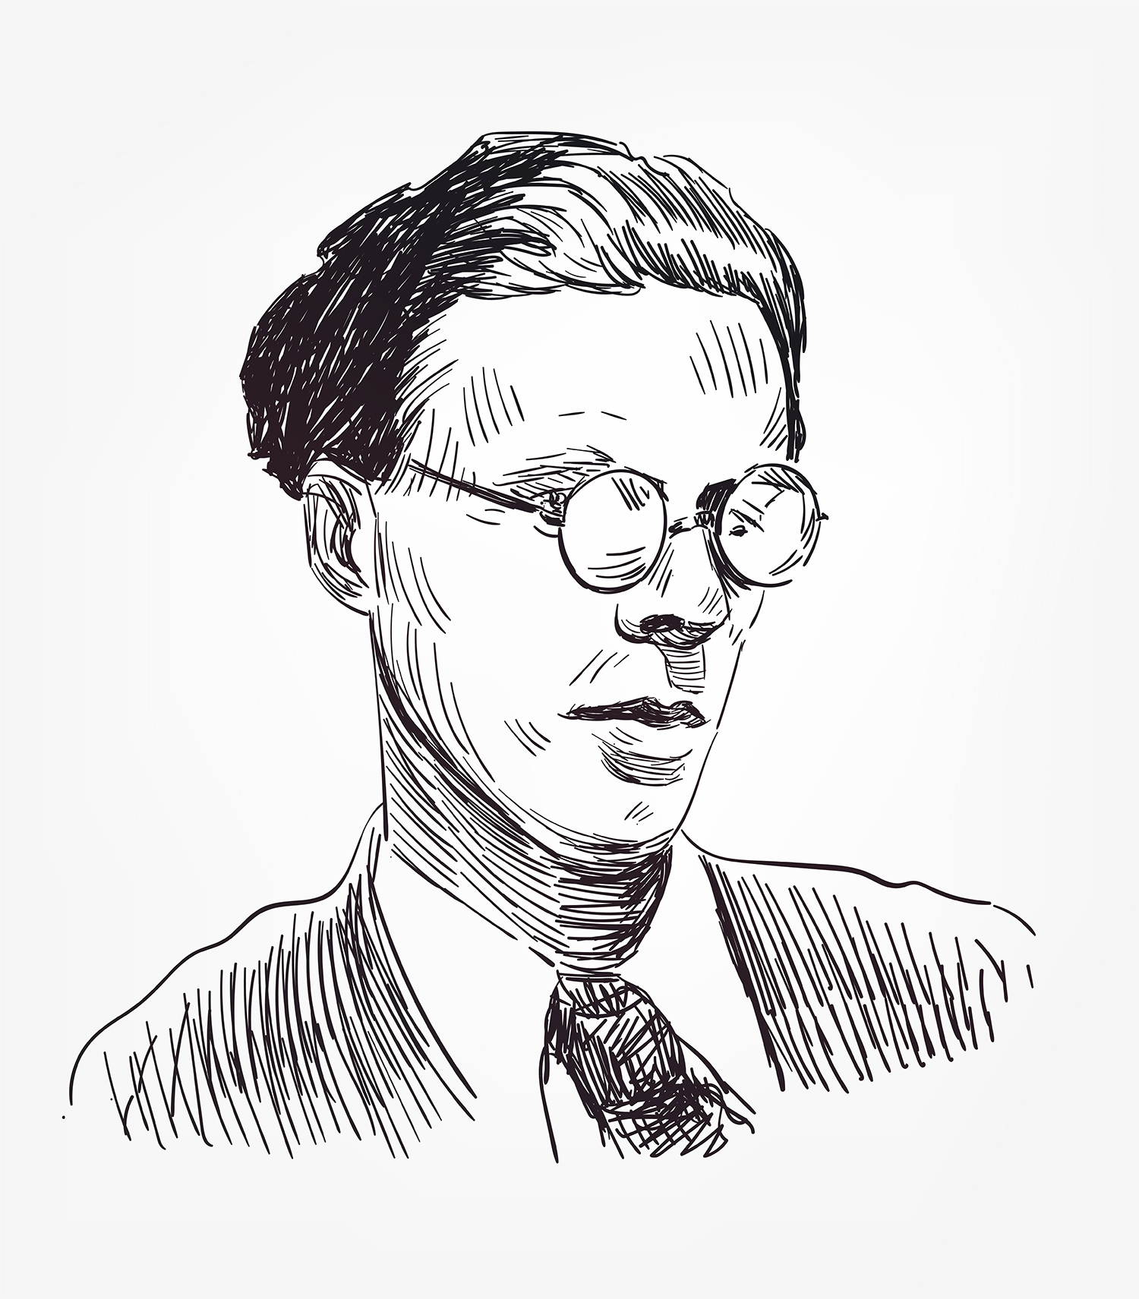
Aldous Huxley (1894–1963) set Brave New World more than five centuries into the future, but the novel satirizes Huxley’s own times. To create his satire, Huxley reasoned from the scientific and technological advances and social movements of the 1910s and 1920s to what he saw as the logical outcomes of those trends. And, in fact, many of the details that Huxley imagined for the distant future are now part of our everyday lives. In Brave New World Revisited, a 1958 work of nonfiction, Huxley admitted, “The prophecies made in 1931 are coming true much sooner than I thought they would.”

Belief in Scientific Progress
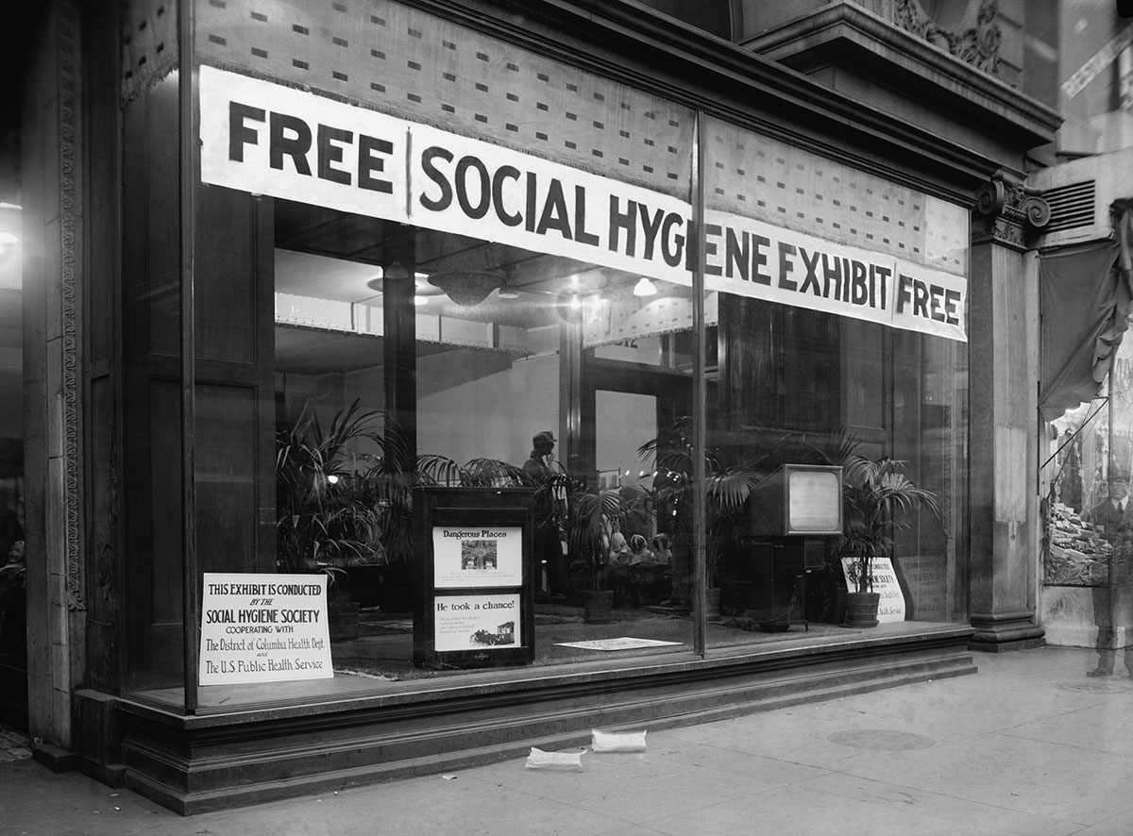
The late nineteenth and early twentieth centuries were a time of general social optimism and faith in modern science and technology. Political leaders and intellectuals in the United States, Great Britain, and other industrialized nations championed such progressive ideas as improving public health and hygiene, tightening government regulation of industry, establishing free public education, and extending voting rights to women. The horrors of World War I (1914–1918), which included chemical warfare, armored tanks, and bomb-dropping airplanes, led many people to lose faith in technology. However, the belief that scientific progress would eventually improve society persisted and is still held by many people today.

Transportation and Communications Technology

After World War I, new inventions and new techniques of mass production improved everyday life for people in industrialized societies. World War I airplane designs were adapted for civilian use. The first regular airlines appeared in France and Great Britain during the 1920s. Thanks largely to the industrialist Henry Ford, the price of automobiles dropped enough so that ordinary workers could afford them. Perhaps the most radical innovation was the radio, the first mass medium of the electronic age. By the end of the 1920s, there were radio networks in most industrialized nations, and radio assembly provided jobs for thousands of factory workers. Huxley’s futuristic World State depends on radios as well as on helicopters, television, and rockets—all cutting-edge technologies in 1931. But to modern readers, Huxley’s transportation and communications future seems almost quaint. Satellites, smartphones, and the Internet would have astounded the citizens of Brave New World.

Social Sciences
The social sciences were relatively new disciplines in the early twentieth century. Anthropology, economics, education, industrial science, political science, psychology, and sociology were struggling to establish themselves as legitimate disciplines dependent on the scientific method. The efforts of these disciplines were directed toward improvement of the human condition. But since social scientists were only human, their good intentions often led to questionable results. For example, Franz Boas, a pioneer of modern anthropology, asked the Arctic explorer Robert Peary for a live specimen of a native from Greenland. In 1897, Peary delivered six Inuit people to the American Museum of Natural History in New York. The Inuit were housed by the museum, extensively studied by Boas and other anthropologists, and hounded by the press and public. Four of the six Inuit died within a year.

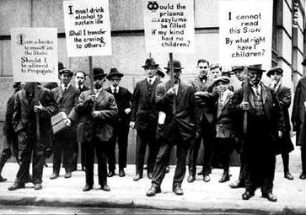
Eugenics
Perhaps the worst black mark against the early social sciences was the widespread belief in eugenics—the idea that negative human traits could be eliminated from the human race by selective breeding. Many prominent people supported the eugenics movement. More than 30 states passed laws allowing forced sterilization of the “unfit”—a category that included not only mentally ill and disabled people but alcoholics, drug addicts, and young unwed mothers. Recent immigrants and Native Americans were also forcibly sterilized, often without their knowledge. The eugenics experiments in the Nazi concentration camps of World War II were an outcome of this movement. The moral issues raised by the eugenics movement are still critical today. We don’t as yet have the equivalent of the Central London Hatchery and Conditioning Centre. However, because of modern human genetic engineering, we know that Huxley’s chilling prophecy could come true—long before 500 years from now.

