## Advances in Psychology and the Understanding of Mental Health

The question of Holden Caulfield’s mental state and his many references to potential mental illnesses in those around him brings forth the role of psychology in society during the time period of *The Catcher in the Rye*. Following World War II, there was tremendous growth in the field of psychology, specifically in the recognition of mental disease as a real health problem. Prior to this time, the U.S. military screened potential recruits for underlying psychological disorders, disqualifying many from entering the service. However, following the war’s end in 1945, hundreds of thousands of veterans still swamped VA hospitals with psychological wounds ranging from what is now called post-traumatic stress disorder (PTSD) to schizophrenia. At the time, PTSD was known as combat stress reaction or “battle fatigue” and was still misunderstood and often not recognized as a “real” condition. As a result, VA mental wards were crowded with veterans, but psychiatrists had few tools to treat them. Lobotomies, in which doctors sliced brain fibers thought to transmit excessive emotions, seemed a promising surgical solution to the VA. Doctors discovered, however, that lobotomies often erased personalities and left patients unable to care for themselves. Electroshock therapy (EST) was another common treatment for mental disease during   
the 1940s and 1950s, and while this treatment has had its ups and down with societal acceptance as a beneficial treatment, EST is still used today. Eventually, in the 1950s, antipsychotic drugs were developed and used for treating mental illness. This transformation in the field of psychology is obvious through Holden Caulfield’s experiences in this novel.

## The “American Teenager” Emerges

Holden Caulfield’s character symbolizes the “American teenager” of the post-World War II era as his character struggles with feelings of alienation while he tries to make sense of the heartless world around him. Just like Holden, many adolescents of this time period began questioning society and looking for individualism and autonomy in a changing world. This new social category and marketing niche of the American teenager emerged with tastes in music, fashion, film, and language that differed blatantly from those of the previous generation. In the 1950s, adolescence lasted a relatively short time as high schools prepared the majority of students not for college but for the responsibilities of adulthood. Therefore, the new American teenagers questioned this push into adulthood, and they moved toward an autonomous youth culture that encouraged fellow teenagers to stay youthful, delay marriage, avoid adulthood, and maintain innocence over sophistication. Holden’s experiences and choices in the novel demonstrate this new youth culture as he wavers between finding autonomy and holding on to youthfulness.

## Women Show Some Muscle

The role of women and girls in Holden Caulfield’s society also shows the transformations that emerged in post-war society. Holden often mentions wanting to protect the girls he sees from their inevitable downfall as they develop into women in a cruel society. He also seems to prefer a strong, intelligent female presence, such as his sister, Phoebe, and his friend Jane Gallagher. However, Holden also objectifies girls and uses them for companionship while judging their deficiencies. These contradictory behaviors match the conflicted view of women in U.S. society in the post-war years. After playing an important role in the nation’s workforce during the war, women were suddenly forced out of the labor market by men returning from military service at the conclusion of the war, and they were expected to return to their roles as caretakers and homemakers. Many women were frustrated by the social expectation to be an idle housewife only capable of cooking, cleaning, shopping, and attending to the children, but marriage rates still rose sharply as society tried to push women back into that position. However, symbols like Rosie the Riveter (from a campaign aimed at recruiting women workers for defense industries during WWII) stuck with the women of the post-war era as they became motivated to fight for equality.

## Innovation, Technology, and Economic Growth

While Holden Caulfield doesn’t specifically mention society’s innovations or economic growth, the disparity in social classes is obvious through his stories and experiences. Again, Holden’s post-World War II society goes through a transformation as the war stirs advancements in technology and other innovations. Following World War II, the United States emerged as one of the two dominant superpowers, becoming a global influence in economic, political, military, cultural, and technological affairs. The unmatched growth of the U.S. economy translated into prosperity that resulted in a growing middle class that moved to the suburbs and embraced consumer goods. An increasing number of workers enjoyed high wages, larger houses, better schools, and more cars and household technology. Examples of how this economic growth led to innovation include the birth of the McDonald’s fast food chain and suburban developments. When the two McDonald brothers, who had opened a drive-in restaurant in California, realized that many working families were looking for inexpensive meals served fast, they focused on assembly line hamburgers. Their innovation led to the global fast food market of today. Another family-owned business, Levitt & Sons, grew similarly as the Long Island construction company found a way to speed up concrete foundation production and preassemble uniform walls and roofs. Such innovation helped the Levitts build Levitttown, New York, an affordable, post-war suburb. The post-World War II wealth did not extend to everyone, however. Many Americans continued to live in poverty throughout the 1950s, especially older people and African Americans.

World War II also sparked scientific research and development as the war prompted the U.S. to find a way to develop more advanced weapons and to produce them faster than its enemies. Since the war demanded technological innovation, the nation’s science labs were mobilized, leading to advancements in medicine, technology, and consumer products. For example, medical researchers produced new antibiotics and discovered how to mass-produce penicillin while also finding a way to perform blood transfusions on the battlefield. Consumer products like televisions and air conditioners were improved, and the computer, first introduced at MIT in 1942, was enhanced. Plastics, frozen food, and microfilm were also developed as solutions to war-time shortages but became dominant products in a growing consumer-driven society.

## Early Days of the Civil Rights Movement

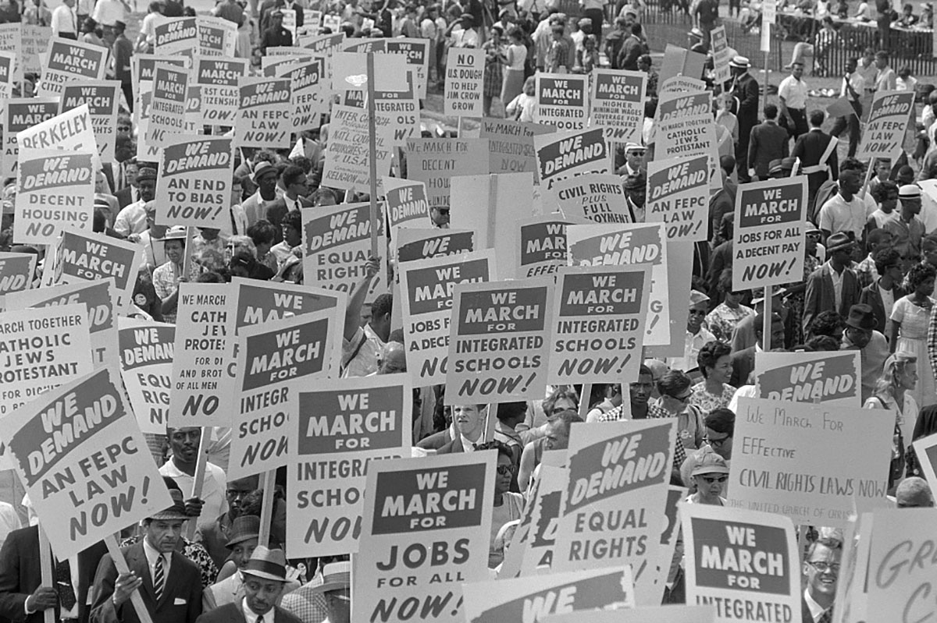While Holden Caulfield references race in some of his dialogue in the novel, the actual lack of diversity in his world demonstrates the racial discrepancies in his 1950s society. Even though Holden feels alienated, he ultimately exists in a very privileged and affluent world in which his parents can continue to send him to new boarding schools despite his struggles. However, many Americans did not live this way; rather, they lived in poverty throughout the 1950s, especially older people and African Americans, the latter of whom continued to earn far less on average than their white counterparts. Immediately after the war, returning veterans needed work, and in many cases, they could not find jobs. Racial tensions rose as African Americans who had taken jobs during the war were now faced with returning white veterans who demanded that they step aside.