## How Puritanism Influenced the Trials

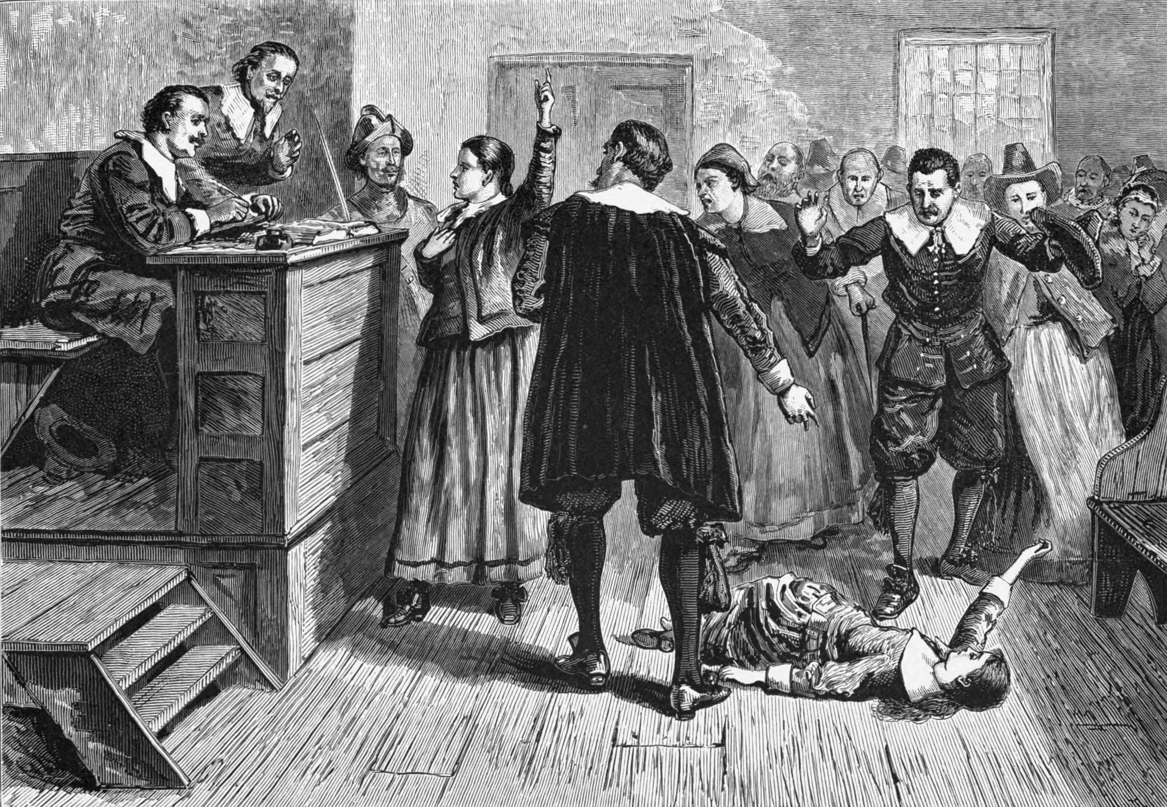Arthur Miller based his play *The Crucible* on the true events of the Salem witch trials that took place between 1692 and 1693. Two hundred people were accused of witchcraft, and nineteen of them were found guilty and hanged. The Puritans’ beliefs contributed to these events.

For Puritans, religion was the most important aspect of their lives. They came to America looking to escape religious intolerance, but in the name of God’s salvation, they became intolerant of difference. In the Massachusetts Bay Colony, church and government officials were one and the same. In addition, those who made the laws enforced the laws. Gambling, adultery, and even kissing a spouse in public were strictly forbidden. Someone could be fined for frequently missing church or celebrating Christmas, which the Puritans viewed as a pagan holiday. Children were expected to be hardworking, modest, and pious.

The New World was harsh, dangerous, and unpredictable. The Puritans’ belief in the supernatural served as a way for them to make sense of what happened around them. They read the events of their lives as signs of God’s providence, like rain for their crops, or as signs of the devil, like a rabid animal or the tragic loss of a child. They believed that those who had pledged their loyalty to the devil had the power to harm others. Women and children were thought to be particularly susceptible to witchcraft. Being a witch was considered a capital crime in Massachusetts punishable by death.