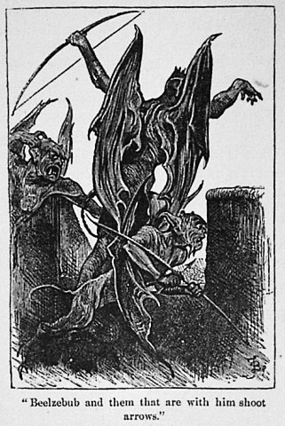Works of literature often make allusions, also called references, to other stories or information. Biblical references are particularly common in literature. Knowing some of these references can add to your understanding of a literary text like *Lord of the Flies*.

## What’s in a Name?

As well as the title of the book, “Lord of the Flies” is another name for the pig’s head in the chapter “Gift for the Darkness.” “‘You are a silly little boy,’ said the Lord of the Flies, ‘just an ignorant, silly little boy.’” “Lord of the Flies” may be an allusion to the demon/devil Beelzebub (or **Baalzebub)**, who is referred to as “the prince of demons” or the devil. As Beelzebub was able to fly, he was sometimes also called “Lord of the Flyers” or “Lord of the Flies.”

## Paradise Lost

The island setting in *Lord of the Flies* is described   
as a paradise in the first chapter of the book. Paradise recalls the Garden of Eden in the Book   
of Genesis in the Bible. This allusion to the Garden of Eden brings up the story of Adam and Eve, who in Judeo-Christian and Islamic traditions were the first humans. Adam and Eve lived innocently in the Garden of Eden until the devil, in the form of a serpent, tempted Eve to go against God’s orders and eat from the tree of knowledge of   
good and evil. After Adam and Eve ate from the forbidden tree, they lost their innocence.   
God punished them for going against his commands by exiling them from the garden. This event is often called “the fall of man” and is the source, in Christianity, of original sin.

## Simon the Saint?

A saint is considered an especially holy, good, and morally perfect person. The word *saint* comes from the Latin *sanctus*. When Simon was washed out to sea at the end of the chapter titled “A View to a Death” in *Lord of the Flies*, the phosphorescent animals, described as “strange, moonbeam-bodied creatures with fiery eyes,” surrounded his dead body “and dressed Simon’s coarse hair with brightness.” This description recalls the image of a saint’s halo. The halo can suggest that Simon is saint-like for being killed while trying to bring the truth about the beast to the other boys.