Twain’s Views on Slavery
“In my schoolboy days I had no aversion to slavery,” wrote Mark Twain in his autobiography.
“I was not aware that there was anything wrong about it.” Twain’s boyhood home, Hannibal, Missouri, is the opening setting of The Adventures of Huckleberry Finn, and Twain’s characters share the viewpoint of his youth. At the time of the novel, the 1840s, slavery was part of ordinary life in Missouri.

Missouri, a Slave State
The founders of Missouri were firmly in favor of slavery. Many Missouri pioneers had emigrated from Southern states, bringing their slaves along to clear and work new lands. They petitioned for statehood as a slave state, even though Congress had forbidden slavery that far north. The Missouri Compromise of 1820 allowed Missouri to join the Union and keep its slaves.
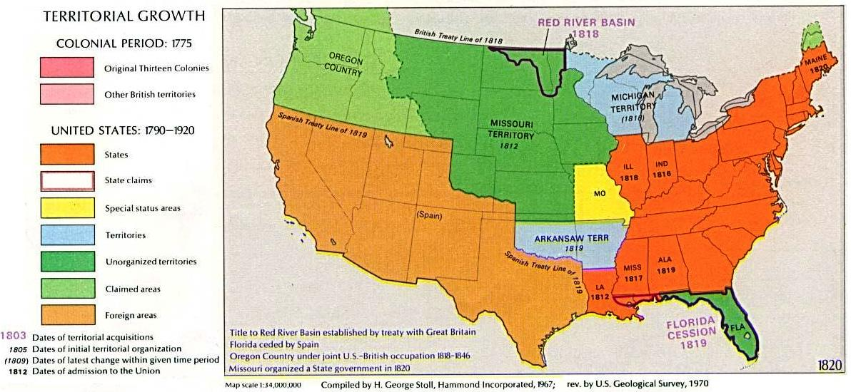
Missouri had fewer large plantations than states farther south, and most white people did not own slaves. However, it was common for farmers
and middle-class town dwellers to own a few slaves or hire slaves as part-time help, paying their owners for their time.

River Routes to Freedom
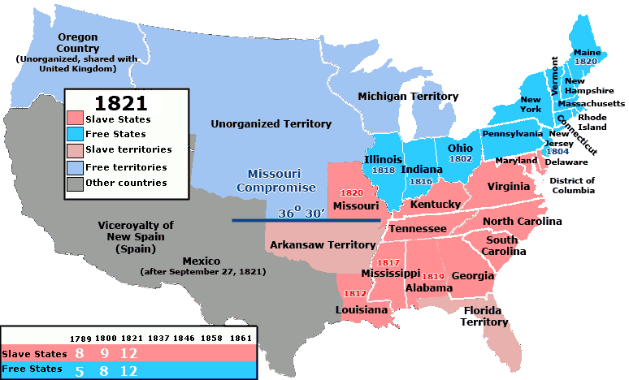
Missouri was surrounded
on three sides by free states and territories. On its eastern border, only the Mississippi River separated Hannibal, Missouri, from Quincy and other Illinois towns with abolition supporters.
But a slave did not become free just by crossing into a free state. Some citizens of free states favored slavery. Some of those who opposed slavery still felt they should follow the law and return escaped slaves to their owners. Bounty hunters tracked slaves who had run away.
The southern part of Illinois, often called Egypt, was especially sympathetic to slave ownership. To avoid Egypt, slaves could go down the Mississippi to Cairo, Illinois, and then travel by steamboat up the Ohio River. There were several escape routes from the Ohio River across the Great Lakes and into Canada. Only by reaching Canada could a slave legally become free.

River Routes to Captivity
Down the Mississippi River from Hannibal lay the city of St. Louis, and below St. Louis lay the cotton regions where the harshest forms of plantation slavery flourished. Some large plantations had hundreds of slaves. The high demand for slave labor tempted slaveholders in Missouri, Kentucky, and Tennessee to send their slaves to markets in New Orleans. Some owners sold slave children to avoid the expense of raising them.
Even under relatively kind masters, slaves always faced the
threat of being “sold downriver.” Like Jim in The Adventures of Huckleberry Finn, many slaves took the risk of escaping rather than submitting to what they knew would be a cruel fate.

Steamboats and Slavery
Steamboats transformed the economy of the Western frontier—and all the land west of the Mississippi River was the frontier before the Civil War. Steamboats allowed planters to move west along the rivers of Louisiana and Arkansas in order to open new cotton plantations. Steamboat transportation itself also demanded extra slave labor: cutting, carrying, and loading wood and coal and loading and unloading baggage.
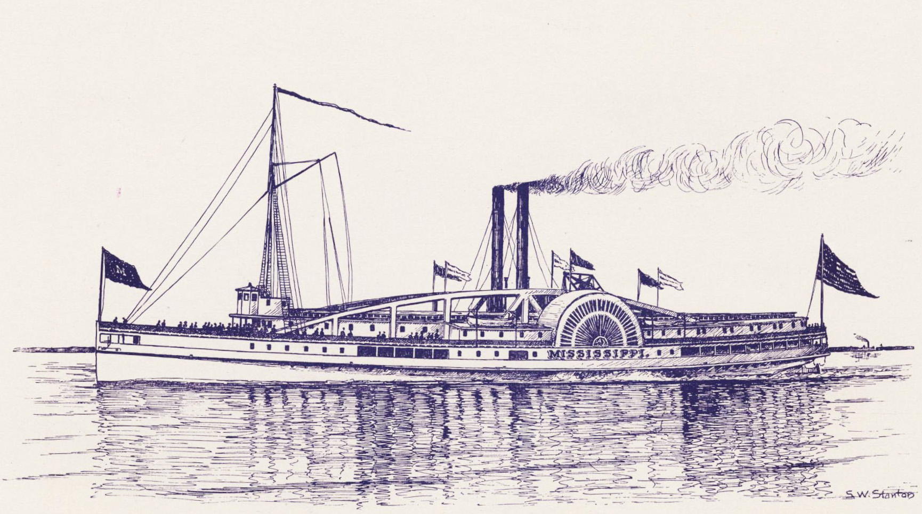
Steamboats also presented new opportunities to escape from slavery. The large numbers of black people on and around steamboats and steamboat landings provided excellent cover for runaway slaves. Some free black people who worked as porters and waiters on the steamboats also served
as conductors on the Underground Railroad.

