## Julius Caesar: Fact Versus Fiction

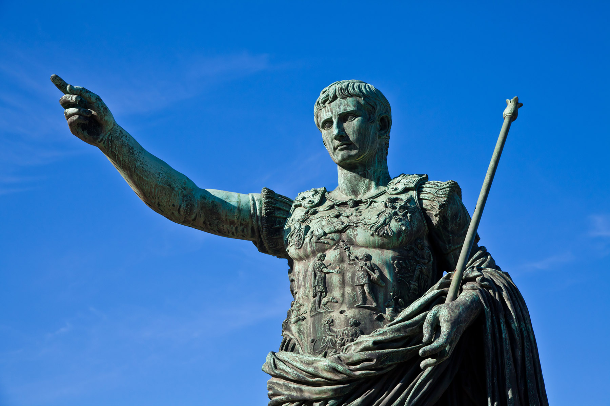Shakespeare is well known for his historical plays; however, there are distinct differences between historical fact and historical fiction. Often, before authors write about historical events, they must first distill a large set of facts or even reshape some events in order to fit them into the concise framework of a play, novel, television show, or movie. Many times, the more important or odd details used by a writer to tell about a historical event, such as the manner of Julius Caesar’s murder, are the details that convey the historical truth, while the smaller, mundane interactions, such as conversations or a character’s thoughts and reflections, are entirely fictional.

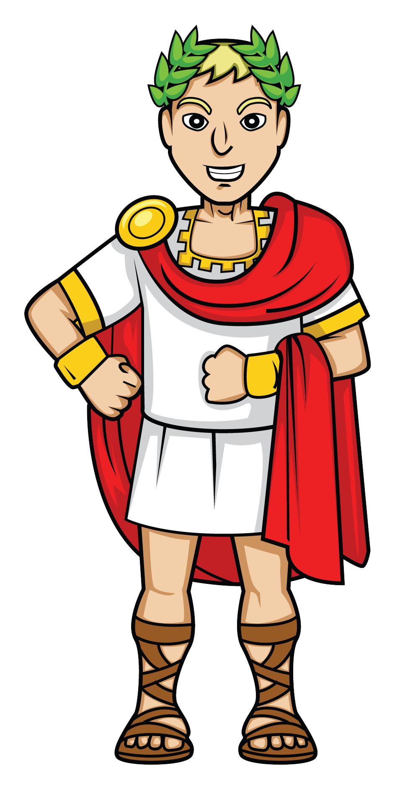Shakespeare shaped his historical dramas to fit into the five-act framework of his plays. To do so, he would often conflate ideas and/or characters or shorten timelines to fit his dramatic purpose. For example, the opening of *Julius Caesar* depicts the commoners celebrating Caesar’s defeat of Pompey during the Feast of the Lupercal. Yet historical records reveals that these two events happened at different times. Caesar’s return to Rome after his defeat of Pompey is recorded to have occurred in September of 45 BC, with a celebration occurring shortly thereafter. The celebration of Lupercalia, however, occurs every year between February 13 and 15 and, therefore, would have been held several months after Caesar’s triumphant return to Rome. Shakespeare also abbreviates the time between Caesar’s murder and Antony’s funeral speech. In the play, Antony’s oration is given mere minutes after Caesar’s death, while historical accounts present the reading of Caesar’s will three days after his death on March 18.

Shakespeare also condenses the Battle of Philippi into a single encounter, while historical records reveal that there were two separate battles—the first battle was between Antony and Cassius, while the second was against Brutus and occurred several weeks later. However, some of the smaller details of the battle presented by Shakespeare, such as Cassius’s suicide due to a miscommunication during the battle, do align with historical records.

Another historical discrepancy between Shakespeare’s *Julius Caesar* and the historical record is the location of Caesar’s murder. In Act 3, Shakespeare places Caesar in the Capitol when he is stabbed and ironically falls dead at the base of a statue of Pompey, his greatest enemy. Yet historical records reveal Caesar’s murder occurred (still ironically) at the Curia of Pompey. One of the more famous and contentious historical divergences is related to Shakespeare’s portrayal of Caesar’s last words, “Et tu, Brute?” (Latin for “And you, Brutus?”). While some historical documents suggest that Caesar may have died saying, “And you, child?” to Brutus, there is no concrete supporting document that suggests what, if anything, Caesar said before he died.

Shakespeare’s plays are filled with omens and predictions. In *Julius Caesar*, a comet is seen in the sky prior to Caesar’s murder. This comet operates as an omen, foreshadowing the death of the greatest man in Rome. However, Caesar’s comet is another conflated historical event. While a comet *did* appear in the sky in 44 BC, it appeared nearly four months *after* Caesar’s murder. Coincidentally and perhaps ironically, the comet’s appearance *did* coincide with a festival held to honor the life of the great Julius Caesar. Many Romans believed that the comet was Caesar’s soul and that Caesar had become a god and was taking his place in the heavens.

## Rome: Empire Versus Republic

In 509 BC, Marcus Brutus’s ancestor (also named Marcus Brutus) helped to overthrow the Roman Empire’s tyrannical king, Lucius Tarquinius Superbus, and, influenced by Greek governmental structures, create the Roman Republic. The Republic consisted of three branches of government: Consuls, the Senate, and the Assembly. The executive functions of government in the new Roman Republic were held by two men who were referred to as consuls. Each man held the power of a king; however, the position lasted for only one year. Each consul had the power to veto the decision of the other as a sort of check-and-balance system. At the end of their terms, the consuls became senators.

The Senate functioned in an advisory capacity. During the Empire, senators were appointed by the king and operated as his advisors. During the Republic, senators were appointed by and advised the consuls and often served for life.

The Assembly was responsible for electing consuls and rejecting or approving laws and sometimes aided in making decisions regarding war. When in great need, Rome could elect one of its consuls to become dictator. This position was considered temporary until Julius Caesar was made dictator for life. The downfall of the Republic began with Julius Caesar’s civil war with Pompey and, subsequently, Caesar’s murder, followed by more civil strife between former allies Octavian Caesar and Mark Antony. It was Octavian’s defeat of Mark Antony and his lover Cleopatra, Queen of Egypt, that ultimately led to the Senate declaring Octavian the first Roman emperor in 27 BC, and it is this event that marked the end of the Roman Republic.