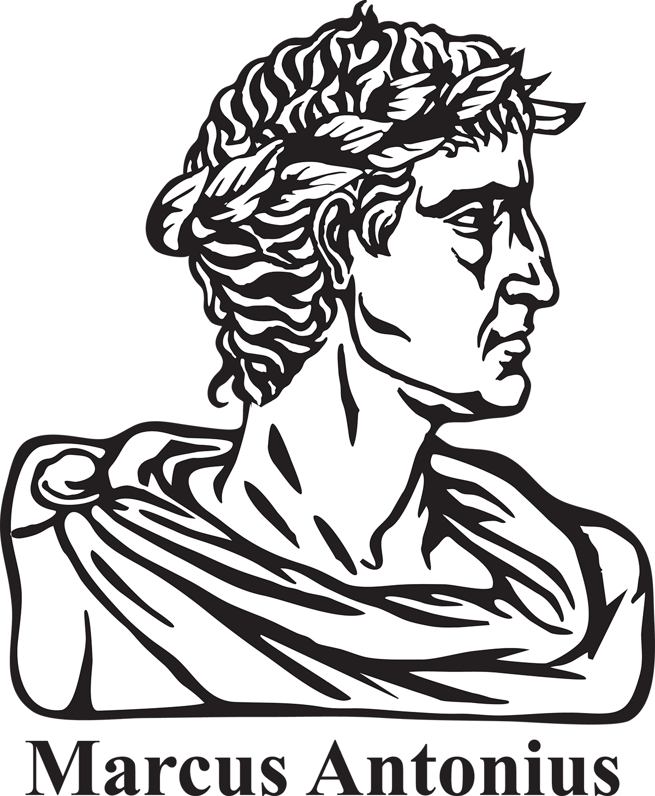After reading Act3,scene 2, in *Julius Caesar*, review the list of rhetorical devices and appeals below. Choose three devices, find examples of each in Antony’s speech, and complete the chart.

**anecdote:** a short yet purposeful story about an event or person; anecdotes are used as examples to illustrate a point that is made in an argument.

**ethical appeal:** an appeal to character and credibility; ethical appeals focus on status, authority, and the general credibility of the subject.

**irony**: an incongruity or discrepancy between appearances and reality.

**verbal irony:** occurs when someone says one thing but really means something else.

**logical appeal:** an appeal that focuses on the reasoning behind an argument; often includes factual details and concrete evidence.

**pathetic appeal:** an appeal designed to provoke a particular emotional response among the audience members; used to sway people’s opinions.

**priming:** indirectly suggesting a course of action; subtle planting of ideas to lead the audience to a particular intended action.

**repetition:** the repeating of words and/or ideas in order to reinforce a point.

**rhetorical question:** the speaker asks a question but doesn’t intend for it to be answered; rhetorical questions are always leading questions that suggest one correct or possible answer that is aligned with the speaker’s purpose.

Use your completed chart to respond to the following writing prompt.

*Review Antony’s funeral speech from Act 3, scene 2, in* Julius Caesar*. Write an essay with a clear thesis and two well-developed body paragraphs that identifies and analyzes how Antony uses four rhetorical strategies to persuade his audience that Caesar was not ambitious as Brutus claimed but a good leader who loved the people. You must include at least four properly cited quotes in your essay to support your ideas. Each paragraph should focus on two rhetorical strategies, explaining how each is utilized by Antony in order to promote his argument.*

|  |  |  |
| --- | --- | --- |
| Rhetorical Strategy/Device | Textual Example | Rhetorical Purpose: Briefly explain how the device is intended to affect the audience. |
| anecdote | “You all did see that on the Lupercal / I thrice presented him a kingly crown, / Which he did thrice refuse. / Was this ambition?”  (No Fear: 3.2.94–96) | Antony describes how Caesar refused to accept the crown from Antony when it was offered to him on the Feast of the Lupercal, an act that was publically witnessed by the thousands in attendance. He describes this refusal in order to contradict Brutus’s claim that Caesar was ambitious. Antony’s logic is that if Caesar wanted to become emperor, he would have accepted the crown when it was offered to him rather than refusing it on three occasions. Antony uses this anecdote to give hard evidence to the audience to convince them of his point of view. |
|  |  |  |
|  |  |  |
|  |  |  |