With a small group, you will explore the attributes of one of the main characters in Shakespeare’s *Julius Caesar* (Caesar, Antony, Brutus, or Cassius) by creating a symbolic character diagram that includes the character’s thoughts and most important actions, excerpts from his most relevant and defining speeches, and what others say or think about him.

**Step 1—Create a Portrait:** First, your group must create a visual portrait of the assigned character as the basis of this project. You can use an art program or draw the portrait by hand. The portrait can show what the character might look like, or it can be made of one or multiple symbolic images that represent the significant attributes of the character. For example, the Soothsayer might be depicted by a picture of a wild-looking older man with a beard in a long robe; alternatively, he could be represented by the image of crystal ball.

**Step 2—Collect Information:** After creating the central portrait, your group will collect the following information and position each element around the central portrait. *Note: Sample answers have been provided using Portia as a character.*

**Thoughts:** Find two areas of the text that reveal the character’s motives through an expression of his thoughts and/or feelings about a situation. Each thought should be accompanied by textual evidence and a one- or two-sentence explanation that reveals how the text demonstrates the character’s thoughts.

Example: Portia pleading with Brutus to tell her why he has been behaving strangely demonstrates her concern and love for her husband. “No, my Brutus. / You have some sick offense within your mind, / Which by the right and virtue of my place / I ought to know of.” (No Fear: 2.1.275–278)

**Actions:** Describe the three most significant actions associated with the character in the play. These should be acts that help characterize the character. Each action should be accompanied by appropriate textual evidence.

Example: Portia stabs herself in the thigh to demonstrate her resolve. “I have made strong proof of my constancy, / Giving myself a voluntary wound / Here in the thigh.” (No Fear: 2.1.308–310)

**What others say or think of the character:** Present two pieces of textual evidence that demonstrate what other characters think about the assigned character. Each quote should be accompanied by a brief explanation connecting the text to what it reveals about the character.

Example: After witnessing Portia stabbing herself in the thigh in order to prove her resolve to Brutus, Brutus declares that he is not worthy of her devotion. “O ye gods, / Render me worthy of this noble wife!” (No Fear: 2.1.312)

**Defining moment:** Choose one moment from the text that defines the character. Briefly describe the moment and its significance, making sure to include the most relevant quote from the text that represents it.

Example: Brutus explains to Cassius that Portia killed herself by swallowing coals. Portia is a strong-willed, determined spouse; she becomes overwhelmed by Brutus’s absence and kills herself in a horrendous manner. “Impatient of my absence, / And grief that young Octavius with Mark Antony / Have made themselves so strong—for with her death / That tidings came—with this she fell distract / And, her attendants absent, swallowed fire.” (No Fear: 4.3.157–160)

When your group has completed the project, present your work to the class as a group, or post your work in the classroom for other groups to see.

[RL.9-10.1](http://www.corestandards.org/ELA-Literacy/RL/9-10/1/) Cite strong and thorough textual evidence to support analysis of what the text says explicitly as well as inferences drawn from the text.

RL.9-10.3 Analyze how complex characters (e.g., those with multiple or conflicting motivations) develop over the course of a text, interact with other characters, and advance the plot or develop the theme.

W.9-10.2 Write informative/explanatory texts to examine and convey complex ideas, concepts, and information clearly and accurately through the effective selection, organization, and analysis of content.

## Answer Key

Sample Small Group Response

Thought 2:

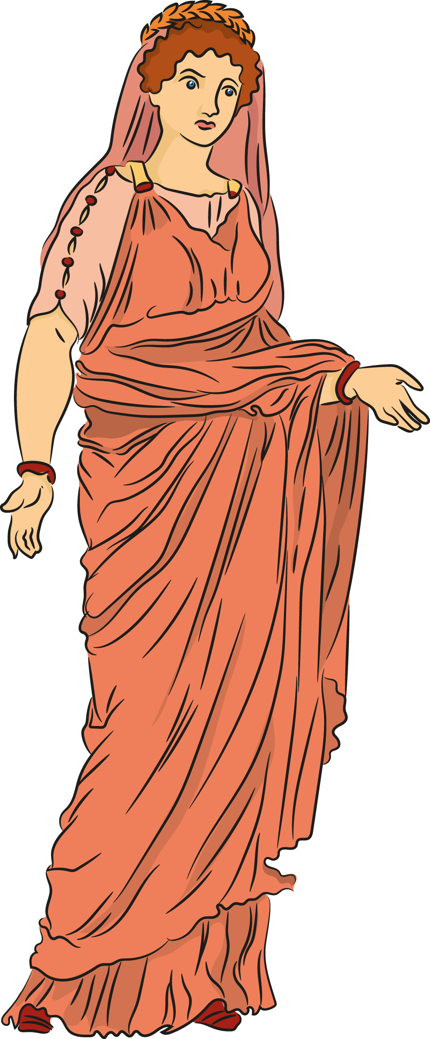

What Others Say 2:

What Others Say 1:

After witnessing Portia stabbing herself in the thigh in order to prove her worth to Brutus, Brutus declares that he is not worthy of her devotion. “O ye gods, / Render me worthy of this noble wife!” (2.1.312)

Thought 1:

Portia pleading with Brutus to tell her why he has been behaving strangely demonstrates her concern and love for her husband. “No, my Brutus. / You have some sick offense within your mind, / Which by the right and virtue of my place / I ought to know of.” (No Fear: 2.1.275–278)

**Defining Moment**

Brutus explains to Cassius that Portia killed herself by swallowing coals. Portia is a strong-willed, determined spouse; she becomes overwhelmed by Brutus’s absence and kills herself in a horrendous manner. “Impatient of my absence, / And grief that young Octavius with Mark Antony / Have made themselves so strong—for with her death / That tidings came—with this she fell distract / And, her attendants absent, swallowed fire.” (No Fear: 4.3.157–160)

Action 2:

Action 3:

Action 1:

Portia stabs herself in the thigh to demonstrate her resolve. “I have made strong proof of my constancy. / Giving myself a voluntary wound / Here in the thigh.” (No Fear: 2.1.308–310)