## The Legend of Leir of Briton

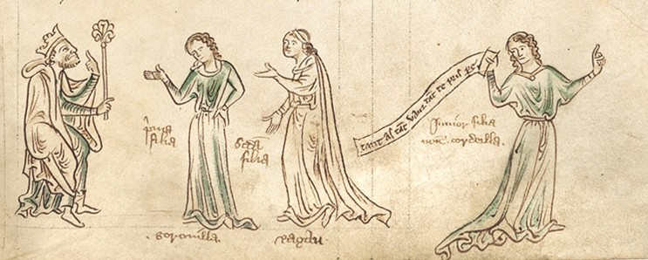The legend of Leir of Briton was first written down by Geoffrey, Bishop of Monmouth in *Historia Regum Britanniae* (c. 1138). In this legend, a son becomes king after his father was killed trying to fly with homemade wings. The son, Leir, ruled Briton for more than sixty years during the 8th century BCE. For Leir, Leir-cestre, or Leicester, is named.

Much of Shakespeare’s play aligns with the plot of this legend. Leir had three daughters: Gonorill, Ragan, and Cordella. He gave half of his kingdom to the two who expressed their love when he asked them to and shunned the youngest, who then married the King of the Franks. Leir’s elder daughters turned against him and took the entire kingdom for themselves. However, in the legend, Cordella and her husband, King Aganippus, invaded Briton and restored Leir to his throne. He ruled for three more years before his death and was then succeeded by Cordella.

No one knows if Geoffrey was a historian or a creative storyteller. Indeed, predating his tale, there was one of a Welsh water god who had three daughters. One defeated the other two in battle to retake the land on her father’s behalf. The river that flows through Leicester, today named the Soar, was once called the Legra, and before that the Leir, and many historians conclude that the city was a major center of worship for a pagan water god named Leir. It seems that Geoffrey may have “borrowed” the story from this Welsh legend.

## Layamon’s *The Brut*

In about 1205, an English priest named Layamon wrote an epic poem of 16,095 lines called The Brut that tells the story of Britain’s history. He reworked and translated the poem from an earlier text, Roman de Brut (c. 1155). Named for Britain’s mythical founder, Brutus of Troy, the poem is one-third about King Arthur. However, it also includes the story of a king named Leir and his daughters, Gornoille, Regan, and Cordoille. This part of the poem, which includes a dramatic refrain that reflects upon the ups and downs of

Leir’s fortunes, focuses on the themes of lies and truth, and gratitude and ingratitude, themes reflected in Shakespeare’s version. The verse of the poem is highly alliterative and uses rhyme and meter in a style that was typical in other Middle English poems, such as *Beowulf* and *Sir Gawain and the Green Knight.*

## Philip Sidney’s *The Countesse of Pembroke’s Arcadia*

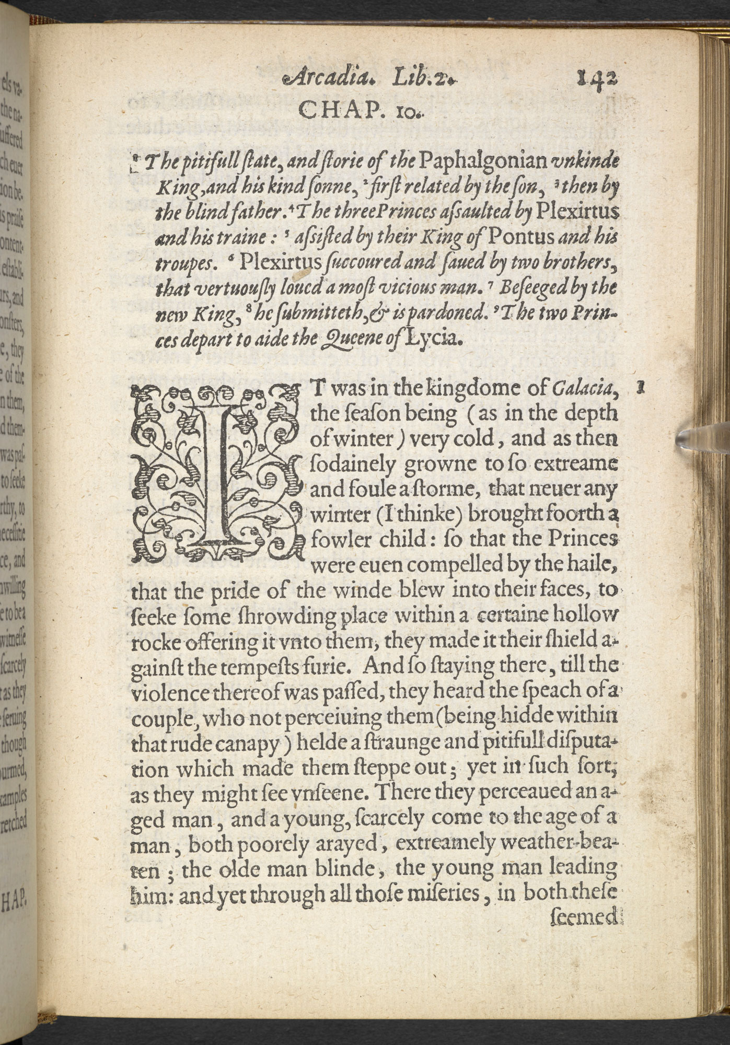Philip Sidney’s *The Countesse of Pembroke’s Arcadia* (c. 1585) includes the probable source of *King Lear’s* subplot. In this long prose romance, two of the main characters are driven into a cave by a terrible storm. There they meet a blind king named Paphlagonia and his son, Leonatus, both shabbily-clothed and worse for wear. The king’s illegitimate son, Plexirtus, ambitious and despicable, has tricked the king into hating his legitimate son, who was forced to flee the kingdom and start a new life. After reducing his father to nothing more than an empty title, Plexirtus blinds his father and throws him out. Leonatus, hearing of his father’s sad fate, finds the king and tries to care for him. In the end, the good son defeats the evil one and is rightfully crowned king after their heartbroken father dies. The good son forgives and pardons the repentant evil son, and the episode ends in harmony.

## Edmund Spencer’s *The Faerie Queen*

The epic allegorical poem *The Faerie Queen* by Edmund Spencer (c. 1590) includes a character named Cordelia who dies by hanging. In Book II, as in Geoffrey’s history, Cordelia reigns for five years until she is deposed by Margan and Cuynedag, the sons of her sisters, Gonorill and Regan. The nephews take their aunt prisoner and she commits suicide.

While in both Spencer’s poem and Shakespeare’s play the queen hangs herself, Shakespeare tweaks the detail, insofar as his Cordelia’s death is a murder disguised as a suicide. In the play, Edmund orders a servant to do the deed (No Fear: 5.3.265–268), and King Lear tells the dead Cordelia, “I killed the slave that was a-hanging thee.” (No Fear: 5.3.287).

In *The Faerie Queen,* Spencer tells the entire tale of Lear in only six stanzas, and he is the first to use the name Cordelia, which Shakespeare also appropriated.

## The Anonymous *King Leir*

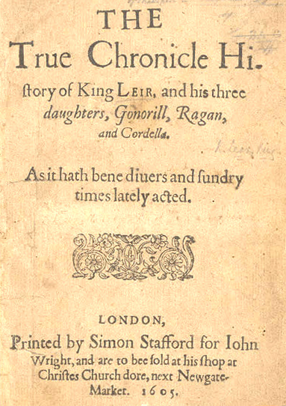Interestingly, a play called *The moste famous Chronicle historye of Leire king of England and his Three Daughters* was listed into London’s official publication records in 1594. However, the play didn’t appear in print until 1605 (with the revised title *The True Chronicle History of King Leir and his three daughters, Gonorill, Ragan, and Cordella*), the same year that Shakespeare drafted his play, which was first performed in 1606 and first published in 1608. Theater records show that the original play was performed at least twice by two acting companies in 1594. Some historians suggest that Shakespeare himself may have performed in the play since he was a member of the Queen Elizabeth’s Men, one of the companies listed in the historical record.

The most significant differences between Shakespeare’s masterpiece and this anonymous play is that this precursor has a happy ending, and the spelling of the main character’s name changes. In the original, Leir is ultimately restored to his kingship and Cordelia does not die. This play does not include the subplot about Gloucester at all, but Shakespeare’s Kent logically draws from its character Perillus. In fact, a side-by-side comparison of speeches of Leir and Lear reveal striking comparisons in meaning, language, and style. Theatrical historians widely agree that the anonymous play was a primary source for Shakespeare’s *King Lear* and that it was probably published in 1605 to piggyback on the popularity of Shakespeare’s genius.

In spite of all this literary borrowing—and perhaps because of it—Irish playwright and critic George Bernard Shaw wrote in his book *Shaw on Shakespeare*, “No man will ever write a better tragedy than *King Lear*.”