The Expulsion of 1290
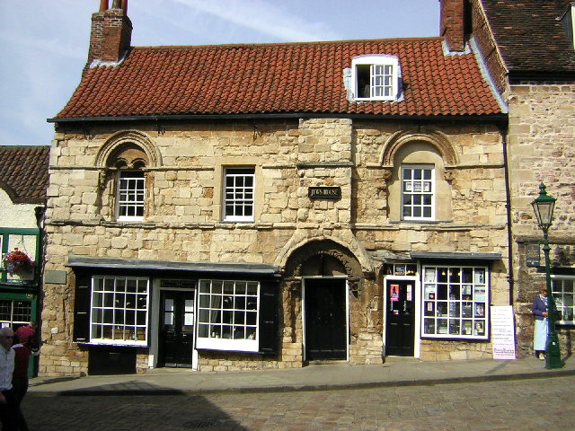
Jews fleeing anti-Semitism in continental Europe had lived in England since the 1000s. Although they established communities in the cities, they were never fully accepted by society. People resented Jews for their presumed wealth, and, inspired by Crusade fervor in the 1100s, emotions turned more strongly against them. Jews were falsely accused of practicing “blood libel”—murdering Christian children to obtain blood for religious rituals. Anti-Jewish riots and massacres erupted on several occasions. More restrictions were levied in the 1200s. Jews had to wear yellow badges on their clothing, were not allowed to settle in areas that did not already have an established Jewish community, and could no longer own land or inherit money. Jews were also forbidden from loaning money with interest, a move that essentially took away one of their vital professions. As a result, Jews took roles as tradesmen or tenant farmers. In 1290, all Jews were forced to leave England, an event called the Expulsion of 1290. Most Jews left for various parts of Europe, but a few Jews remained, either converting to Christianity or practicing their religion secretly. By Shakespeare’s time, only about a few hundred Jews could be counted among the thousands of London’s residents.
The Jew’s House in Lincoln, England, which dates to the late 12th century

Jews in Sixteenth-Century England
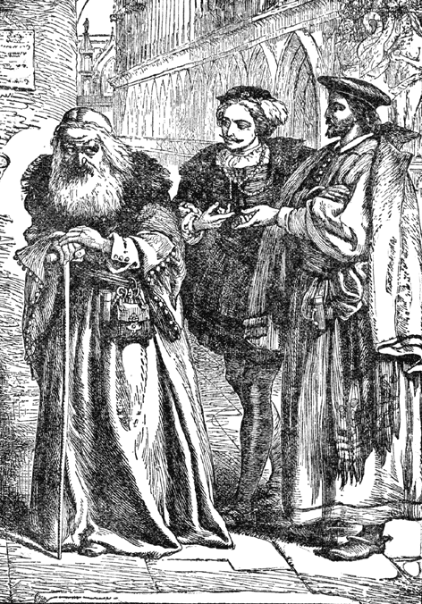
Even though William Shakespeare created Shylock, one of literature’s most famous Jewish characters, he likely would not have come across a Jew in his daily life due to The Expulsion of 1290. While some remained and practiced their faith in secret, most Jews remaining in England converted to Christianity. Known as Conversos, their number included a handful of poor converts who lived at the “House of Converts,” as well as Spanish and Portuguese Jews who migrated to England after their expulsion from Spain in 1492. Some of these Conversos worked in trade and banking. A few even held prominent or public positions, including Jewish scholars who taught Hebrew at England’s universities, musicians who played at King Henry VIII’s court, and a physician to Queen Elizabeth I. Despite Jews’ relative invisibility in society, the English still treated them with prejudice and fear. In 1577, John Foxe wrote a sermon accusing Jews of “heinous abominations, insatiable butcheries, treasons, frenzies, and madness.”

The Rise of Venice’s Jewish Ghetto
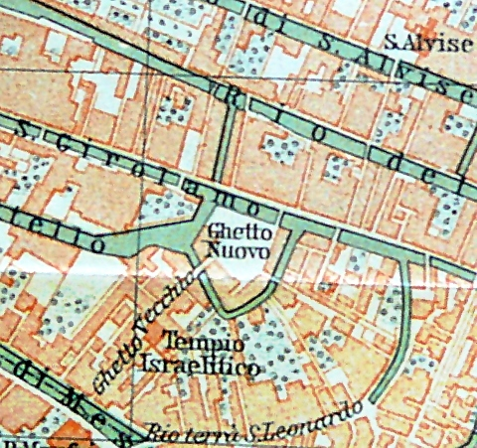
Jews had a mixed history in Venice. In the 1200s, Jews first settled around the city before gaining permission to live in the city itself in the late 1300s, but just a few years later, they were expelled again. Until 1516, Jews could only enter Venice for short periods of time to conduct business. In 1516, however, officials decided to reverse their ban and invited Jews to return to the city to take up residence. As they wanted to limit Jews’ contact with Christians, Venice created the world’s first ghetto. Around 900 Jews crammed into the ghetto’s tall buildings behind walls that were locked each night and monitored by guards. Jews could only leave the ghetto during the day, crossing one of two bridges to reach the rest of Venice. Jews were restricted to a handful of professions and had to wear identifiers. (In the 1500s, it was a red hat.) Within the ghetto, however, Jews were free to practice their religion, and the ghetto had five synagogues. The Jews in Venice came from all over Europe, so numerous languages were spoken, including Spanish, French, German, and Italian. Hebrew was the universal language for signs, official purposes, and religious rites. A population of Jews remained in the ghetto in Venice for hundreds of years.

The Role of Jewish Moneylenders
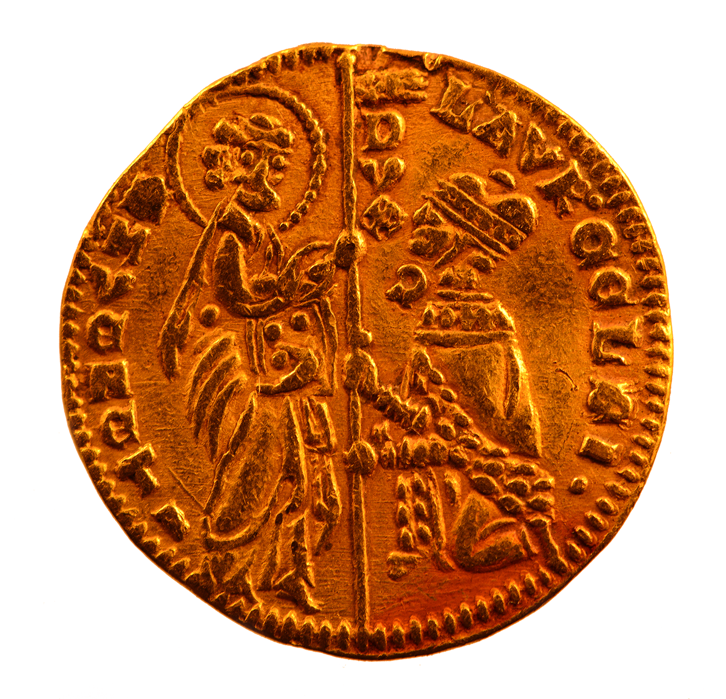
In Medieval and Renaissance Europe, Christians were not allowed to lend money and charge interest for it; such activity was considered to be a sin. From England to Venice, from Germany to Poland, Jews stepped in to fulfill this vital economic role. While Jews could earn great sums of money for their work, they also served as valuable economic drivers. In England, Jews charged a high interest rate on their money, but the government benefited as well because Jews were taxed at a far higher rate than Christians. In the late 1100s, for example, Jews provided about 8 percent of the taxes collected by the royal treasury even though they made up only a fourth of a percent of England’s population. In Venice, Jews lent money to everyone from poor workers to wealthy merchants. In this way, Jews stimulated trade as well as the local economy.

