Artists often create depictions of characters and scenes from literature. But do they always perceive these characters or scenes in the same way? Below are two artists’ renditions of Shylock and Jessica. Study the paintings and then answer the questions that follow.
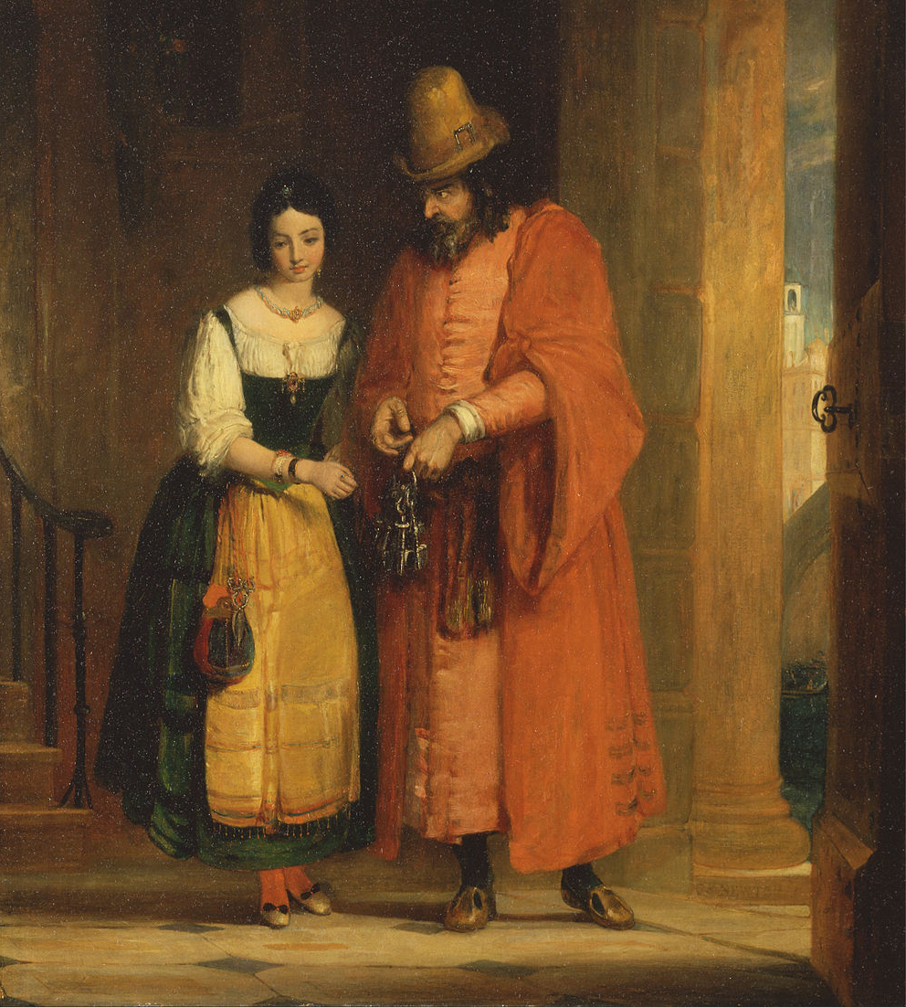
Shylock and Jessica from the ‘Merchant of Venice,’ II, ii
by Gilbert Stuart Newton, 1830

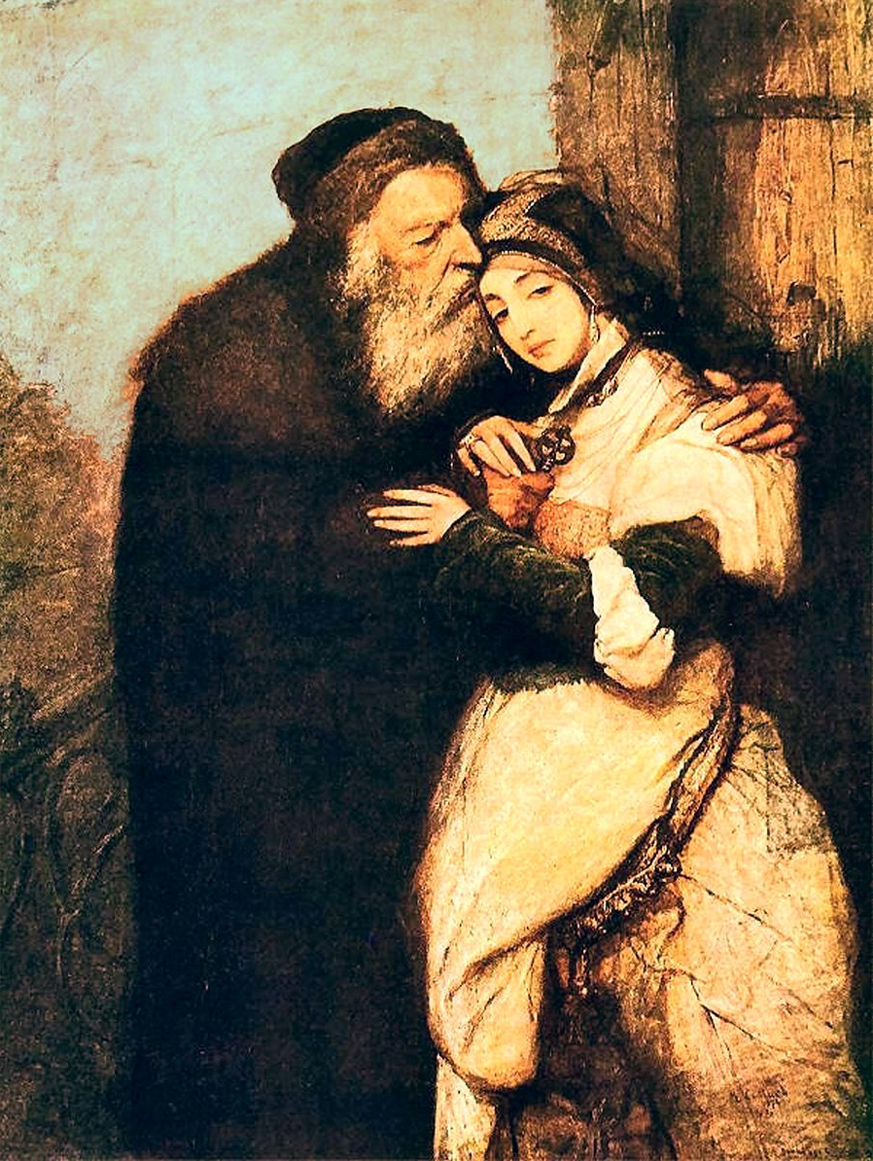
Shylock and Jessica
by Maurycy Gottlieb, 1876

1. What characteristics of the characters are emphasized in each painting?

2. Does either painting render Shylock more empathetic? If so, how does the artist show this characteristic?

3. Which painting do you think better represents the father–daughter relationship as Shakespeare portrays it in The Merchant of Venice?

4. What details do the artists include to tell more about their subjects?

5. Imagine that you are an artist responsible for creating illustrations for a new edition of The Merchant of Venice. Think about how you would convey the relationship between Jessica and Shylock. What aspect of their relationship would you emphasize? What images would you use? Either write a few sentences explaining your answer or create a drawing in the box.
RL.9-10.1 Cite strong and thorough textual evidence to support analysis of what the text says explicitly as well as inferences drawn from the text.
RL.9-10.3 Analyze how complex characters (e.g., those with multiple or conflicting motivations) develop over the course of a text, interact with other characters, and advance the plot or develop the theme.
RL.9-10.7 Analyze the representation of a subject or a key scene in two different artistic mediums, including what is emphasized or absent in each treatment (e.g., Auden's "Musée des Beaux Arts" and Breughel's Landscape with the Fall
of Icarus).

