What Are Dreams?
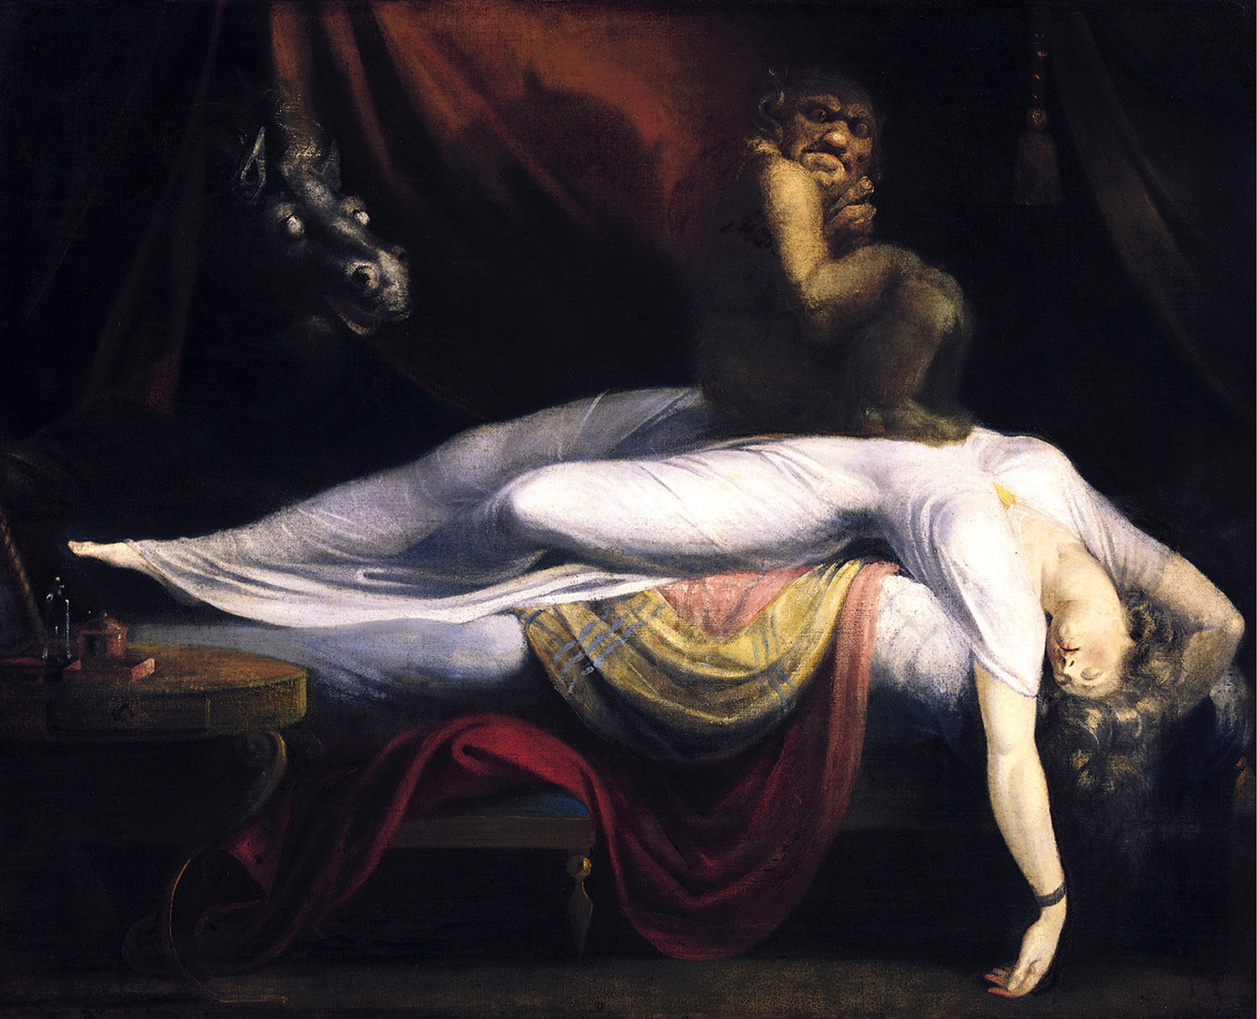
In Renaissance England, people were as captivated by the mysterious nature of dreams and the act of dreaming as they are today. They asked the same questions as we do now: Where do dreams come from? What do dreams mean? How should dreams be interpreted, if at all? Even as today’s science and technology promises to “unlock the code” of dreaming by understanding the biological and psychological processes behind dreaming, definitive answers to
these questions still remain (tantalizingly) out of reach.

Early Dream Interpretation
As far back as the third millennium BCE, Mesopotamian kings were known to record their dreams on clay tablets, suggesting that even then people were aware that dreams held at least some importance and relevance to daily life. Ancient Egyptians were one of the first cultures to attempt to systematize the interpretation of dreams by creating a “dream book” that listed over one hundred common dreams and their meanings. According to this ancient culture, the gods spoke to humans through dreams, and interpreting dreams was a divine practice reserved for those with special training.

Classical and Medieval Dream Interpretation
The art of “divining” the true meaning of dreams continued through the medieval and classical eras. Within this religious context, the art of discerning and interpreting dreams became a matter of separating the authentic from the bogus. After all, if God really did communicate through dreams, then it was of the utmost importance to be able to tell which dreams truly were divine and who were the people worthy and virtuous enough to receive them. Furthermore, whoever had the power to unlock a dream’s meaning was of special interest to political and military leaders looking for solutions to complicated problems and special advantages in war. For many, dreams were thought to be the same as prophecies.

Dreams in Elizabethan England
In Shakespeare’s time, Thomas Hill’s The Most Pleasant Art of the Interpretation of Dreams (1576) was the most comprehensive text on dream theory and interpretation. Hill’s text laid out the history of dreams and dream interpretation through the ages and reflected the general anxieties Elizabethans had over dreams at the time. Hill acknowledged that the art of dream interpretation was indeed complicated and approached the subject with a fair degree of skepticism and balance. Elizabethans were especially concerned with sleep dynamics both physical and psychological. They pondered questions like, How vulnerable was one to supernatural forces while asleep? Is it possible to control dreams so that one is visited only by angels, and not demons? Could one’s bad character be “exposed” through dreams? Shakespeare plays on these ideas in his works, as he has characters experience prophetic dreams, have their guilt exposed, and manipulate others through dreaming and the dream state.

Are Dreams Just . . . Dreams?
Even as these loftier ideas were discussed, more mundane theories about dreams persisted. Some of these ideas extended as far back as to Aristotle, who suggested that dreams were the result of simple biological functions. Some Elizabethans considered dreams a simple yet stranger “retelling” of the day’s events. Still others reserved judgment and sought to control their dreams through healthy diet and prayer and used such strategies as wearing gemstones or drinking special potions before bed to stay on the safe side and avoid nightmares.

Freud’s The Interpretation of Dreams
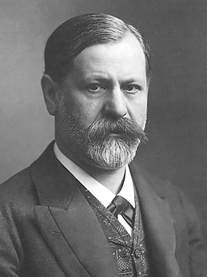
Today, Sigmund Freud’s The Interpretation of Dreams (1899) has replaced Hill’s text to become the most recent comprehensive exploration of dreaming and dream interpretation. Freud’s provocative proposal suggests that we dream to achieve a level of “wish fulfillment,” meaning that our dreams represent desires we have not yet achieved in “real life,” so we manifest or obtain these goals in the dream state. Dreams then, Freud argues, become a larger picture of our unmet and/or repressed desires. Freud also suggests dreams are a collection of images from our daily conscious mind that have symbolic meanings that correspond to our subconscious, primitive mind. He argues that if we can decode the symbolic meaning of these images, we can unlock our repressed desires, and therefore make the subconscious known, leading us towards psychological unification and healing.

The Science of Dreaming
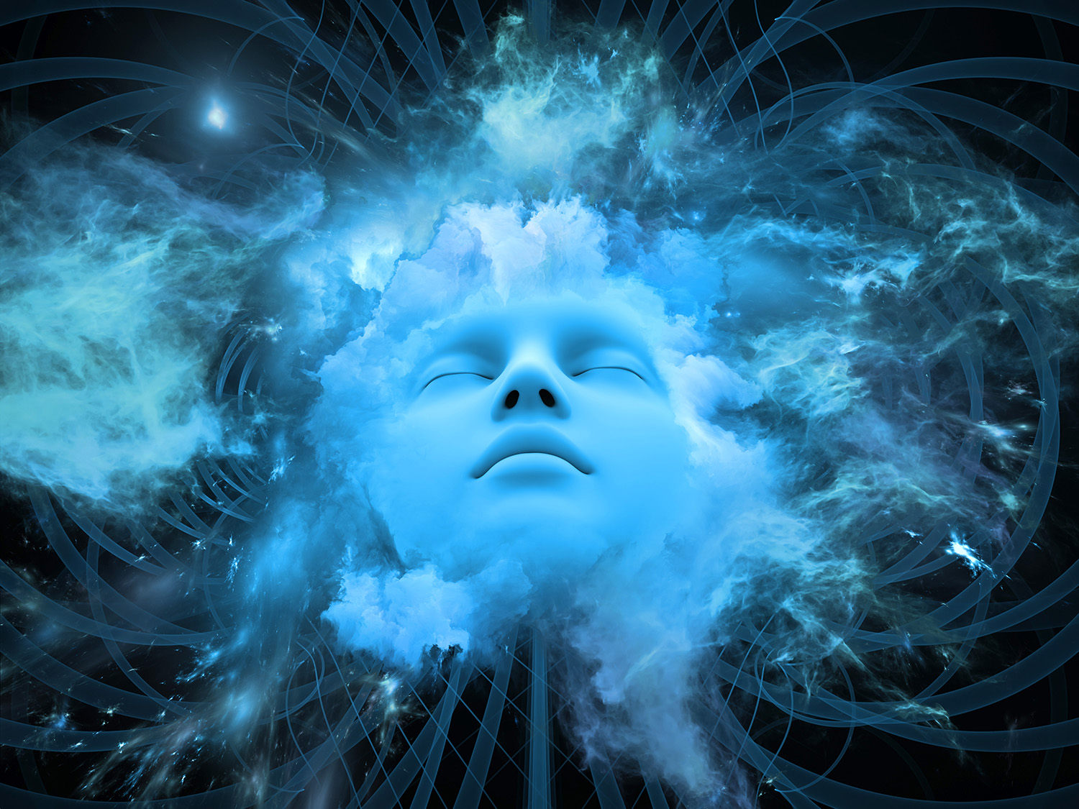
Psychological studies since Freud offer even more explanations for why we dream and what dreams mean. Some theories propose that certain memory processes can only happen while we are asleep, and dreams are a simple biological byproduct of the storing and consolidation of memories. Other theories propose that dreams act like a “sieve” for the plethora of neural connections we make during the day that we no longer need and which could clog up our brains. Some other theories acknowledge that these biological-based explanations are not sufficient. These theories suggest that much remains ambiguous about dreams, even as they point to the possible emotional and potentially healing value of dreams. Thus, despite our long search for answers about dreaming, it remains a mysteriously elusive part of the human experience.

