## Courtship

Onlyentering the English language toward the end of the 16th century, the word *courtship* describes the period in which a couple engages in social activities in order to get to know each other better with hopes of getting married. During Shakespeare’s time, friends and family played a primary role in courtship, often serving as matchmakers, much as Beatrice and Benedick’s friends did. While young people could meet on their own — they were at liberty to meet and mix in public places, like markets and dances — if a man was interested in a woman, he asked her father for permission to court. This request showed that his intentions were serious. A courting couple could attend social events together and often exchanged gifts that had symbolic meaning.

## Betrothal and Marriage

Once a couple completed the courtship rituals, they entered into a betrothal period by becoming formally engaged to be married. A betrothal was a legally binding relationship that could last as long as a year. Couples publicly pledged themselves to one another in a ceremony in front of a priest. (In England, this tradition was called *handfasting*.) If the man or woman wanted to break the betrothal, church lawyers had to get involved. The Council of Trent, which met from 1545–1563, however, brought reforms to the process of betrothal and marriage for members of the Catholic Church, which comprised most Europeans. To be lawfully married, the couple had to receive the Church’s consent, either by purchasing a license or reading the “banns,” which announced the names of the couple and their intention to marry. Either process took a month to finalize. Drawing on long tradition, the couple exchanged rings to signify that they were no longer betrothed but now married.

## Arranged Marriages

In the Renaissance, marriage was not seen as a matter of love between two people but rather as a practical matter. Marriage involved not just individuals but families, fortunes, and communities. Sometimes families sought an economic alliance, such as the joining of property. Other times they wanted to forge or strengthen political alliances or even unite kingdoms. Upperclass families arranged their children’s marriages, often with little thought to the wishes of their children or whether the couple

even liked one another. Brides in the Italian Renaissance tended to be significantly younger than their spouses; the legal age for marriage was 14, and these girls could be married to men twice their age. As part of the marriage arrangements, a dowry — which was money, goods, or property that the bride brought to her husband when they married — was agreed upon. Among the peasant class, parents arranged their children’s marriages far less frequently. Members of the lower classes had more freedom to meet potential partners and embark on courtship routines in their daily lives.

## Married Life

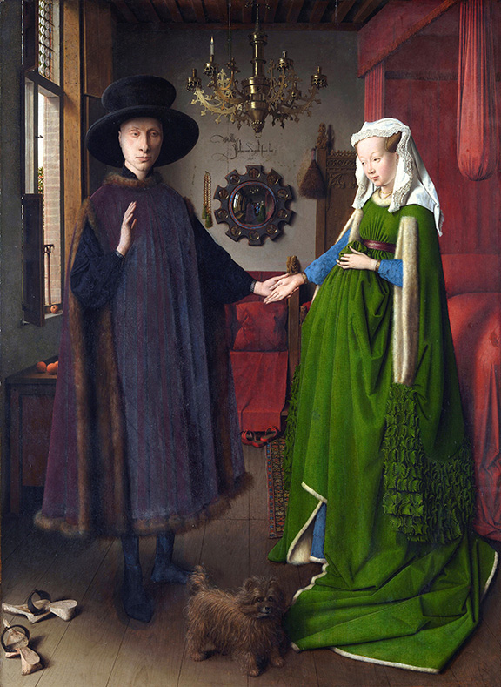Married men and women had specific roles and responsibilities in their relationships. Men held complete authority over their wives. Married women had little or no decision-making authority nor could they generally own property. While peasant women labored in the fields and middleclass women might help tend their husbands’ businesses, women were always expected to take care of the home and children. Men, on the other hand, had the obligation to support and protect their wives. Married men and women were viewed as providing companionship to one another, not romantic love. Even if a man and a woman no longer served as good companions to one another, divorce was forbidden. While marriages were occasionally annulled, most marriages ended when one partner died. Since many people died young during the Renaissance, many adults married two or even three times.

## Representations of Love in Literature

The concept of love in Renaissance poetry manifested itself in different ways. In the 1300s, Italian poets Dante Alighieri and Petrarch, working from the concept of courtly love with its roots in the love stories of knights and ladies, developed a poetry that idealized love itself. These authors created a perfect female who served as the source of inspiration for her beloved. This ideal of love transcended daily life and did not truly reflect the relationships of mortal men and women. Later poets focused on Platonic, or non-romantic, ties; instead of existing as a fleshy, earthy concept, love became a path to a higher virtue and led to a better understanding of the divine. Pastoral poetry was also popular during the Renaissance. Again drawing from earlier traditions, pastoral poems glorified the simple life of shepherds and nymphs who lived in the countryside, far from the corruption of the urban world.