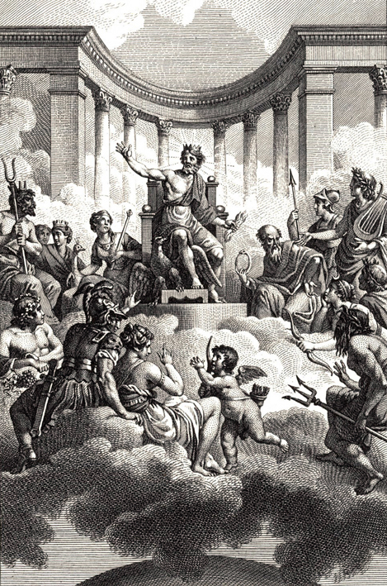The major deities of ancient Greece belonged to a family of gods descending from the Titans. Zeus, Poseidon, and their siblings rose up against their parents, Cronus and Rhea, in a war for supremacy. According to mythology, when they emerged victorious, the three brothers—Poseidon, Zeus, and Hades—drew straws to see who would rule. Zeus drew the skies and became the supreme deity, while Poseidon was given the seas and waters, and Hades the underworld (the land of the dead). Several of Zeus’s children, including Athena and Hermes, also joined the older generation as the ruling gods. The deities, with the exception of Hades, all lived on Mount Olympus and were called the Olympians.

## Athena

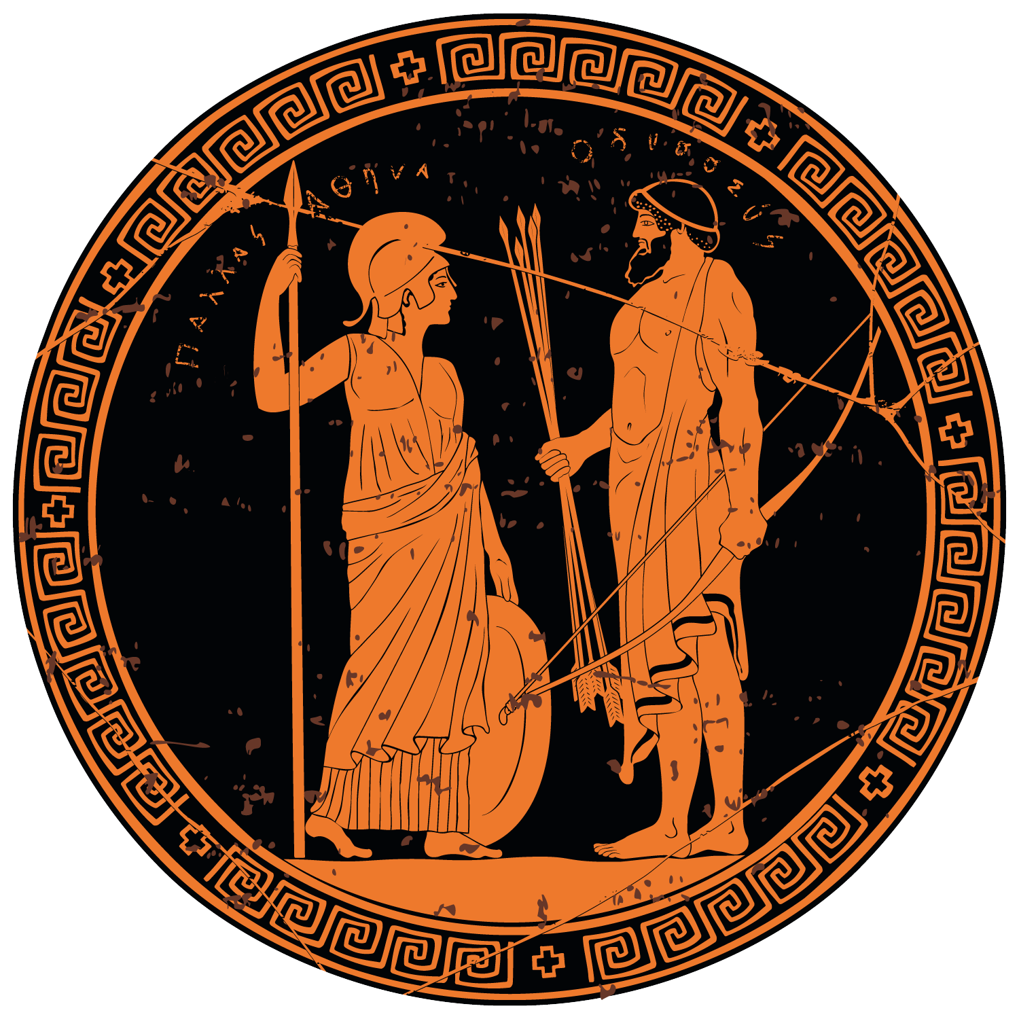Athena, the Greek goddess of wisdom, household crafts, and war, was a multifaceted deity. While associated with war, Athena emphasized not blood lust and violence, but strategy, skill, and justice. She was associated with the city of Athens, the ancient Greek center of arts and learning. She was often referred to by the epithet Pallas Athena or simply Pallas, which derives from the Greek word for “young woman.” Several elements in her background shed light on some of the events in *The Odyssey.* She was Zeus’s favorite child (having sprung fully grown and fully armored from his head), and he often sided with Athena in arguments. She also was the patron of heroes and supported the Greeks in the Trojan War, which certainly influenced her favoring of Odysseus. Athena also once bested Poseidon, Odysseus’s ardent foe, winning a competition to be Athens’ patron deity when she planted the first olive tree.

## Poseidon

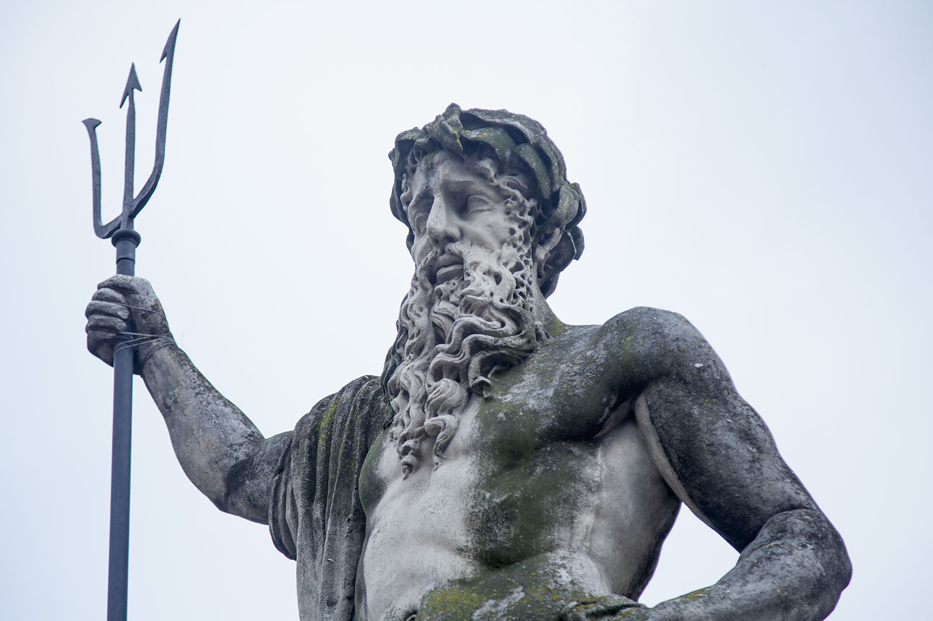Poseidon was the god of the water, the seas, earthquakes, and horses. He was also perhaps the most unstable of the Olympians, prone to moodiness, bad temper, and a desire for vengeance—as demonstrated in his desire to punish Odysseus for putting out Polyphemus’s eye. Sometimes called the Earth-shaker, Poseidon could strike the ground with his trident and cause earthquakes, shipwrecks, and drownings. He was the protector of seafarers—sailors turned to him to provide them safe passage on sea voyages, or, conversely, he could make their voyages challenging and dangerous.

## Zeus

Zeus was the god of the sky, ruling from Mount Olympus as the king of the gods. He controlled the weather, and his symbol was a lightning bolt, which he hurled as a powerful weapon. As the supreme god, Zeus dispensed justice, meted out punishment, brokered peace among the other deities, and maintained order among the gods and mortals. Zeus actually has only a minor role in *The Odyssey,* but his presence is keenly felt. Only with Zeus’s consent was Athena able to help Odysseus to the extent she did.

## Circe

Circe, an enchantress and sorceress, was the daughter of the god Helios and the nymph Perse. She came from a family of powerful magicians and worked her magic with the help of potions, herbs, and even a wand. In fact, Circe’s wand in *The Odyssey* is the first mention of a magic wand in history. She was known for her ability to use drugs and spells to turn humans into animals, as she did with Odysseus’s men. Some stories even gave her the power to bring the dead back to life or to bestow immortality upon mortals. According to the Greek poet Hesiod, Circe had three sons with Odysseus, one of whom ended up killing the hero.