Was Othello Black?
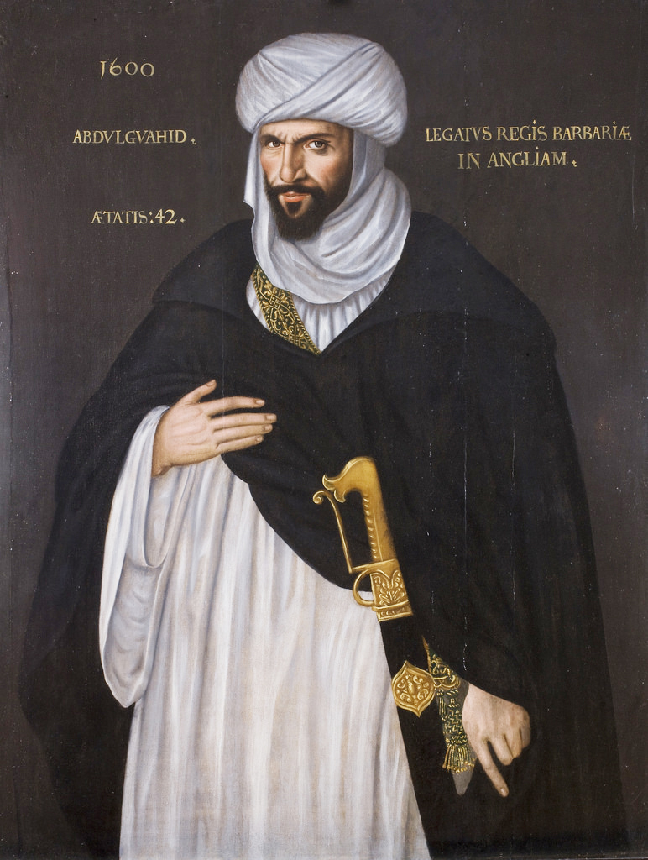
Contemporary stagings of Othello often depict Othello the Moor as a black African. But, in Shakespeare’s day, Europeans commonly referred to Muslims generally, and especially North African Muslims of Arab descent, as Moors. While these people usually had darker skin than Europeans, it remains a matter of debate whether Othello was “black” in the modern sense as contemporary audiences often imagine. Many scholars believe that Shakespeare conceived of Othello as an Arab. In around 1600, the Moroccan ambassador visited England’s Queen Elizabeth and became a local celebrity. Some cite his image as inspiration for Othello. He is not what people today would call “black,” or sub-Saharan African.

Racial Epithets in Othello
When Iago calls Othello a “black Moor” or Roderigo calls him “thick lips” and an “old black ram,” these lines sound like racial epithets, but modern ideas about race make it difficult for us to grasp what Othello’s blackness really means in the context of the play. Unlike today, early modern Europeans did not link skin color to genetic or evolutionary heritage. These concepts would not become prevalent until the emergence of modern biological science. Similarly, notions of racial superiority didn’t become widespread until the rise of colonialism and slavery.

Racial Prejudice in the Elizabethan Era
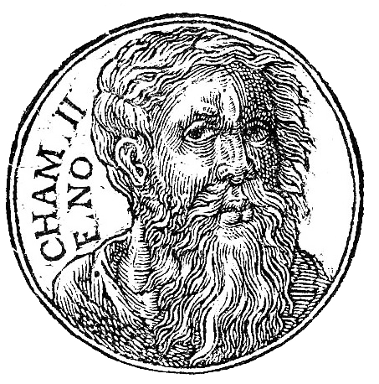
Although early modern European culture did maintain a color prejudice, this prejudice stemmed from two very different sources. The first was medieval climate theory, which linked dark skin to sun exposure, connecting the hot climate of Mediterranean North Africa with blackness. The second source of early modern color prejudice stemmed from Christian mythology, which tells the story of how God cursed Noah’s son Ham to be “black and loathsome.” According to this narrative, Ham’s line went on to populate the lands of Africa. Presumably the blackness of Ham’s lineage does refer to skin color, but the primary function of that blackness in the story is metaphorical—that is, it serves as a lingering mark of Ham’s sin.

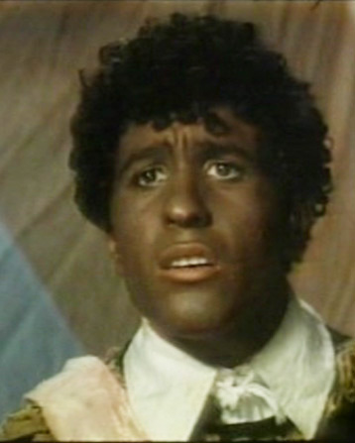
Blackness
Othello’s “blackness” does relate to his skin color, but its primary function in the play is symbolic. Some theatergoers watching the play in Shakespeare’s time would have known that Moors come from North Africa, but few, if any, would have actually encountered any such individuals. Othello himself would have been played by an actor who had darkened his skin with soot or coal, a common technique used to indicate a character’s Moorish or Turkish roots. But audiences would also have understood that Othello’s dark skin was emblematic of his dark or evil nature. Othello’s blackness cannot be understood solely in terms of physical appearance. Nor does it have obvious links to the long history of racism that has formed our current cultural moment.

Modern Views
The question of Othello’s race has received a great deal of attention in recent decades. Modern critics have examined the play through the context of contemporary ideas about race and racism, pointing out that Othello’s violence, jealousy, and alleged sexual prowess (according to Iago and Roderigo) reinforce contemporary stereotypes about black men. Also problematic is the fact that until the middle of the twentieth century, Othello was played by white actors who darkened their skin with makeup, a practice that recalls the deeply racist use of “blackface” in minstrel shows of the nineteenth century.

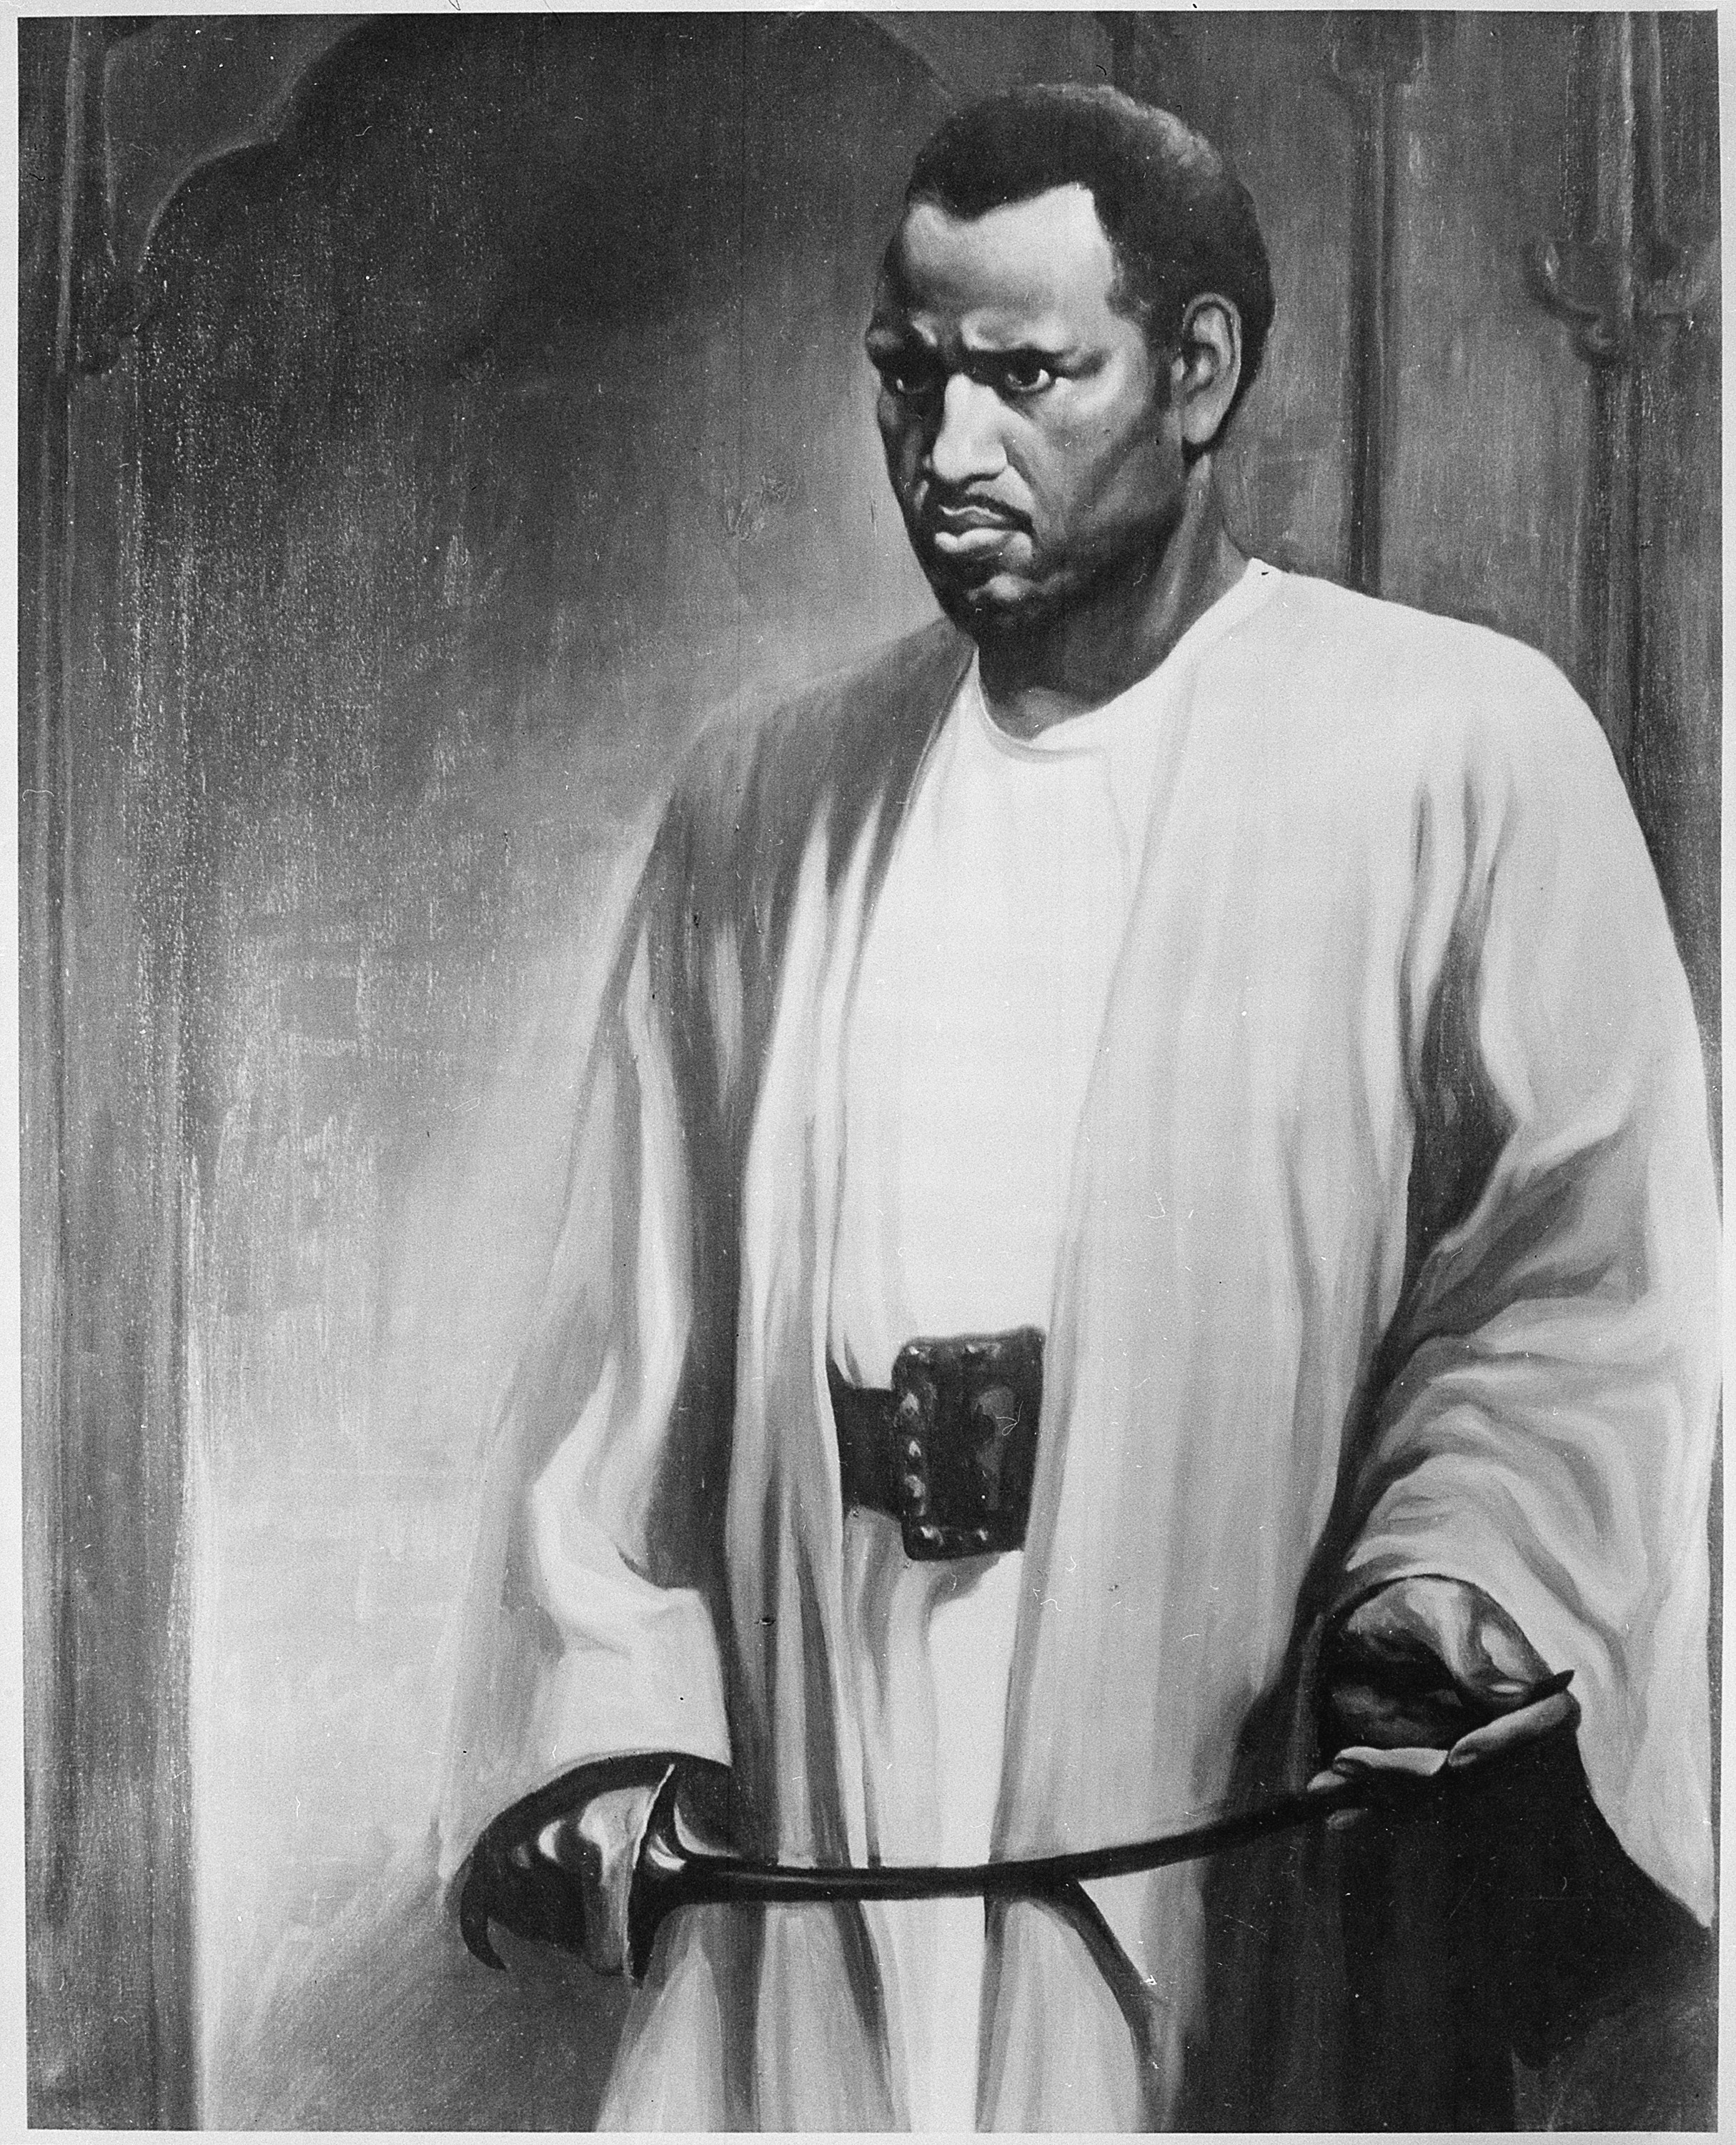
Evolving Ideas of Racial Identity
When black actor Paul Robeson played the role of Othello in London in the 1930s, audiences were shocked to see a black man kiss a white woman onstage. But Robeson revived the role on Broadway in the 1940s, and since then Othello has almost always been played by a black actor in major productions. In 1997, the white actor Patrick Stewart played Othello in an otherwise all-black production; a more recent staging featured black actors as both Othello and Iago. While the original meaning of Othello’s blackness has grown obscure, the provocative and timeless nature of the play’s subject matter makes it fit for countless interpretations as notions of racial identity continue to evolve.

