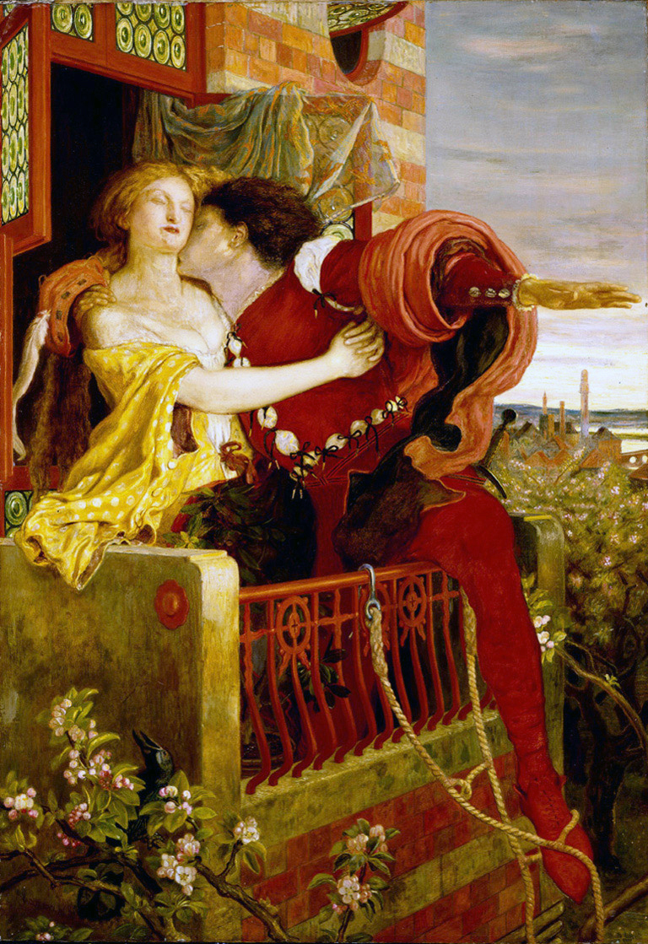
Courtship in the Elizabethan Era
Shakespeare’s depictions of courtship in his plays capture
the complex and shifting attitude toward the proper way to choose a mate that embodied the ethos of the Elizabethan era. In Shakespeare’s day, courtship was a formal process, almost akin to a modern business deal. A father would seek out a suitable mate for his daughter and engage in negotiations to make certain that she would be well situated in life. Women from wealthy families and those of noble birth often had little say in who they married, although wooing, or the act of gaining the affection of a woman, was an important part of courtly love. The suitor would first have to ask the father of his intended mate for permission to woo. This request would formally announce the beginning of a courtship that might result in marriage, which, for most noble women of the time, was the biggest event of their lives. Shakespeare’s depictions of courtly love are not very flattering. More often than not, his characters rebel against this process and seek comfort in the arms of a chosen lover, an attitude that reflects the evolving morality of the period.

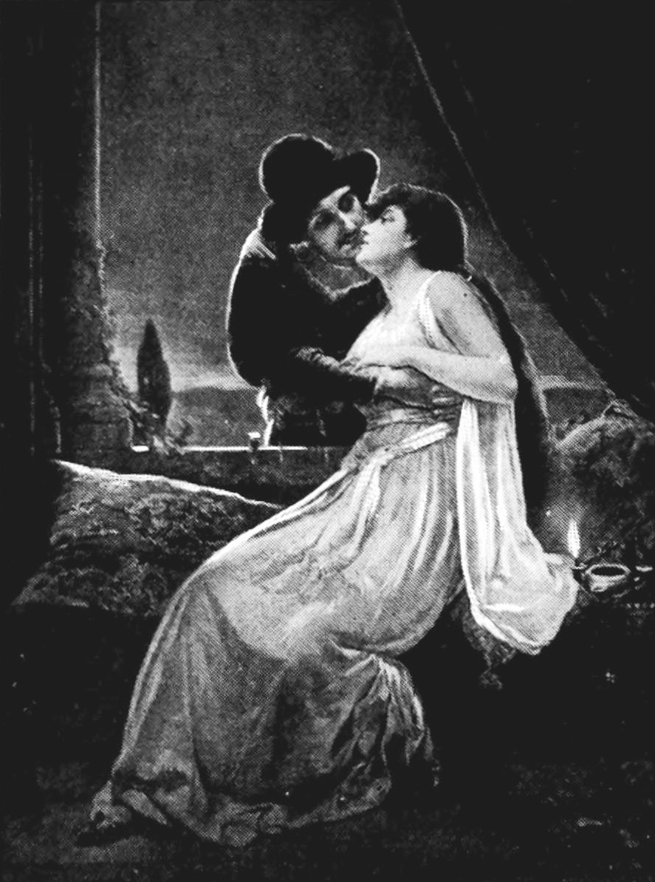
Romance and Young Love in Romeo and Juliet
Age is relative, and some say love is a state of mind. From a modern perspective, Romeo and Juliet are often considered far too young to marry or fall in love. When a modern audience hears for the first time that Juliet is only thirteen years old, they are often astonished and sometimes a little disgusted. However, while boys and girls of this era were allowed to marry in their early teens, it was more common and even encouraged for couples to marry in their twenties. Juliet’s age is likely used to add credibility to the rash decisions she makes as a result of facing the unfamiliar and intense emotional turmoil that she encounters in the play. It is important for audiences to consider the perceptions of women and sexuality during Shakespeare’s time. Women were property, and being chaste until marriage was paramount. There was no such thing as dating as most Americans know it today.

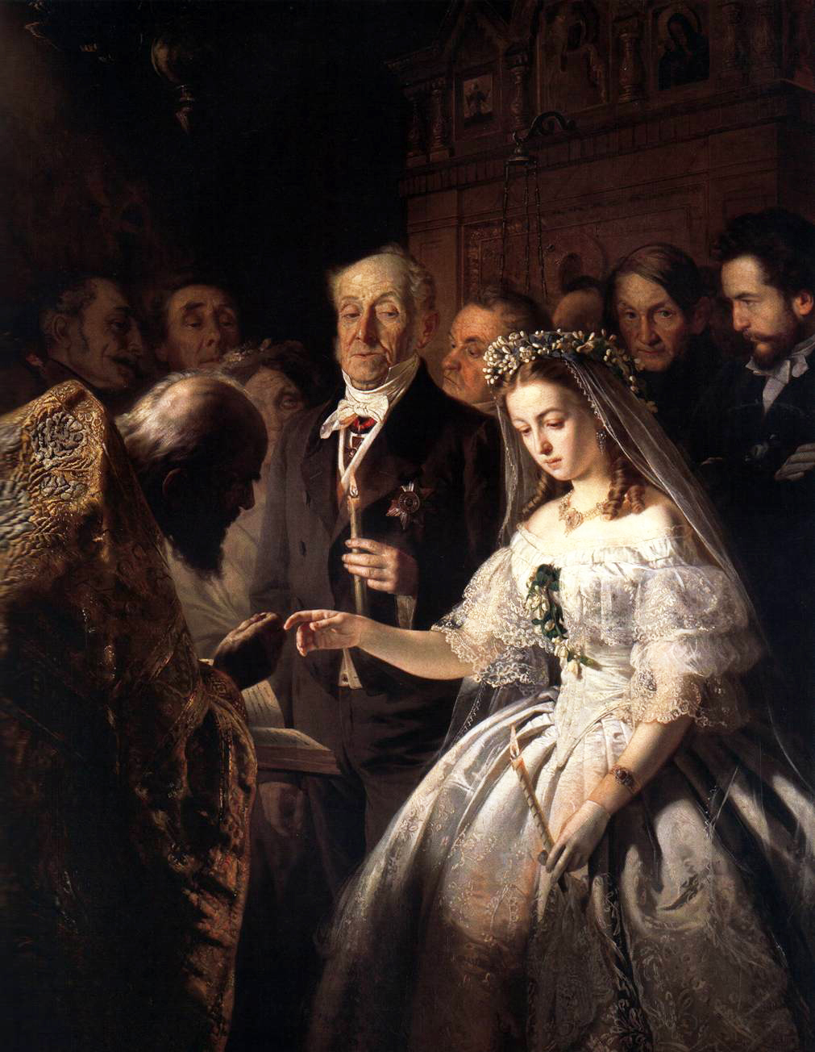
Arranged Marriages
During the Elizabeathen era, few noblewomen married for love. In fact, love was often considered a foolish idea to these practically-minded people. Marriage was a contract, a negotiation tool used to gain wealth and social status. Ironically, the more wealthy and noble a woman was, the less freedom she often had to choose her husband. Arranged marriages were used to create treaties or seal business ventures and tie families together for the good of the family, or country in the case of royal men and women. Marriages were not made for the happiness of the individual. Since a woman was considered her husband’s property, the dowry, or money and other forms of wealth the lady brought with her to the wedding, became her husband’s property. It’s easy to think of arranged marriages as occuring between total strangers; however, this was rare. Children from wealthy or noble families were often matched with one another at an early age.

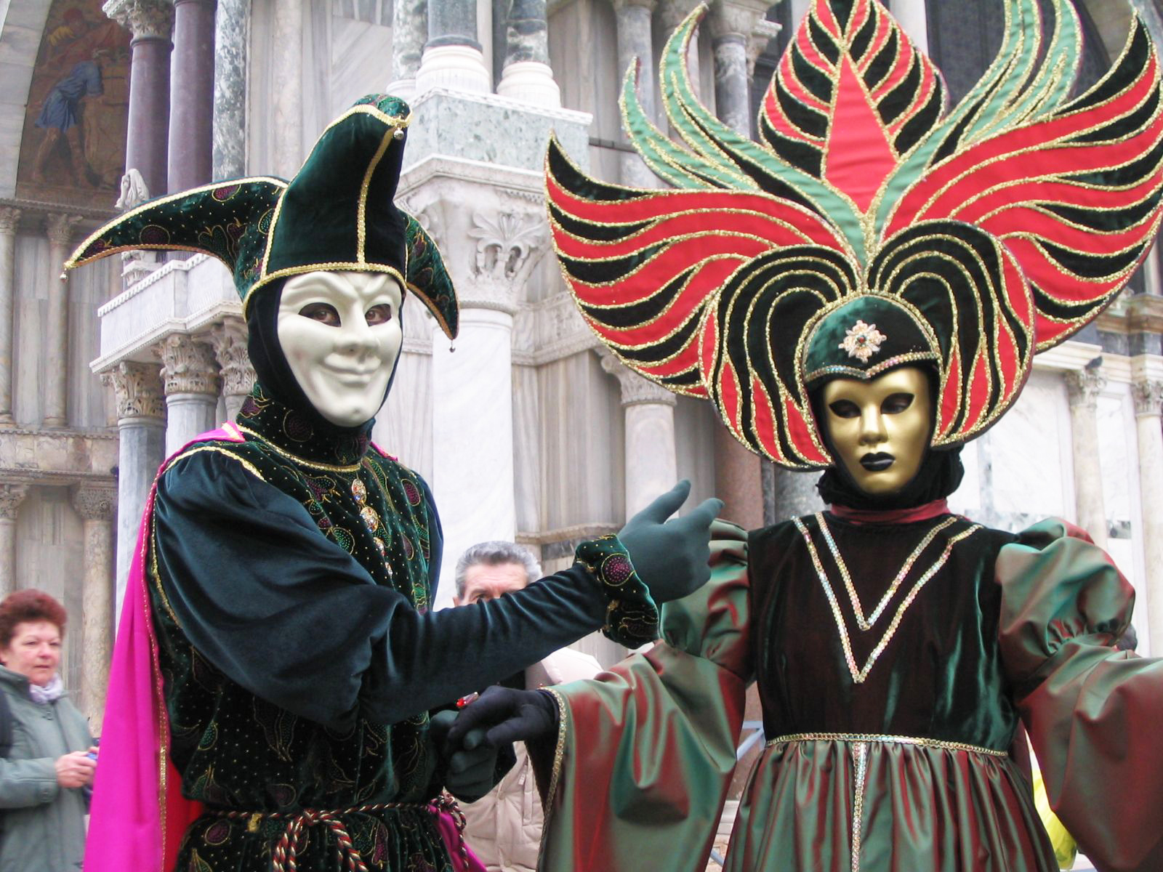
Masquerade Balls
Queen Elizabeth was well known for her love of dancing and music, and as such, masquerade balls were popular and often held during her reign. A masquerade was thought of as a wholesome way for young people to meet, and dancing with a lady was very much a part of the courtship rituals of the time. Shakespeare uses the setting of Capulet’s masquerade in order to bring his two star-crossed lovers together. The portrayal of this scene provides a glimpse into what was often the only means for most proper young men and woman to interact during this time. The masks worn at the ball created an air of mystery and intrigue and sometimes allowed for individuals of lower standing to mingle with those higher up in the social order.

