From forth the fatal loins of these two foes
A pair of star-crossed lovers take their life,
(No Fear: 1.Prologue.5–6)
Shakespeare embeds the idea of fate in many of his plays. As a storyteller, Shakespeare crafts and shapes the lives of his characters, and being fictional, their actions are predetermined by the author. But by including the concept that fate has some influence over his character’s actions, Shakespeare entices his audience to consider whether their lives are also guided by a higher power. At the very beginning of Romeo and Juliet, Shakespeare announces to the audience that the two lovers will die at the end. He insinuates that their death is an act of fate by initiating the motif through his description of them as “star-crossed lovers.” Therefore, the story’s tension and suspense are built upon not the audience wondering what will happen but rather how the play will come to its inevitable conclusion.
The motif of fate is present throughout Romeo and Juliet. Shakespeare uses references to fortune, fate, and the stars to foreshadow the inevitably tragic conclusion to his play.
Find five examples from the play where Shakespeare foreshadows future events.
Properly cite each example and briefly explain how each is an example of foreshadowing.
Create a unique image for each example that visually depicts its foreshadowing and, if possible,
Example:
Foreshadowing text reference:
“From forth the fatal loins of these two foes/A pair of star-crossed lovers take their life,” (No Fear 1.Prologue.5–6)
Explanation:
Romeo and Juliet’s tragic fate is revealed before the play actually begins. They are not able to avoid their fate as it is predetermined by the stars.
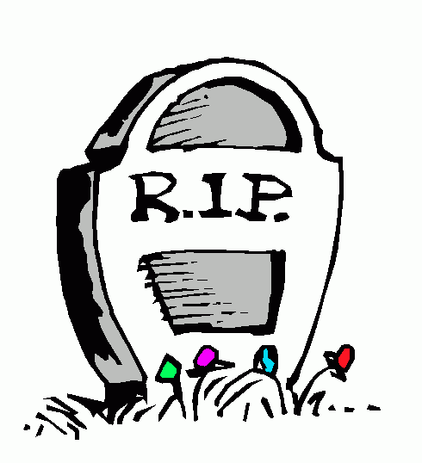
Image:
This Photo by Unknown Author is licensed under CC BY-NC-ND
This Photo by Unknown Author is licensed under CC BY-NC-ND

1.
Foreshadowing text reference:

Explanation:

Image:

2.
Foreshadowing text reference:

Explanation:

Image:
RL.9-10.2 Determine a theme or central idea of a text and analyze in detail its development over the course of the text, including how it emerges and is shaped and refined by specific details; provide an objective summary of the text.

3.
Foreshadowing text reference:

Explanation:

Image:

4.
Foreshadowing text reference:

Explanation:

Image:

5.
Foreshadowing text reference:

Explanation:

Image:
RL.9-10.1 Cite strong and thorough textual evidence to support analysis of what the text says explicitly as well as inferences drawn from the text.
RL.9-10.2 Determine a theme or central idea of a text and analyze in detail its development over the course of the text, including how it emerges and is shaped and refined by specific details; provide an objective summary of the text.
RL.9-10.5 Analyze how an author's choices concerning how to structure a text, order events within it (e.g., parallel plots), and manipulate time (e.g., pacing, flashbacks) create such effects as mystery, tension, or surprise.

