A*motif*is a recurring image, symbol, or concept used by an author to help develop the major themes in a text and convey those themes to the reader or audience.

In *Romeo and Juliet*, Shakespeare first develops a motif of light and darkness in a traditional representation, where light represents life, beauty, and love, and darkness represents sadness, danger, and depression. But later, Shakespeare purposely shifts the meanings of light and darkness in order to illustrate a transformation in his characters.

As you read *Romeo and Juliet*, look for examples of the light and darkness motif and record your examples below. For each example, quote the text using proper citation and write a brief explanation demonstrating the meaning of the light or dark image in the quote.



**Light Motif   
Acts 1 and 2**

**1.**

**Darkness Motif   
Acts 1 and 2**

**1.**

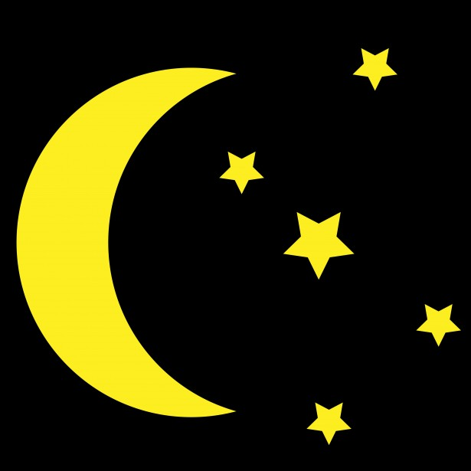

In Act 3 of *Romeo and Juliet*, the symbolic meaning associated with images of light and darkness shifts as Romeo and Juliet are now married and must conceal their hidden love. Light now is the force that reveals their love and works to separate them, while darkness hides their love and allows them to express their feeling for one another in more intimate ways.

**Darkness Motif   
Act 3, scenes 2 and 5**

**1.**



**Light Motif   
Act 3, scenes 2 and 5**

**1.**