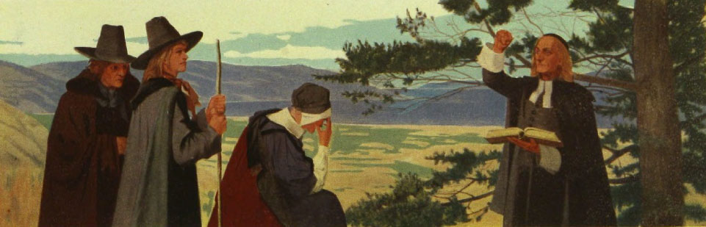
Overview
During the sixteenth century, a group of people set out to “purify” the Church of England. Even though King Henry VIII had broken with papal authority and established a national church in the 1530s, Puritans rebelled against a church they thought remained too closely tied to the rituals and hierarchy of the Catholics. They separated themselves from their local parishes and organized into communities of “visible saints” led by charismatic leaders who were well educated and delivered lively, eloquent sermons. Their focus was on good behavior and social responsibility rather than on ornate churches, despotic priests, and the wealthy pope in Rome.
One such group, fearing for their safety, moved to Holland in 1608 and then to New England in the decades following. Unlike other migrants to the New World, many Puritans brought their entire families. Most Puritans were literate and valued a simple life of devotion and service to others. Each congregation, and each individual, was directly responsible to God. Puritan rules were strict and their punishments often harsh, and they believed in a devil who was behind every evil deed. They may have been just as intolerant as the social order from which they fled in Europe, but they considered themselves progressive and righteous. By 1640, the time of Hawthorne’s tale, their communities in North America had grown to more than 15,000 members. By 1700, there were more than 100,000 Puritans in what is now New England.

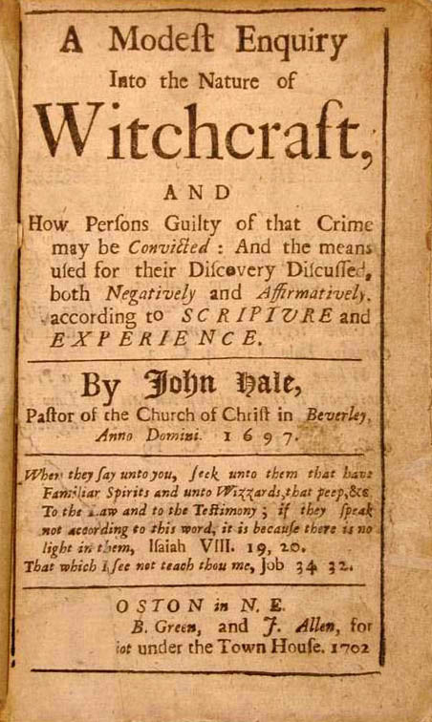
What are the Puritans known for?
The Puritans were among the first society to offer free public education to all children, where lessons in morality and religion took precedence. The Bible and the Greek and Latin classics were central to lessons, and poetry was always religious in content.
Half a century after the time of The Scarlet Letter, Puritans became famous for the witch trials. In Salem, Massachusetts, and surrounding communities, more than 200 people—mostly women—were accused of being witches. Nineteen were found guilty and executed. Today, we look back at this period as a prime example of deadly mass hysteria as well as a warning of the dangers of both isolationism and religious extremism. The Scarlet Letter makes several references to witches and witchcraft, specifically to the Black Man who lives in the forest and is worshipped in secret at night.

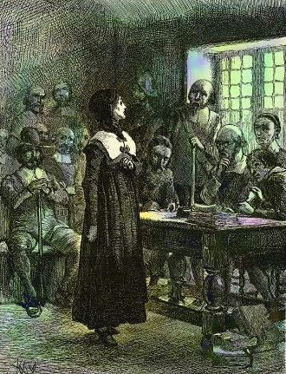
Anne Hutchinson: Saint or Sinner?
Anne Hutchinson moved with her family from England to Massachusetts in 1634. They followed their Puritan minister, John Cotton, who soon joined John Wilson as the teachers of the Boston church. The following year, the charismatic and educated Hutchinson began to offer meetings in her home to discuss sermons with women in her community. Soon, she began to disagree with Wilson. Wilson believed that people were saved by God’s choosing; Hutchinson believed that good works could save a person’s soul. Over the next few years, tensions built between the two factions into a battleground of words, emotions, and, ultimately, legal battles. In 1638, Hutchinson was found guilty of 82 errors and banished from the colony. Private meetings were discouraged, and criticizing the clergy was forbidden. Hutchinson moved to what would later become Rhode Island and then outside New York City. Tragically, she and six of her children were massacred in 1643 by members of the Siwanoy tribe.
Some scholars suggest that Hutchinson was Hawthorne’s inspiration for Hester Prynne. The author describes Hutchinson in Chapters I and XIII as “sainted” and “a prophetess.” History has cast her as a pioneer woman in ministry who challenged authority and represented religious freedom. Today, a statue of Hutchinson stands in front of the State House in Boston.

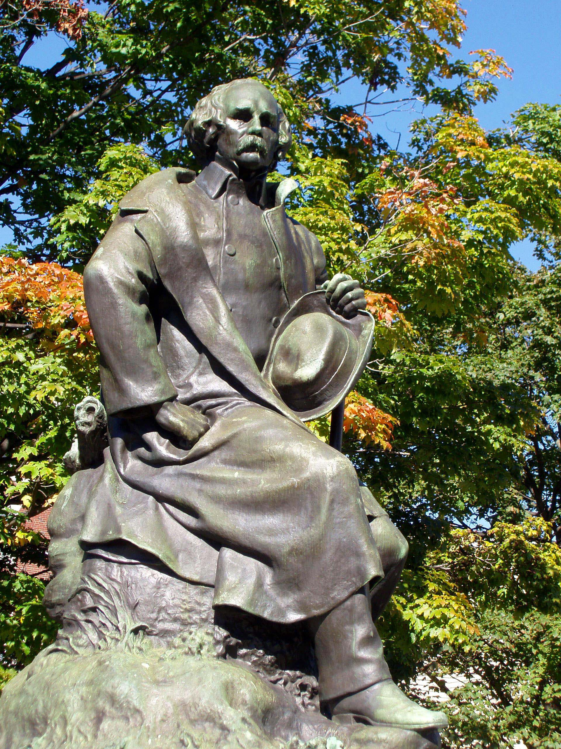
Hawthorne’s Connection to Puritanism
Two of Hawthorne’s paternal ancestors were famous Puritans, but their surnames were spelled without a w. William Hathorne was one of the original Puritan leaders who immigrated to Massachusetts in 1630. He became famous for his harsh criminal codes, such as making adultery a crime punishable by death. William’s son, John Hathorne, was one of the sternest Salem witch judges and claimed to have been cursed by one of the accused. A century later, perhaps Nathaniel changed the spelling of his name to disassociate himself from these relatives, even though he used Salem and the Puritan setting in several of his literary works, notably The Scarlet Letter, The House of Seven Gables, and “Young Goodman Brown.” His examination of the themes of guilt and innocence, crime and punishment, and hypocrisy and transparency makes these narratives timeless, universal, and relevant to any society that punishes some forms of human sexuality as a crime and marginalizes perpetrators as a punishment.

