Marriage and Gender Roles in Elizabethan Times

During Shakespeare’s time, marriage between a man and a woman was considered a social necessity and more of a business arrangement than a declaration of love. Women especially were seen as outcasts if they were not married by a certain age. Girls could be married as young as twelve years old, while men often did not marry until they were in their twenties. Marriages were almost always arranged by the parents of the bride and groom, and often the couple would not meet before the wedding day. Women were valued by their dowry, or how much money or property they could bring into a marriage. Once the marriage was complete, the husband had full legal control over his wife as well as her dowry.

Why Shakespeare Set Plays in Italy
Although William Shakespeare lived primarily in England, he set many of his plays, including The Taming of the Shrew, in Italy. He likely had several reasons for doing this. First, while it has never been proven that Shakespeare himself traveled there, Italy was a popular destination for British residents during the Elizabethan era. He likely heard a good deal about the country from his friends and acquaintances. Another reason is that many forms of poetry, such as the sonnet, originated in Italy. Setting his plays in Italy was a sort of ode to the country that provided him with the tools to write. Padua, Italy, was also seen as the epicenter of culture and the arts, making it a natural destination for someone like Lucentio who wishes to study.

Social Class in the Elizabethan Era
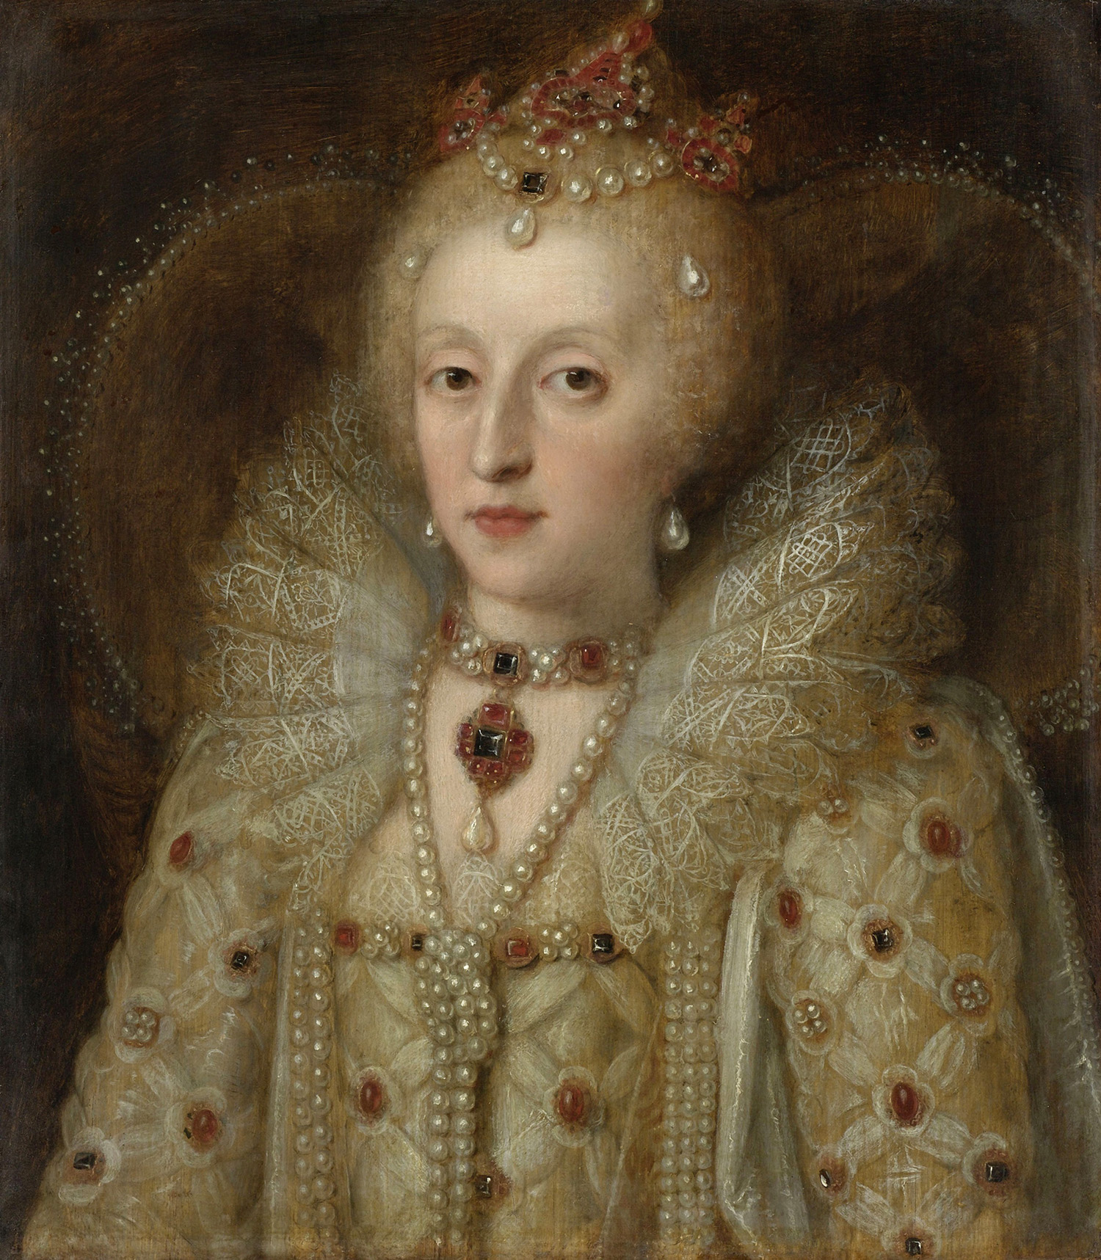
During the Elizabethan era, one’s social class depended entirely on what kind of family one was born into. The four major classes were the nobility, the gentry, the yeomanry, and the poor. The nobility were members of rich and powerful families who were appointed by the monarch as nobles. The gentry consisted of knights and squires, who were very rich and did not have to work but who were not deemed nobility by the monarch. The yeomanry were considered the middle class, those who worked and could live comfortably but who did not have any powerful titles and could lose their fortune easily. The poor were people who could not find work and could not afford good housing or food. The main characters in The Taming of the Shrew are likely on the same level as those in the gentry.

