## Magic and Superstition in Shakespeare’s Time

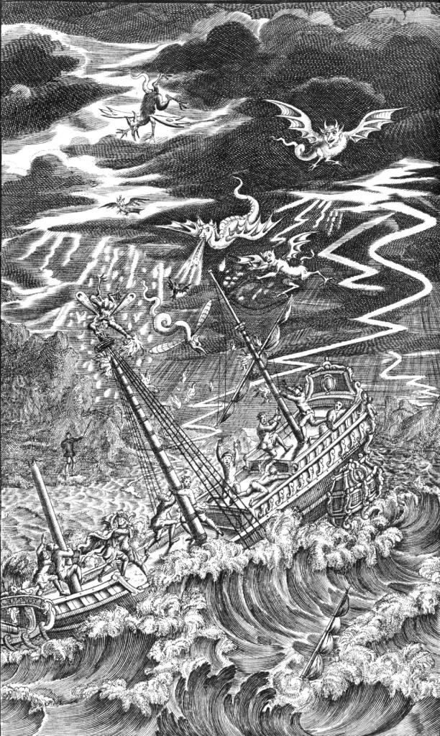William Shakespeare wrote *The Tempest* for audiences who believed in magic, sorcery, witchcraft, and other “dark arts.” At this time, Europeans were bitterly divided between the Roman Catholic and Protestant branches of Christianity. However, both Catholic and Protestant scholars taught that demons, witches, and sorcerers actually existed. Ancient superstitions also insinuated themselves into Christian beliefs. Most Christians considered supernatural characters from folklore, such as gremlins, goblins, ghosts, and spirits, to be servants of the Devil. Another satanic figure was the *familiar*, a supernatural spirit who accompanied a witch or magician and helped carry out spells. Theologians blamed witches, magicians, and their familiars for tempests and other natural disasters because the Bible refers to the Devil as “the prince of the powers of the air” (Ephesians 2:2). The secular ideals of the Renaissance were beginning to challenge such literal religious beliefs, but even scholars whom we now consider pioneers of science accepted supernatural explanations for natural events.

## John Dee, Scientist and Occultist

Shakespeare’s inspiration for the character of Prospero was probably Dr. John Dee (1527–1608), a pioneering mathematician and scientist. Dee was a graduate of St. John’s College, Cambridge, who studied mathematics, astronomy, and cartography with some of Europe’s leading scholars. He made important contributions to mathematics, astronomy, and navigation. He was a scientific advisor and personal astrologer to Queen Elizabeth I, and he prepared maps for Sir Martin Frobisher and other English navigators and urged the queen to found colonies in America. He built a scientific laboratory and owned a huge personal library of scholarly books. However, he was always a controversial figure, and scientific ignorance contributed to his legend. As Dee studied meteorology, word got around that his sorcery had conjured up the storm that destroyed the Armada, the Spanish fleet that tried to invade England in 1588. He was also rumored to be a spy and secret agent. Dee added to the rumors with his explorations of occult matters. He believed that mathematics could reveal the mind of God, and, with the assistance of Edward Kelley, a convicted criminal who claimed to be a medium, Dee attempted to find universal truth by conversing with angels. Dee claimed that one angel, named Uriel, gave him a piece of magic crystal. Dee and Kelley even compiled an alphabet of the angelic language.

## King James VI and I, Protestant Demonologist

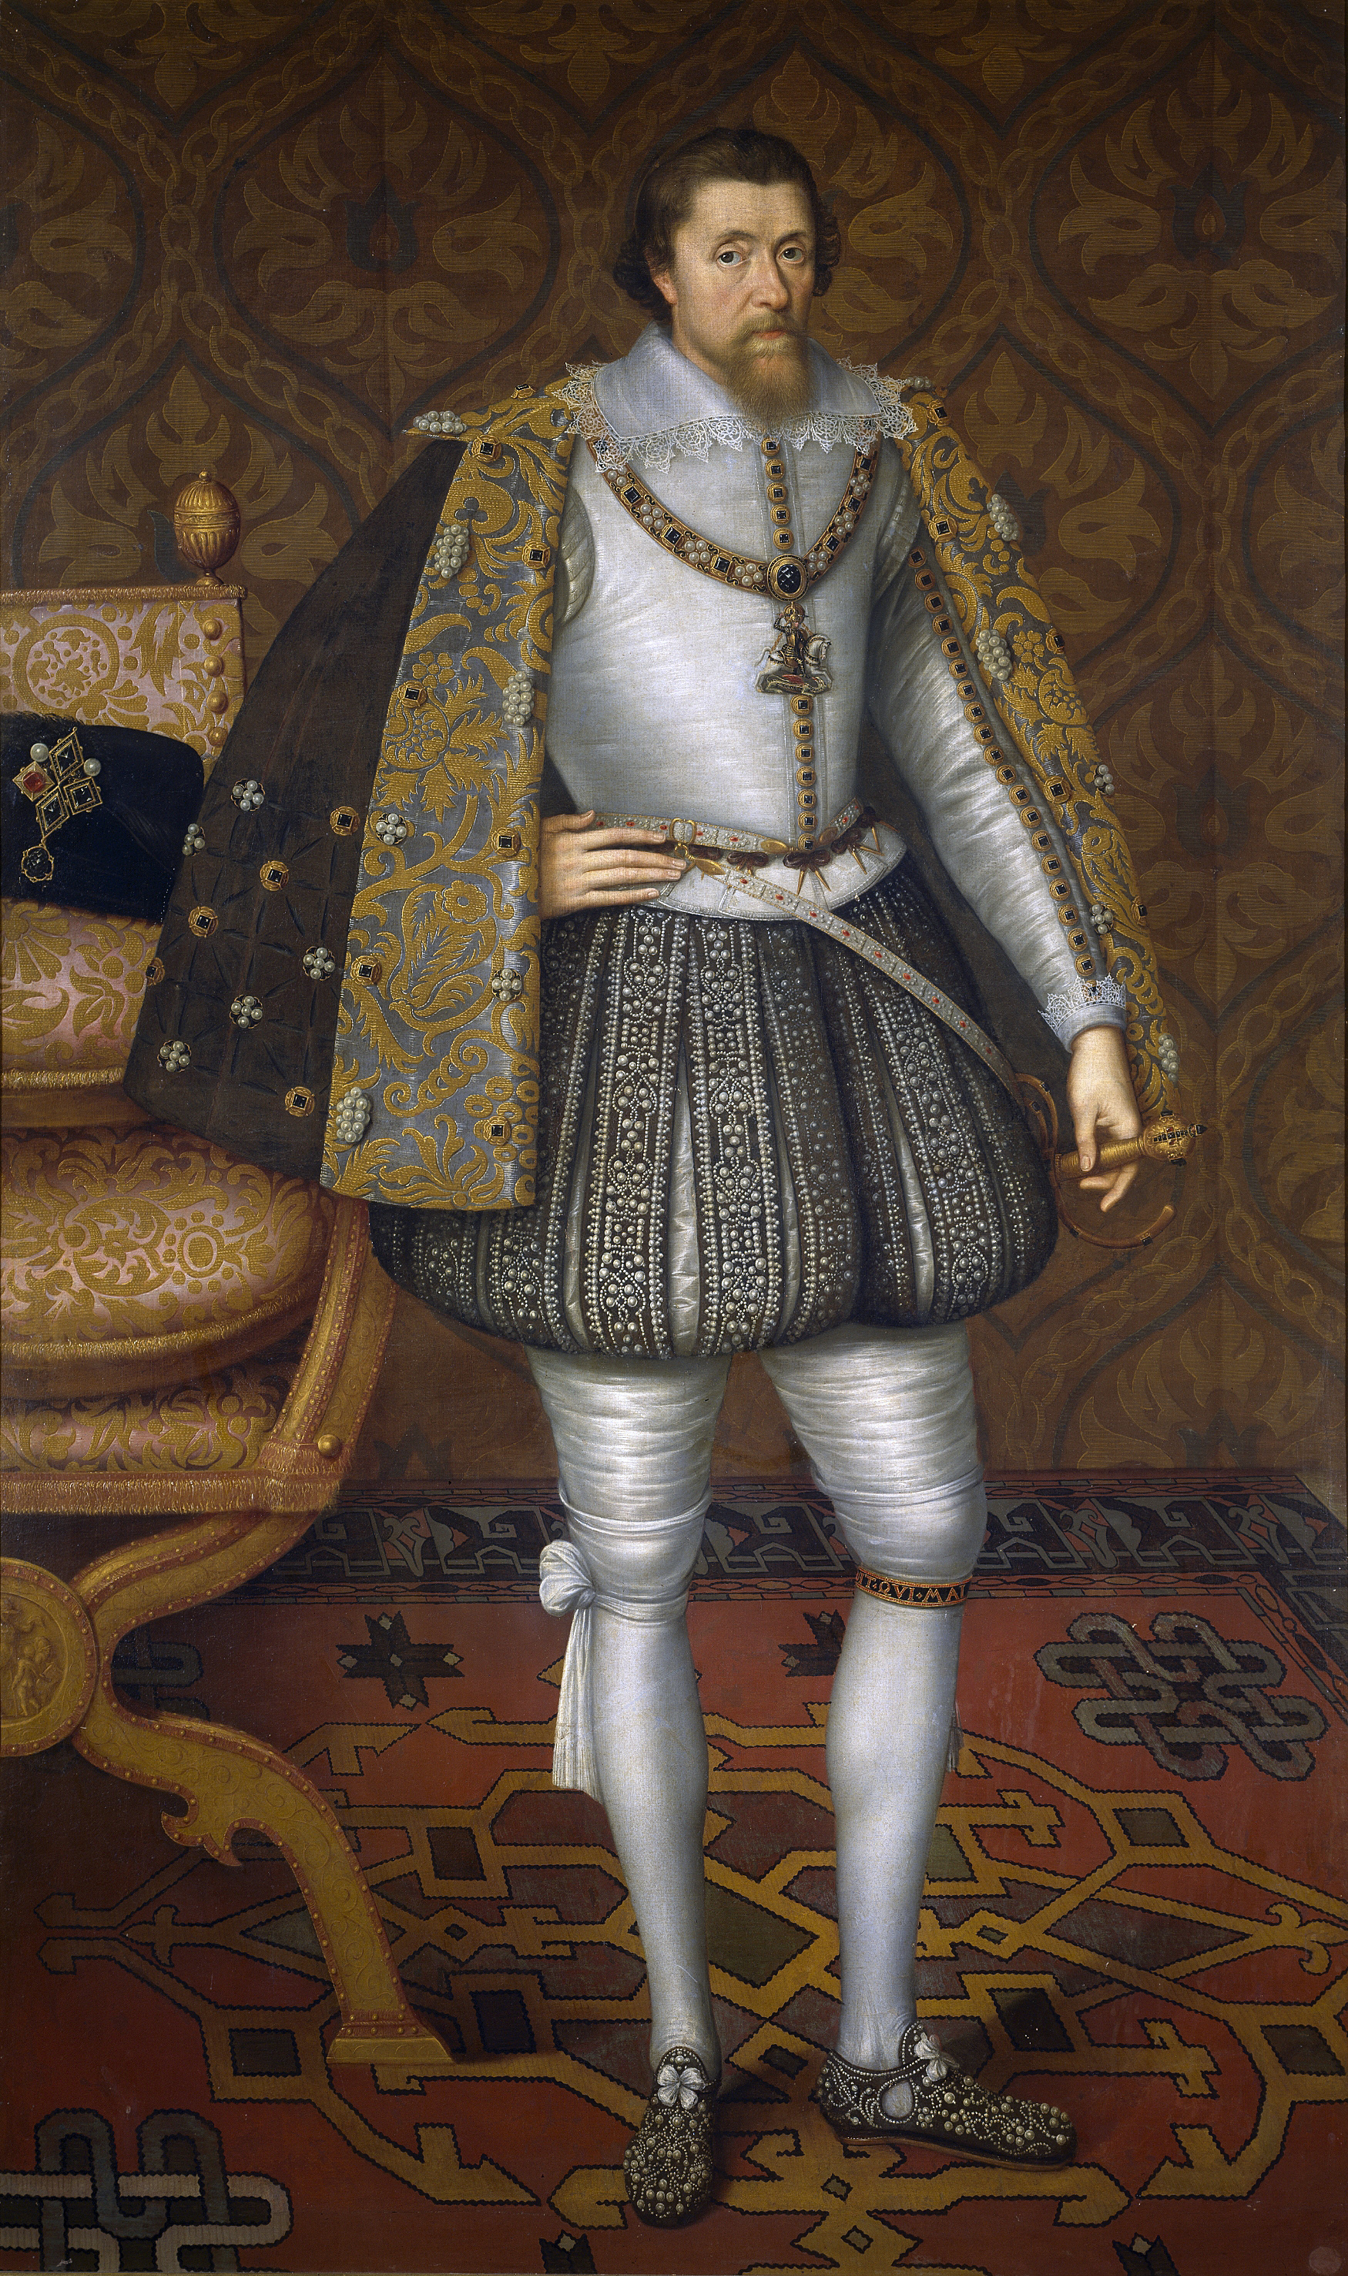Before he succeeded Elizabeth I in 1603 and became James I of England, James Stuart (1566–1625) was King James VI of Scotland. He was the son of Mary, Queen of Scots, a Roman Catholic who was the chief rival of Elizabeth I of England, a Protestant. After Scottish noblemen forced Mary to abdicate in favor of her one-year-old son, the regents who ruled in the young king’s name educated him as a Protestant. The religious controversies surrounding his monarchy probably contributed to James VI’s intense interest in theology. His best-known theological work was *Demonology* (1597)*.*

James believed that witches and demons interfered with his own rule. He married Anne of Denmark, a Protestant, in 1589. The marriage took place by proxy. When the new queen tried to sail for Scotland, terrible storms prevented the Danish fleet from departing. So, James went to Denmark to marry Anne in person and bring her home. When James sailed back to Scotland with Anne, in 1590, another fierce tempest almost sank their ship. Officials in both Denmark and Scotland blamed the tempests on witches and demons. According to the authorities, the witches worked with Catholic enemies to prevent James VI’s Protestant marriage. James attended the Scottish trials in person and approved of the torture and execution of a number of witches. He remained paranoid about the dark arts throughout his reign. In *Demonology,* he warned that the Devil might send magicians to court to act as spies and double agents. One demonic ploy was “to please Princes by faire banquets and dainty dishes, carried in short space from the farthest parts of the world.”

## Real Magic versus Shakespeare’s Magic

Although Shakespeare’s audiences held genuine religious beliefs in magic, they understood that stage magic was a deliberate illusion. Audiences knew that candles and mirrors created the flames that appeared to the sailors during the storm in *The Tempest* and that a flipping table created the magical disappearing banquet. *The Tempest* pleased audiences because the elaborate stage effects mimicked how people thought “real” magic worked. Even so, it seems audacious, perhaps even subversive, of Shakespeare to include so many references to James I’s personal experiences and prejudices against magicians in a story about using magic to restore political order. Perhaps Shakespeare got away with it because Prospero gives up magic and abandons his books at the end of the play. Shakespeare’s company, the King’s Men, performed *The Tempest* at James I’s court in 1611 and again in 1613, on the occasion of the marriage of the king’s daughter. The fact that James I applauded both performances is a testament to Shakespeare’s almost magical powers as a writer.