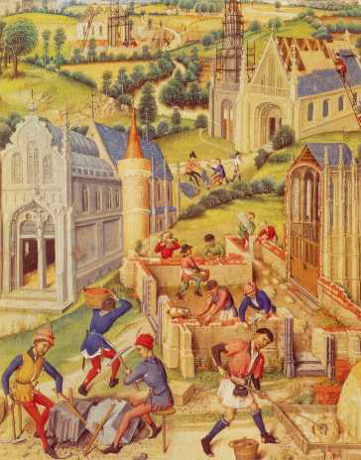Early feudal society was comprised of three estates, or classes: the clergy, who prayed; the nobility, who fought; and the peasantry, who labored. By Chaucer’s time, workers such as merchants and clerics had emerged as a developing middle class. Income inequality cut a sharp divide in medieval society, so much so that in 1381, the Peasants’ Revolt, a violent and deadly protest, erupted and was soon put down. Women’s status in medieval society was determined by sexual and marital relationships: A woman was considered a virgin, a wife, or a widow.

## Guilds

Urban medieval workers—craftsmen and merchants—joined together in associations called guilds to oversee their trades. Architects and masons formed guilds in the construction trade; weavers and dyers formed guilds in the wool trade; butchers, bakers, blacksmiths, and leatherworkers formed guilds as well. The guilds evolved into powerful economic, political, and social organizations. Economically, a guild created a monopoly of its trade in a particular town, set standards for work, and worked to stabilize prices. Politically, guilds sought to gain control of municipal government to further their interests. Socially, a guild provided mutual aid and protection to its members.

## Pilgrimages

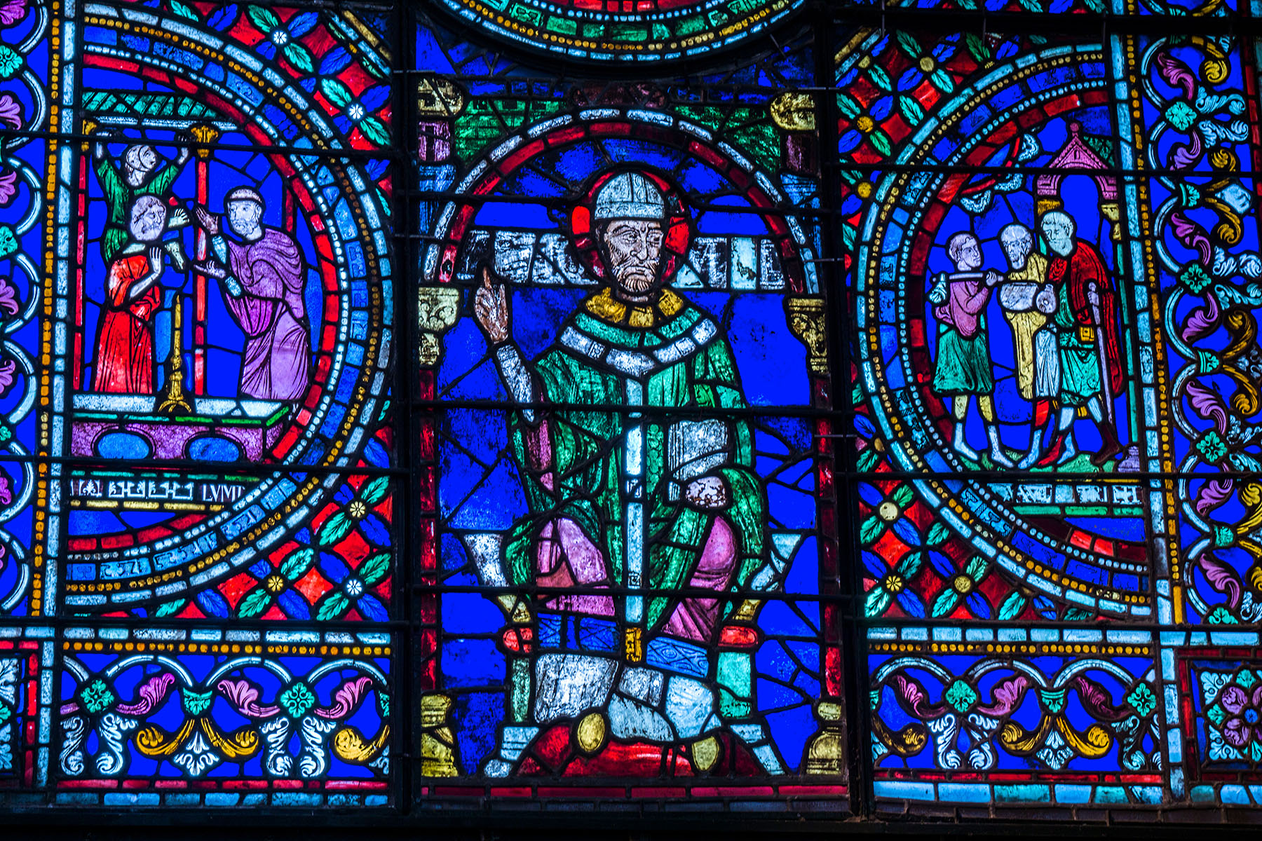The Roman Catholic Church was dominant in medieval Europe, and a pantheon of Catholic saints garnered followers. To show their devoutness to God and saints, people went on pilgrimages—spiritual journeys to religious sites. (The practice of pilgrimage is found in many religions and throughout history and is a practice continued today.) In medieval times, pilgrims usually traveled together, partly for safety but even more for the sense of company and social conviviality that group travel provided. Travelers made pilgrimages to shrines to pray for their sins to be forgiven, to work toward salvation, or to ask for a divine favor. One such shrine was the Cathedral of Canterbury, where Saint Thomas Becket, the former archbishop, was buried. Becket was a martyr—murdered for adhering to his loyalty to the Church over the king in 1170. Within a few days of his death, pilgrimages to his tomb began. Becket’s shrine became a famous and popular destination for pilgrims for centuries to come.

## Courtly Love

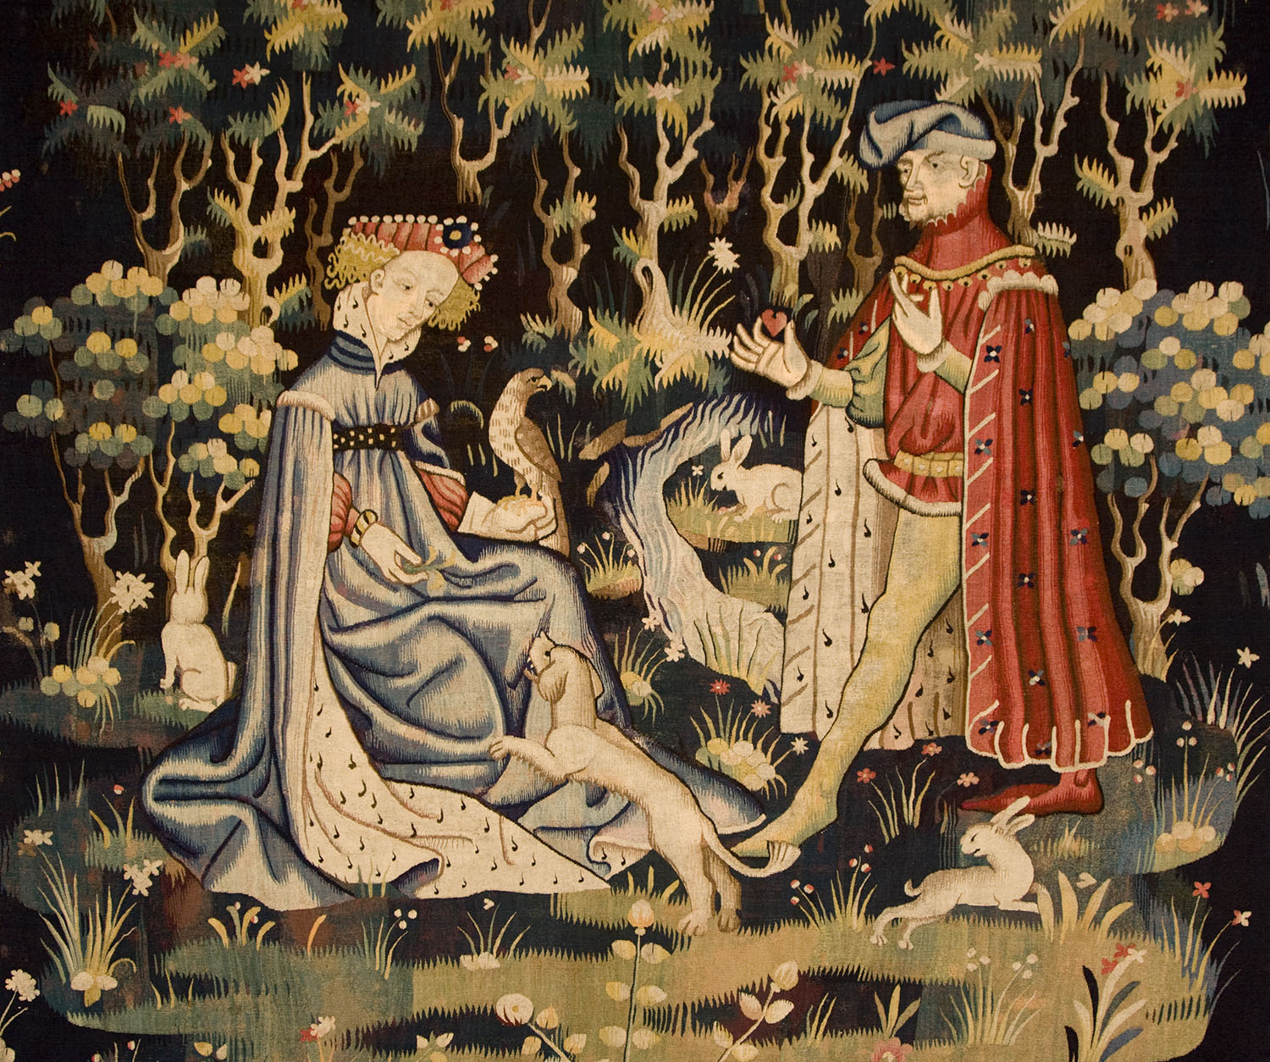The notion of love so romantic and spiritual that it need not be physically consummated became popular during the Middle Ages, influencing literature, art, and even life at medieval courts—leading to the term “courtly love.” Troubadours in southern France first sang of this “fine love.” The concept then spread throughout much of western medieval Europe. Love became a disease of desire: Lovesickness could rob a lover of his appetite and make him a slave to his passion. In true courtly love, a man lived only to serve and worship his lady—who likely was already married to someone else. Their secret relationship was ruled by a chivalric code of conduct and simple rituals. A man might write his beloved a poem or offer her a bouquet, and she would give him a slight show of affection in return.

## Literary Genres

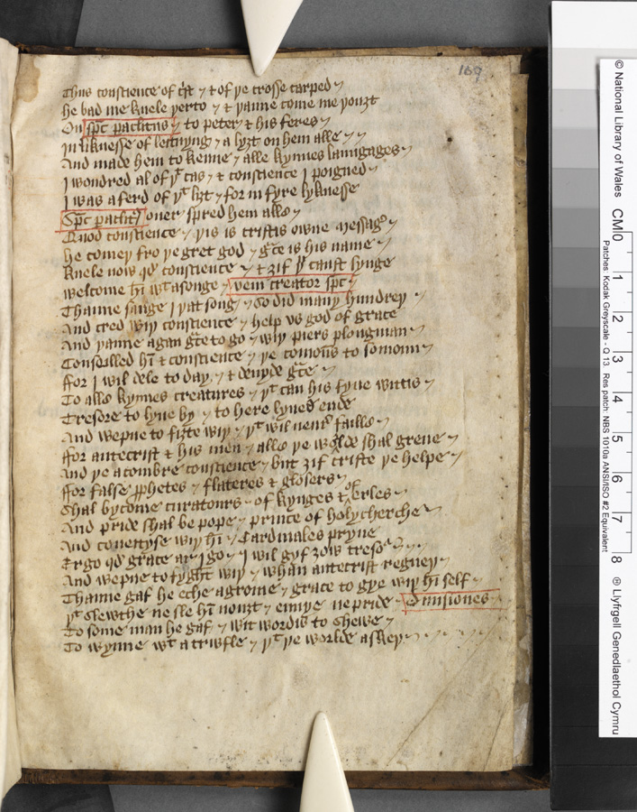Medieval storytelling took different forms and was shared both orally as well as in text. Listeners delighted in fabliaux—bawdy, off-color stories such as “The Miller’s Tale” from *The Canterbury Tales.* Troubadours sang stories of romance and chivalry. Breton lais were short rhyming tales about love that usually involved the supernatural or fairy world. In dream visions, as popular then as novels are today, the narrator would fall asleep and travel through a dream. Dream visions were used to console grief, muse on the divine, offer political advice, and even champion feminism. *The Canterbury Tales* belongs to the genre of estates satire, which, as the name suggests, ridiculed and parodied the social classes.