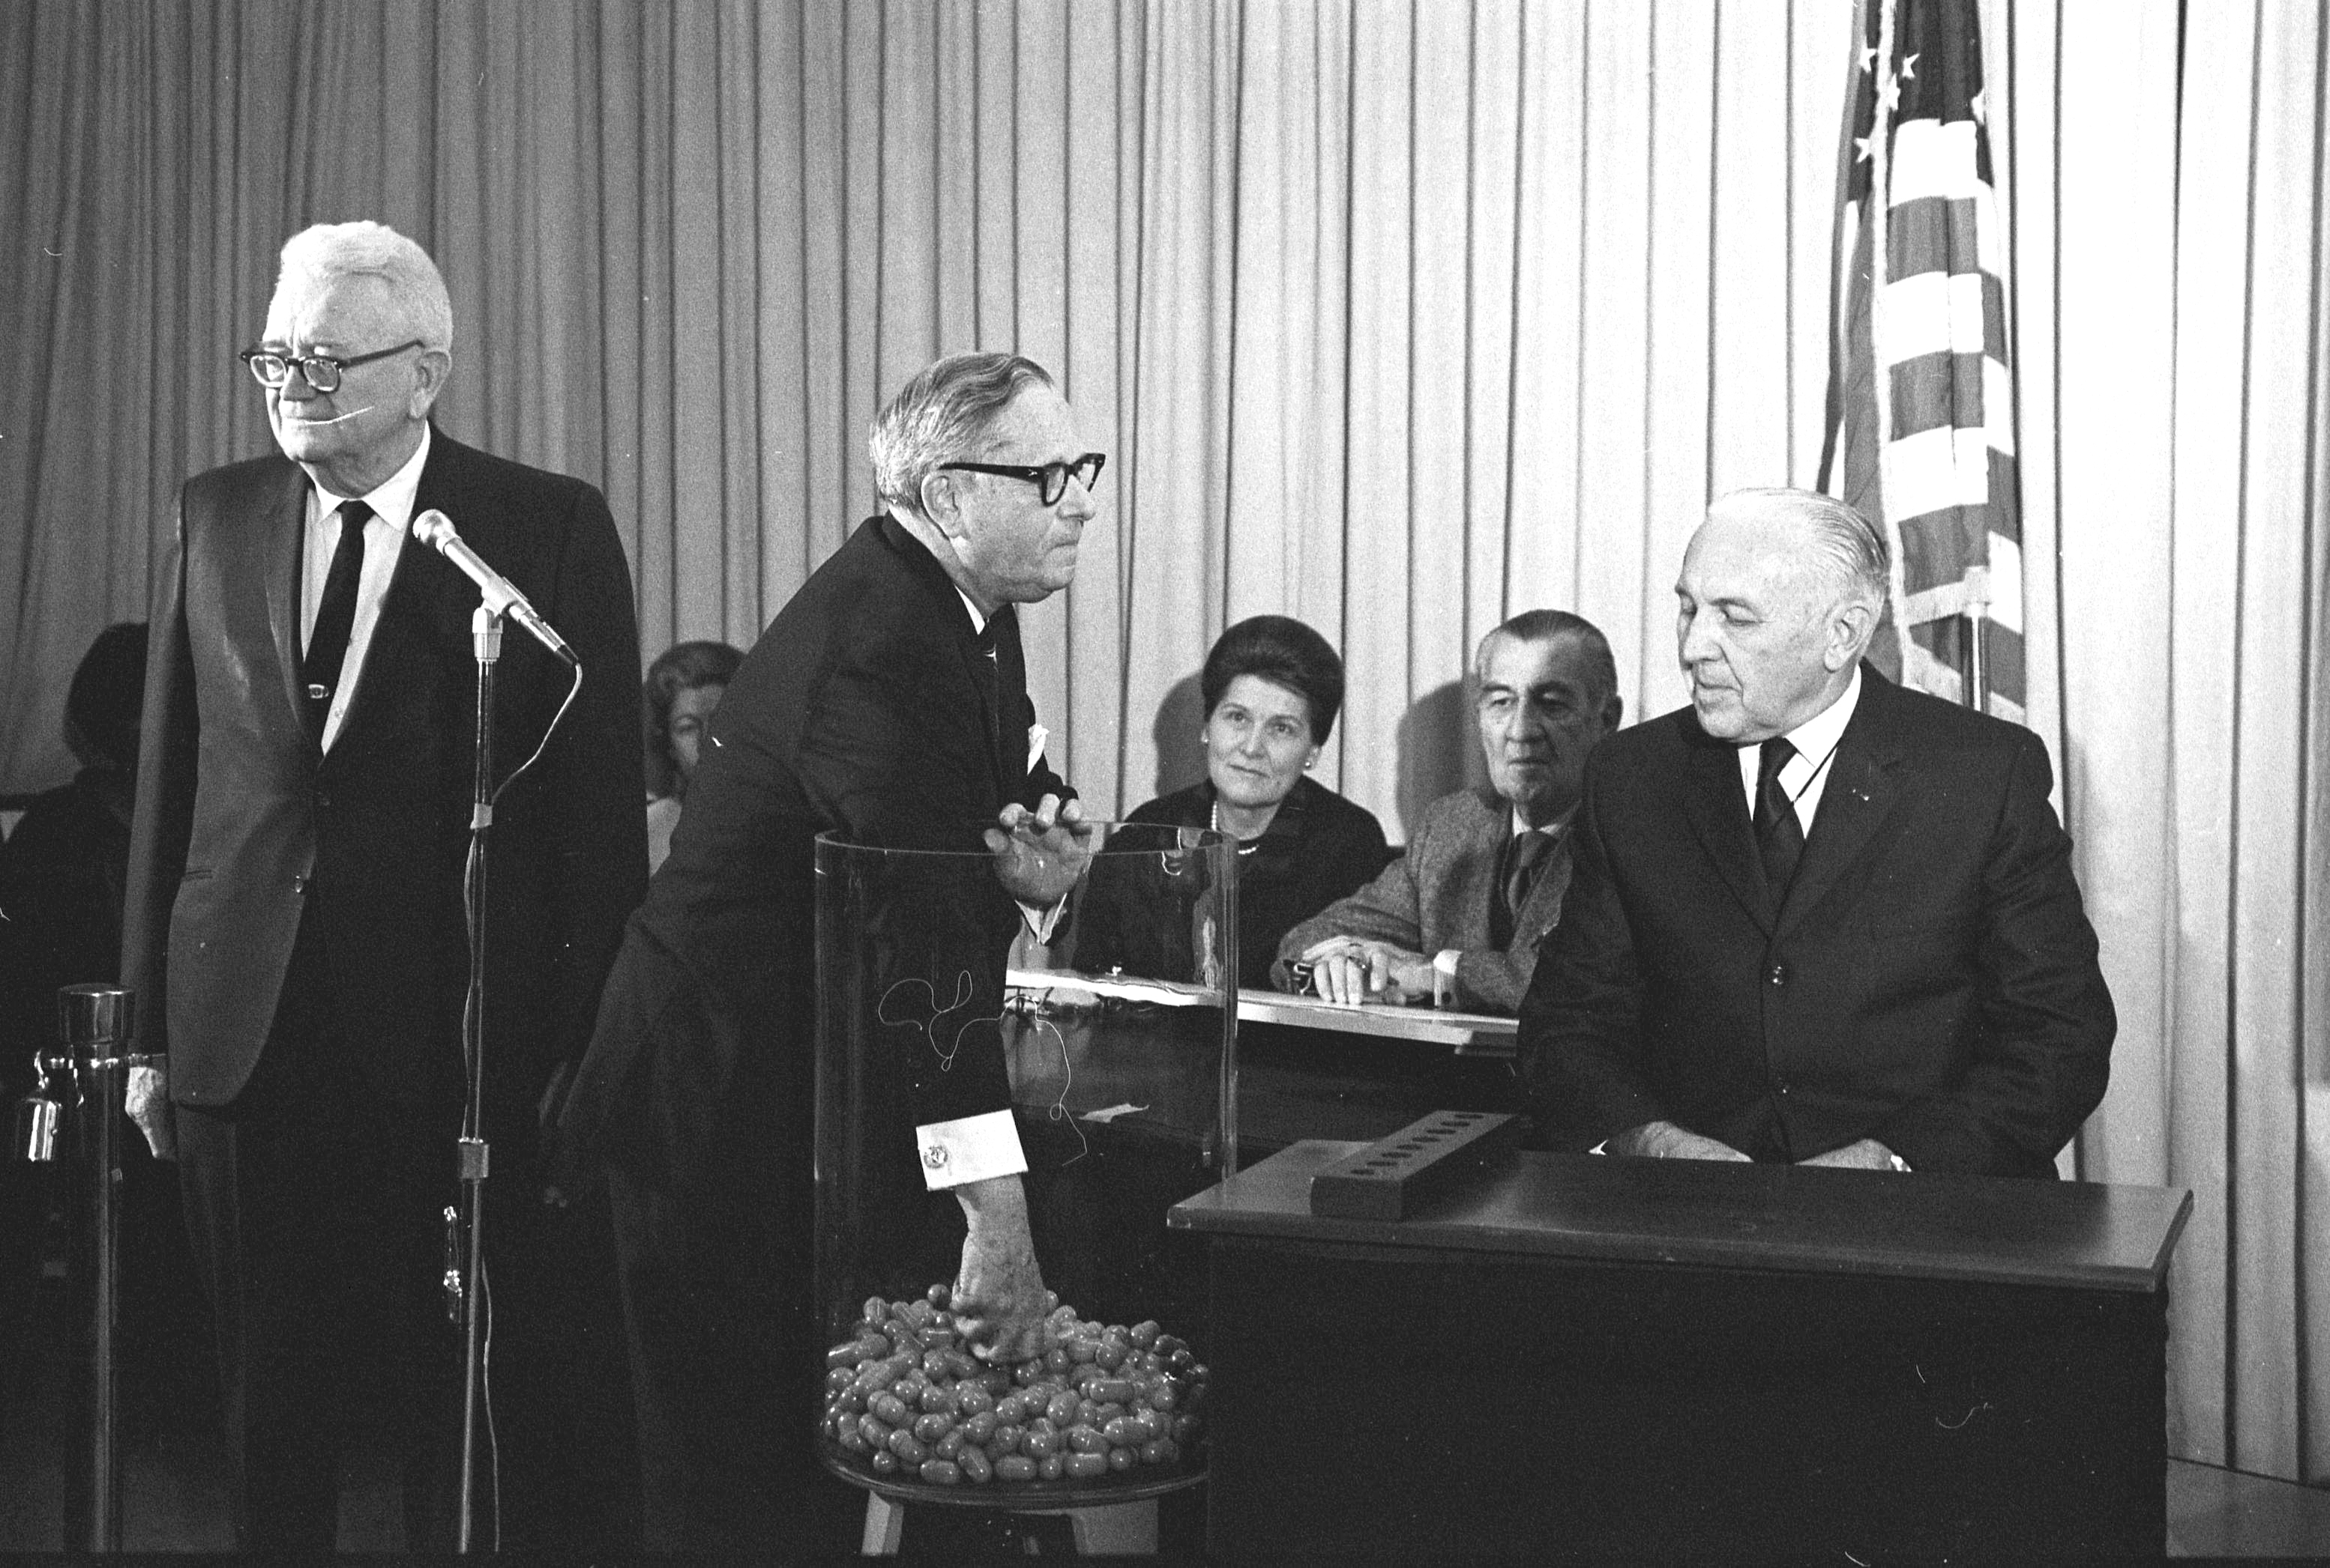
On December 1, 1969, people gathered around their televisions or radios. Regular broadcasting was interrupted to bring a live broadcast of the first draft lottery since 1942. The conscription or draft required eligible young men to join the U.S. Armed Forces. In 1969, 366 blue opaque capsules that had been shuffled in a shoebox and placed in a glass jar were selected one by one. Inside each capsule was a piece of paper on which was printed a day of the year (including February 29). Each pick was assigned a number and then pinned on a board titled “Random Selection Sequence 1970.”
The first date picked was September 14. Everyone born on that day between 1944 and 1950 was assigned the number 001. After each day of the year received a ranking, a second lottery was held using letters instead of dates. This lottery determined the order in which men with the same birthdays would be drafted. The letter “J” was the first pick, so a man born on September 14 whose last name began with “J” would be drafted before someone who was born on the same day with a last name that started with “G,” the second letter picked, and so on.
Those men who had numbers in the bottom third were most likely to be drafted, while men with numbers in the top third had a good chance of not being drafted. December 7, 1972, was the last day men were called up in the draft.
The draft was employed during the American Revolution, Civil War, World Wars I and II, the Korean War, and the Vietnam War. From 1940 to 1973, the Selective Training and Service Act allowed the government to draft men into the U.S. Armed Forces during times of both peace and conflict.
The United States was involved in conflict with Vietnam, Laos, and Cambodia from November 1, 1955, to April 30, 1975. The United States never officially declared war on Vietnam, but after North Vietnamese torpedo boats attacked two U.S. warships in 1964, the Gulf of Tonkin Resolution authorized President Johnson to take any measures necessary to retaliate against the attack and to maintain peace in the region. By the end of 1965, Johnson had sent 82,000 troops to Vietnam. The military wanted an additional 175,000 men.
The draft lottery was supposed to increase the manpower for the Vietnam War effort and to correct what seemed to some to be inequities in who was drafted into the military. Before the lottery, some men were drafted yet were already serving or had a deferment based on a medical condition or because they were enrolled in college. In addition, prior to the lottery, some men volunteered for other service, like the National Guard, hoping that they would not be sent to Vietnam. The draft lottery increased resistance to military service.
Today the U.S. Armed Forces is all volunteer.

